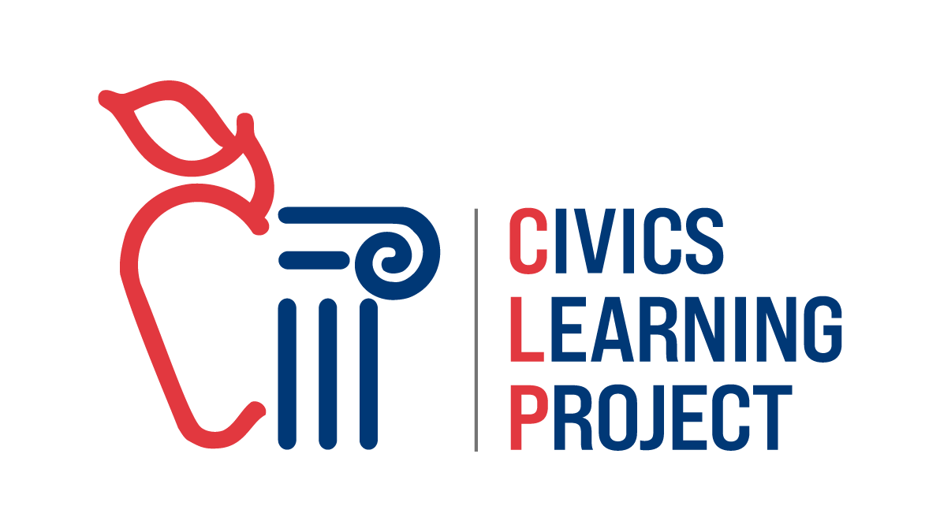

Civics Learning Project Presents

Future of Water in the Klamath Basin:
A Town Hall Simulation

In this packet:
- Overview of a Town Hall Simulation
- Teacher Lesson Plan
- Background Information
- Student Handouts

Last updated: Dec 10, 2024

Civics Learning Project Presents
Future of Water in the Klamath Basin:
A Town Hall Simulation

Introduction:
This simulation invites students to engage with the complex issues surrounding water rights, agricultural demands, environmental conversation, and indigenous rights within the Klamath Basin. Students will explore the perspectives of various stakeholders in a mock town hall setting, aiming to negotiate solutions that balance ecological sustainability with community needs.

Quote From NOAA’s The Essential Principles of Climate Literacy
“Climate plays an important role in the global distribution of freshwater resources. Changing precipitation patterns and temperature conditions will alter the distribution and availability of freshwater resources, reducing reliable access to water for many people and their crops. Winter snowpack and mountain glaciers that provide water for human use are declining as a result of global warming.”

Objectives of Town Hall Simulation:
- Students will practice civic engagement, understanding that their voices matter
- Students will understand the historical and cultural significance of the Klamath Basin to various communities.
- Students will analyze the competing needs for water resources in the face of environmental challenges and agricultural demands.
- Students will engage in inquiry to support an argument with relevant evidence.
- Students will construct and present a compelling argument that represents a particular point of view on a current and complex issue that needs to be addressed.
- Students will develop and present arguments supporting diverse stakeholder perspectives.
- Students will develop and hone listening skills to better understand contrary positions.
- Students will identify ways to compromise and collaborate.

Town Hall Simulation Process in Brief:
Day 1: Introduction and Background
1. Anticipatory Set/Hook: Water Uses Rankings 10 min
2. Teacher Direct Instruction on Background of Issues: 20 mins
3. Students study background sources: 15 mins
4. Assemble in role groups to read overviews: 15 mins
Day 2
5. Research day to find data and write testimony class period
Note: Panel group will do more data study since they will not be writing testimony
Day 3
6. Town Hall Simulation 55 min
Options: Use a fishbowl format with only one student per group giving the testimony or break into several town halls and jigsaw the student groups.
7. Whole Class Debrief: 15 mins
Teacher Lesson Plan: Drought and the Deschutes Town Hall Simulation

LESSON DESCRIPTION
Democracy requires public participation and compromise to solve problems as a community. By simulating a town hall, students will be exposed to the multiple interests involved in the future of water in the Klamath Basin post-dam removal. They will identify evidence that best supports each user’s interest and will practice writing and delivering persuasive testimony to the Klamath River Renewal Project. One student group will be pretending to be the panel.

LESSON GOALS AND OBJECTIVES

Oregon Social Studies Standard(s)

Social Studies Analysis
- 8.34 Analyze how a specific problem can manifest itself at local, regional, and global levels over time, identifying its characteristics and causes, and the challenges and opportunities faced by those trying to address the problem.
- HS.74 Analyze an event, issue, problem, or phenomenon, critiquing and evaluating characteristics, influences, causes, and both short- and long-term effects.
Civics and Government
- HS.8 Examine the institutions, functions, and processes of Oregon’s state, county, local and
- regional governments.
Geography
- 8.21 Explain how technological developments (such as the cotton gin, roads, railroads, canals, etc.), societal decisions, and personal practices interact with the physical environment in the United States (e.g sustainability, economics ecosystems).
- HS.40 Use geographic data to analyze the interconnectedness of physical and human regional systems (such as a river valley and culture, water rights/use in regions, choice/impact of settlement locations) and their interconnectedness to global communities.
- HS.48 Determine the influence of long-term climate change and variability on human migration, settlement patterns, resource use, and land uses at local-to-global scales.
Oregon Science
- HS.ESS3.1 Construct an explanation based on evidence for how the availability of natural resources, occurrence of natural hazards, and changes in climate have influenced human activity.
Oregon Language Arts
- 9-10.SL.1d Respond thoughtfully to diverse perspectives, summarize points of agreement and disagreement, and, when warranted, qualify or justify their own views and understanding and make new connections in light of the evidence and reasoning presented.
- 9-10.SL.4 Present information, findings, and supporting evidence clearly, concisely, and logically, so listeners can follow the line of reasoning; ensure that the organization, development, substance, and style are appropriate to purpose, audience, and task.*
- 11-12.SL.1c Propel conversations by posing and responding to questions that probe reasoning and evidence; ensure a hearing for a full range of positions on a topic or issue; clarify, verify, or challenge ideas and conclusions; and promote divergent and creative perspectives.

Objectives
- Students will practice civic engagement.
- Students will broaden their understanding of the competing needs for scarce resources in our region in the face of a changing climate.
- Students will engage in inquiry to support an argument with relevant evidence.
- Students will construct and present a compelling argument that represents a particular point of view on a current and complex issue that needs to be addressed.

LESSON PREPARATION
Vocabulary to pre-teach: see the list below

Skills to pre-teach: Media literacy and best research practices should be pre taught before the inquiry component. Also check that students understand rhetorical structure and devices for persuasion, oral delivery techniques.

Initial Teacher-Led Discussion:
Inform students that the goal of this activity is to be able to analyze and articulate various perspectives on water issues and that this is not an attempt by the teacher to advocate for a certain position on a specific issue. Rather, you as the teacher hope students will see:
- There is no easy solution or the allocation of water would already be resolved.
- Roles of governments vs. private interests in assisting with the solution
- There is opportunity to shape future policy to adapt to changing circumstances

Instructional Materials
- Hard copies of roles for each student present.
- Access to internet-connected tablets or laptops for overview preloading and for inquiry part of lesson.
- Big enough space to comfortably fit all students and allow them to all see each other.

Learning Supports
Accessibility: Teacher projector to display all the preloading information plus student devices for inquiry. Keyboards for ease of typing, speech to text apps to make writing the testimony more accessible.
Cultural & Linguistic Responsiveness: Depending on your student group, you may need to teach the academic vocabulary in addition to the topic terminology. Also, a student group that has not worked much in persuasive speaking and writing could use some instruction on rhetorical methods and devices.
Differentiation: Some students may need help identifying good sources for the inquiry piece. A teacher could provide some resources. What comes after the town hall could be very in depth, real life policy making like a Community Action Project with students proposing policy to actual stakeholders. Alternatively, students could do some field work with stream restoration as a hands-on learning experience. Students could do a community education campaign to spread awareness of water savings techniques. The sky’s the limit!
Socio-emotional supports: Preteach the importance of representing the role respectfully and not exaggerating the dramatic performance. Continually remind students that the point of the lesson is to broaden understanding of multiple perspectives and the complexity of solving a problem with so many stakeholders, not to have any particular point of view win an argument.

LESSON PROCEDURES
Anticipatory Set/Motivation/Hook, Time: 10 min start of Day 1
Give students in groups of four an envelope full of cut upriver uses and ask them to rank them in terms of importance from top to bottom.

Anticipatory Set Materials:
Have students work in groups to rank these river uses by importance before handing out the roles. Photocopy this list, cut up and put in envelopes for groups to manipulate.

- Irrigating for food crops
- Human drinking water
- Irrigating for livestock feed (hay) and pastures
- Water in the river for endangered salmon and other wildlife in the lower basin
- Water for protected sucker fish and other threatened species in the upper basin
- Water for waterfowl migrating via the Pacific Flyway in the lower basin
- Water to produce hydroelectric power
- River flows for rafting

Focused Instruction (Teacher-as-Model), Time: Rest of class period Day 1
Teacher introduces scenario: The Klamath River Renewal Corporation has been created by states of Oregon and California, Tribal Governments, and other stakeholders to oversee the four Klamath dam removals and support the restoration of the region post-removal. As this is an ongoing process with much at stake for a variety of stakeholders, the KRRC is holding a town hall hearing for all stakeholders to answer the following question:

- How can everyone in the Klamath basin work together to share water fairly, supporting our farms, protecting natural habitats and endangered species, honoring local traditions, and ensuring communities thrive, when water is limited?

Teacher walks students through source review via direct instruction of the issue, the background history and how Oregon law works regarding water rights, and has students interpret the maps. Teacher identifies multiple government agencies at the tribal, local, state, and federal levels to show the complexity of a federalist system. Here’s an overview of the history to get you started: https://www.watereducation.org/aquapedia/klamath-river-basin

Guided Instruction (Teacher-to-Student Joint Responsibility), Time: First 10 min period for Day 2
Teacher hands out roles to students for them to read role sheets. Give instructions on students brainstorming what information could support the role’s point of view and give them time to conduct research to find data. Students read roles.

Group Application (Student-to-Student Joint Responsibility)
Part I, Time: Day 2, 25 min, 35 min
Students work in groups to find evidence that supports their role’s point of view. Then students work in groups during the second half of the period to write their role’s testimony. Teacher can decide if this will be a fishbowl with one student per group doing the oral testimony presentation or run multiple town halls simultaneously, jigsaw style in the room. Also, teacher can decide if any students will act as the decision makers afterwards or if the class will follow up with a consensus building style discussion like a Socratic seminar.
Part II, Time: Day 3, 55 min
Teacher Does/Students Do: Teacher gives instructions on how the town hall will run (either one or multiple simultaneously) and the order of go. Students who are listening should have some form of evaluation (rubric) or note taking sheet to respond in writing with as they are receiving the testimony. What teacher plans next will determine what the students should be doing.

Closure, Time: Day 3, 20 min
Teacher Does/Students Do: Have a debriefing discussion to hear how students’ understanding of the issue changed from doing the town hall. Return to the opening activity of ranking uses and compare that to the existing law in Oregon regarding water rights.

Extension: Individual Learning (Independent Practice and Application), Time: varies
This is entirely up to teacher discretion. Write a position paper, work as a class to propose a public policy solution to decision makers. Invite the actual professionals involved in the water resource distribution and have a panel discussion with students asking questions. Students could write an op-ed to the local newspaper or make a PSA for the public on water conservation.

ASSESSMENTS
Formative Assessment(s)
Student written and oral testimonies from each role. Students use the rubric to score each other’s presentations.
Summative Assessment(s)
Shed the assigned roles and hold a class discussion on what policy they would propose to law-makers in Oregon. Make sure the discussion is collaborative, building toward consensus, rather than antagonistic. This can lead to any of the following extensions:
- individual student position papers
- op ed to local newspaper
- make a video PSA for the public
- host a panel of professionals in the classroom
- do field work for watershed health
- attend a real town hall in the community and provide testimony
- propose policy to decision makers

Teacher Resource 1:

Federalism is a system where power is shared between national and regional governments. There are over 90,000 governments in the USA because of all the layers!
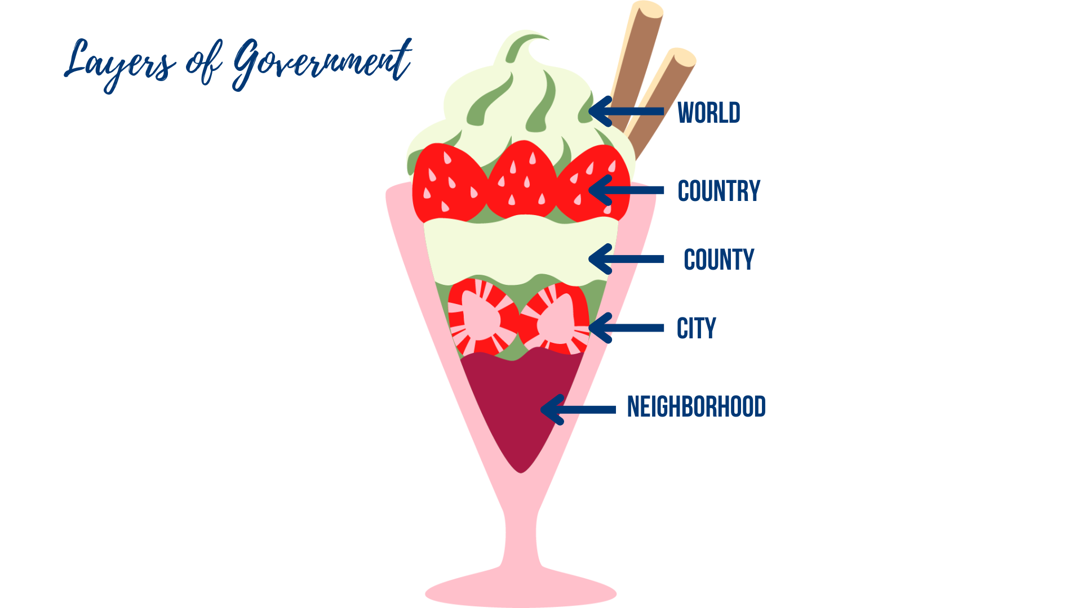

When it comes to regulating water use, there are many many agencies involved. Here are some:

Country Level: USA’s Federal/National Agencies

US Bureau of Land Management: The Bureau of Land Management's mission is to sustain the health, diversity, and productivity of public lands for the use and enjoyment of present and future generations.
Bureau of Reclamation: best known for the dams, power plants, and canals it constructed in the 17 western states. The BOR is the largest wholesaler of water in the country and reclamation is also the second largest producer of hydroelectric power in the United States.
U.S. Fish & Wildlife: Working with others to conserve, protect and enhance fish, wildlife, plants and their habitats for the continuing benefit of the American people.
US Department of Agriculture Farm Services Agency: Is equitably serving all farmers, ranchers, and agricultural partners through the delivery of effective, efficient agricultural programs for all Americans.
US Forest Service (under the USDA): manages the nation's 154 national forests and 20 national grasslands covering 193 million acres of land.
US Geological Survey: The science arm of the Department of the Interior. The USGS brings an array of earth, water, biological, and mapping data and expertise to bear in support of decision-making on environmental, resource, and public safety issues.
Environmental Protection Agency: Established to protect human health and the environment.

State Level: Oregon’s State Agencies

Oregon Water Resources Department: The Department's mission is to serve the public by practicing and promoting responsible water management through two key goals:
- To directly address Oregon's water supply needs
- To restore and protect streamflows and watersheds in order to ensure the long-term sustainability of Oregon's ecosystems, economy, and quality of life
Oregon State Police Fish and Wildlife Division: Ensures compliance with the laws and regulations that protect and enhance the long-term health and equitable use of Oregon's fish and wildlife resources and the habitats upon which they depend.
Oregon Department of Fish and Wildlife: Protecting and enhancing Oregon’s fish and wildlife, and the habitats they use, for the use and enjoyment of present and future generations
Oregon Dept. of Environmental Quality: DEQ's mission is to be a leader in restoring, maintaining and enhancing the quality of Oregon's air, land and water.

Tribal Governments:

Klamath Tribes: A federally recognized Tribe with a Reservation at the top of the Klamath River estuary
Yurok Tribe: Works to exercise the ancestral rights of the Yurok people and safeguard the land and water of the tribal region.
Karuk Tribe: The Karuk Tribe is one of the largest tribes in California. Karuks are also enrolled in two other federally recognized tribes, the Cher-Ae Heights Indian Community of the Trinidad Rancheria and the Quartz Valley Indian Community.

Regional Level:

Irrigation Districts:
Tulelake Irrigation District; Klamath Irrigation District; Klamath Drainage District; Shasta View ID and Malin ID; Van Brimmer, Westside and Sunny ID; Klamath Basin Improvement District
Soil and Water Conservation Districts:
Klamath Soil & Water Conservation District; Fork Rock/Silver Lake SWCD; Lakeview SWCD

County Level:
Klamath County, Lake County, Jackson County

City Level:
City of Klamath Falls, City of Keno, City of Worden, City of Midland, City of Chiloquin, City of Odessa

Teacher Resource 2: Claim Evidence Reasoning for Testimony Drafting

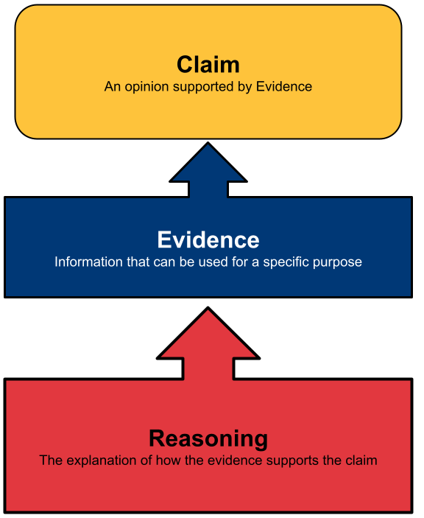

Teacher Resource 3: Sources for Inquiry

Use these to examine the issue with your students. As the situation changes, updated sources will be important to include.

- U.S. Drought Monitor National Map
- NOAA Monthly Drought Outlook Map
- Water Rights and Oregon Law
- On the headwaters of the Klamath River, water shortages test tribes, farmers and wildlife, USA Today, Dec 27, 2023
- Biden administration announces truce in Klamath Basin water wars, San Francisco Chronicle, Feb 14, 2024
- Farmers, tribes reach ‘historic’ Klamath River deal, E&E News, Feb 14, 2024
- Oregon tribe wins ruling on water rights but Klamath Basin irrigators challenge allocation Oregonian, Mar. 03, 2021
- A Treaty Right and Indigenous Regulation, Oregon Historical Society
- Who Has a Right to the Klamath River? Underscore, 2021
- The Klamath Tribes Are Trying to Save the C’waam and Koptu Suckerfish From Extinction, Sierra, December 18, 2023
- Treaty with the Klamath, etc., 1864, Tribal Treaties Database
- Klamath Homestead Drawing, Oregon Historical Society
- OSU Study Details Devastating Effects Of Water Shortages On Klamath Basin Economy, Daily Tidings, June 4, 2024
- Urgent Action Needed to Save Endangered Fish in Upper Klamath Lake, Siskiyou News, Sep 22, 2024
- Federal water managers announce 2024 allocations for Klamath Basin agriculture, OPB, April 17, 2024
- Tens of thousands of birds die at wildlife refuges in southern Oregon, the largest die-off to date, The Oregonian, Sept 27, 2024
- After the Klamath Dam Removal, Residents Grapple with an Uncertain Future, Outside Magazine, Nov 24, 2024
- Video: Salmon make historic trek past recently removed Klamath River dams, NBC Bay Area, Nov 22, 2024
- Video: Salmon return to historic habitat after largest dam removal project in the US, Associated Press, November 16, 2024
- ​​$367.8 Million is no Small Potatoes, Basin Ag News, June 17, 2024

Teacher Resource 4: Rubric for Evaluation of Testimony

Group:

Exemplary | Proficient | Approaching | Does not Meet
Testimony is full of details such as statistics and quotes that illuminate the point of view accurately | Testimony had enough details to represent the point of view accurately | Testimony had some information but it was general or not tied to this role’s perspective | Lacked details or information did not match the role
Evidence is well chosen, up-to-date, and supports the specific role | Evidence supports the point of view and was accurate | Evidence was mismatched to the role or wasn’t recent or accurate enough | Testimony lacked research evidence or contained erroneous information
Delivery was vibrant, clear, compelling, and realistic | Delivery was clear and persuasive | Delivery was read, not performed, but was clear and audible. | Delivery was not persuasive, clear, or audible.
Score:

Strengths:

Suggestions:

Questions:

Teacher Resource 5: Consensus Building Fist to Five Method
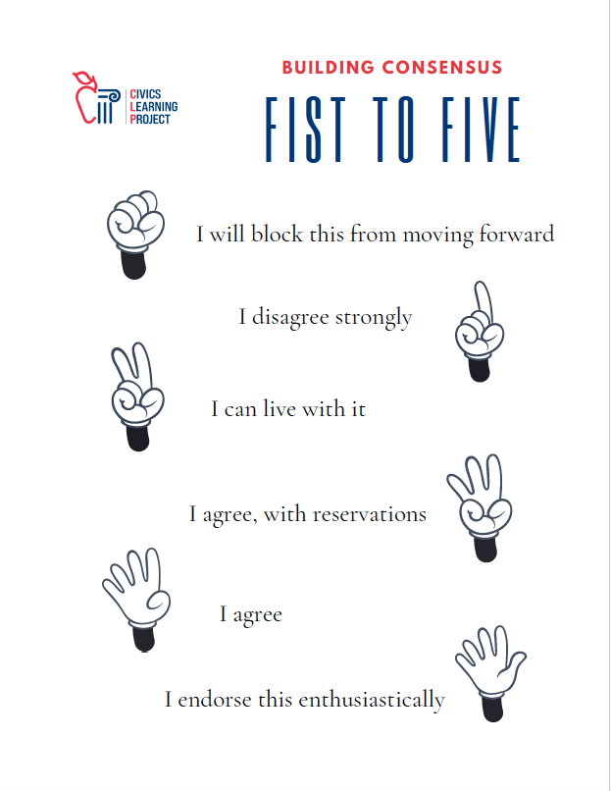

Student Handout 1: Ranking Water Uses

Irrigating for food crops
Human drinking water
Irrigating for livestock feed (hay) and pastures
Water in the river for endangered salmon and other wildlife in the lower basin
Water for protected sucker fish and other threatened species in the upper basin
Water for waterfowl migrating via the Pacific Flyway in the lower basin
Water to produce hydroelectric power
River flows for rafting

Student Handout 2: Town Hall Simulation Roles

Scenario:
The Klamath River Renewal Corporation (KRRC), in collaboration with the States of California and Oregon, local governments, Tribal nations, PacifiCorp, irrigators, and conservation and fishing groups, is convening a Town Hall meeting. As the organizing body, KRRC will hear testimony from the stakeholder groups included in the roles below. This gathering seeks to engage the wider community in a discussion about the dam removal process, address concerns and suggestions, and explore additional measures that can contribute to a sustainable future for the Klamath Basin.

How can everyone in the Klamath basin work together to share water fairly, supporting our farms, protecting natural habitats and endangered species, honoring local traditions, and ensuring communities thrive, when water is limited?

Roles:
- River Finn, Yurok Fisheries Manager
- Taylor Gills, Copco Resident
- Casey Chinook, Klamath Tribes
- Cameron Fielder, President Klamath Reclamation Project Irrigators
- Skyler Rapids, Rafting Business Owner
- Sam Steere, Rancher Upper Klamath Basin
- Jordan Waters, Biologist from Lower Klamath Wildlife Refuge
- Parker Storm, Pacific Power Corporation

Student Handout 2: Student Directions:
Once you have been assigned your role, read the handout that gives an overview of your character’s point of view. Brainstorm what type of data could make your testimony strong in the town hall. Spend some time gathering evidence and then write up a one-page testimony that you will deliver at the town hall.
1. Read your role overview
2. Brainstorm what type of data you would want to support this point of view with the prep worksheet
3. Gather evidence that supports your character’s point of view
4. Write a 2 min testimony (about 300 words)
5. Deliver testimony orally in town hall simulation

Research Notes
Source | Evidence

Student Handout 3A:

Role 1: River Finn, Yurok Fisheries Manager

Ever since my earliest memories, the stories and practices of our ancestors have guided me in understanding the sacred relationship we, the Yurok People, share with the Klamath River. The river provides us not just with sustenance, but is the foundation for our traditions and way of life. As the Yurok Tribal Fisheries Manager, I carry the weighty responsibility of bridging the wisdom of our past with the challenges of today, aiming to restore and protect the vibrant life of the Klamath Basin for generations to come. Our work at the Yurok Tribal Fisheries Program is vast, spanning across divisions dedicated to Harvest Management, the Lower Klamath, Trinity River, and the broader Klamath River ecosystem. We focus on species crucial to our culture - such as the Chinook and Coho salmon, steelhead, and Pacific lamprey. We employ advanced research and restoration techniques, informed by both scientific and traditional knowledge. The decision to remove the dams gives our community hope. It’s a significant step towards rebuilding the river’s once-teeming life and encouraging the preservation of the cultural practices that define us. We look forward to seeing the river flow freely once more.

Student Handout 3B:

Role 2: Taylor Gill, Resident of Copco Lake

Life at Copco Lake was a serene experience, intertwined with the rhythms of nature and the changing seasons. Our community, nestled beside the tranquil waters, thrived on the joys of fishing, wildlife watching, and the peaceful ambiance the lake provided. It was more than just a body of water; it was the heart of our community. But then, the landscape of our lives changed dramatically. The decision to remove the Klamath dams, while understood to be a step towards ecological restoration, brought an immediate loss to our doorsteps. The draining of Copco lake turned our beautiful community into a stark, mud-caked wasteland. The impact extended beyond the visual and emotional shock. My neighbor, Harry Heron, suddenly found himself without water and had to be moved to a hotel temporarily. The wildlife too has suffered. The scenes of deer, once graceful backyard visitors, are becoming hopelessly mired in the mud. While many of us support efforts for a healthier Klamath River system, we also advocate for consideration of the residents and wildlife that have called this place home.

Student Handout 3C:

Role 3: Casey Chinook, Klamath Tribes Member and Advocate

From the dawn of creation, the Klamath, Modoc, and Yahooskin-Paiute peoples, collectively known as the Klamath Tribes, have thrived in the lush and bountiful Klamath Basin. Our legacy is deeply rooted in the stewardship of our lands and waters, honoring the covenant with Gmok’am’c, the creator, to safeguard our homeland for all its inhabitants for generations to come. The decision by the Federal Energy Regulatory Commission (FERC) to remove four of the six dams from the Klamath River marks another pivotal moment in our history. This step forward in the dam removal process highlights our advocacy for the rights of the river and its inhabitants. We are particularly concerned about the absence of c’iyaals (salmon), c’waam (Lost River Sucker), and koptu (shortnosed sucker) from our rivers as it has prevented us from accessing a significant part of our cultural identity. The prospect of reintroducing these endangered species to the Upper Klamath Basin will represent a restoration of a forgotten ecosystem. We understand that the path to recovery is filled with challenges because of this. The ecosystem in the Upper Klamath Basin has been severely damaged over the last century which still threatens the success of reintroducing these important fish to their ancestral spawning grounds and the healthy river systems of the past. It is essential that we have a comprehensive plan for restoration in the region. This process is only just beginning and it is important to remember the words that have passed through generations: “naanok ans naat sat’waYanaat ciiwapk diceew’a” which means: “We help each other; we will live good.”

Student Handout 3D:

Role 4: Cameron Fielder, Klamath Reclamation Project Irrigators

Out here in the Klamath Basin, farming isn’t just a job; it’s a way of life. I’m a third generation farmer and I’ve seen firsthand the ebb and flow of seasons and the challenges we face with water management. My family has been tilling this land and nurturing crops like barley, alfalfa, and potatoes since my grandfather’s time, relying on water from the Klamath Project. The Klamath Project is the lifeline for farmers like me, transforming 230,000 acres of what was once rangeland and marsh into productive fields that feed our nation. It’s a complex system of dams, canals, and reservoirs, painstakingly designed to capture the spring runoff from Upper Klamath Lake and the Klamath River. But farming here isn’t without its trials. The balance between agriculture needs, wildlife refuges, and indigenous rights has always been delicate. The decisions made about the Klamath Project’s water affect not just our crops but the entire ecosystem, including the migratory birds along the Pacific Flyway and the fish species that local tribes depend on. The 2001 cutoff of irrigation water was a stark reminder of how quickly our fortunes can change driven by the need to protect endangered fish species. Working together is important so that all can prosper in this region.

Student Handout 3E:

Role 5: Skyler Rapids, Rafting Business Owner

I’m Willy Rapids and running a rafting outfit on the Klamath River is not just my business, it’s my passion. For years, the Upper Klamath’s rapids, particularly the Hell’s Corner Canyon stretch, have provided thrilling adventures for countless guests. Our operations, like many others in the valley, thrive on reliable water releases from the J.C. Boyle Dam, which creates ideal conditions for summer rafting. However, the impending removal of the dam and three other dams on the Klamath River signifies a monumental shift for the ecosystem and our community. While the environmental benefits of dam removal and the restoration of salmon habitats are clear, the changes bring both anticipation and apprehension for those of us whose livelihoods depend on these waters. As an association, the Upper Klamath Outfitters, we stand by the principle that restoring the Klamath is critical but we also want to make sure that we consider the impact on local businesses. As we prepare for a year without operations in 2024, we’re still looking to the future with optimism. The river’s landscape will transform, and with it, new opportunities for rafting adventures will emerge.

Student Handout 3F:

Role 6: Sam Steere, Rancher on the Upper Klamath Basin

Life up here in the Upper Klamath Basin, it’s never been easy, but it’s the life I chose and the life my family has embraced for generations. I’m Sam Steere, a rancher facing what feels like an endless battle against nature’s wrath. For years, the land under our care has been parched by drought. It’s a drought that didn’t just dry out the rivers and streams but swallowed the snowpack we relied on to replenish them. It’s left us with fields of dust and cattle that can’t get by with no water and no fields. Our wells, once a reliable backup, have run dry, leaving some of our neighbors without water in their homes at times. We’ve had to make tough decisions like culling herds we’ve spent decades building up. With hay prices sky-high - if you can find it at all - feeding our livestock has become a financial black hole, draining what little reserves we have left. The dry land and warm temperatures have also led to plagues of grasshoppers that devour what little greenery survives the drought. Fires have left us with ash where once we had pasture. In the midst of all this, the wider community battles over water, a resource so scarce yet so desperately needed by all. The fight has pitted neighbor against neighbor, our tribe against theirs, as we all scramble to secure our way of life. We need solutions that honor our traditions, needs, and way of life as well. We need to ensure we aren’t left out in the dust.

.

Student Handout 3G:

Role 7 : Jordan Waters, Biologist from Lower Klamath Wildlife Refuge

My name is Jordan Waters and I am a biologist dedicated to the conservation efforts at the Lower Klamath Wildlife Refuge. The refuge is an integral part of the Klamath Basin ecosystem, a crucial stop along the Pacific Flyway for migratory birds and a habitat rich in biodiversity. These birds will now get less water at the refuge when it goes to the river. However, our work extends beyond avian species, as we are deeply involved in one of the most significant ecological restoration efforts in history: the removal of the Klamath River dams. This is the world’s largest dam removal project ever undertaken and is spearheaded by a coalition of Indigenous tribes, scientists and environmentalists. Our work at the refuge involves monitoring the changes caused by dam removal on water chemistry, macroinvertebrates, and salmon. We are working to understand how the reintroduction of salmon will influence the broader ecosystem. By analyzing the data, we hope to better understand how salmon in the Klamath River spend their lives to better support their reintroduction into the ecosystem and to discover ways to sustain this population for decades to come.

Student Handout 3H:

Role 8 : Parker Storm, Pacific Power Corporation Representative

As a representative of Pacific Power, part of PacifiCorp, I want to share a bit about our past and what we hope to achieve in the future with this historic undertaking. We believe dam removals represent a significant step forward in environmental stewardship and community collaboration. Over the years, the debate over the fate of the four Klamath River dams has been intense, with valid concerns raised about environmental impacts, cultural significance for local tribes, and the future of energy production in the region. Our involvement in this project, along with the states of California and Oregon, several Native American tribes, and a multitude of stakeholders, underscores our commitment to finding solutions that balance ecological restoration with the needs of the communities we serve. The decision to remove these dams, which were acquired by Pacific Power’s parent company, PacifiCorp, from the California Oregon Power Co. (COPCO), comes after the realization that modernizing our energy infrastructure is crucial for the health of the river and the well-being of all who depend on it. It is also important for us as a company to consider the cost-benefits of upgrading features of these dams and how much energy is actually being supplied for our users. Keeping the dams just doesn’t make dollars and sense. We know that ultimately, this is a shared responsibility and a collective effort towards the largest dam removal project in U.S. history. We also acknowledge the financial aspects of this endeavor, including the contribution from California taxpayers and the costs borne by PacifiCorp, were the result of negotiations aimed at ensuring the project's viability without placing an undue burden on any single party. We need to look to the future of energy rather than drain our resources in dams that are no longer viable.

Extra Resources for Study:

2015 Deschutes Basin Study
https://www.deschutesriver.org/news-and-resources/upper-deschutes-basin-study/

Read the whole August 2021 memo from the Oregon Water Resources Department:
https://www.opb.org/pdf/OWRDMemo_DeschutesGroundwaterLevelDeclines_2021-09-01_FINAL_1657754829743.pdf

Overview of Water Rights in Oregon by the Water Resources Department:
https://www.oregon.gov/owrd/WRDPublications1/aquabook.pdf

Update on proposal in review now:
https://oregonwatershedplans.org/north-unit-id

Reservoir levels:
https://www.usbr.gov/pn/hydromet/destea.html

History of Deschutes Plan:
https://www.usbr.gov/projects/index.php?id=445

Op ed from The Source in Bend:
https://www.bendsource.com/bend/water-wars-are-here-lets-work-together/Content?oid=15074253

Bureau of Reclamation Klamath Project
https://www.usbr.gov/projects/index.php?id=470

Congressional Report on Klamath River Dam Removal https://crsreports.congress.gov/product/pdf/IF/IF11616

Klamath River Renewal Corporation
https://klamathrenewal.org/our-story/

Yale 360; Yale School of the Environment
https://e360.yale.edu/features/on-the-klamath-dam-removal-may-come-too-late-to-save-the-salmon

Student Handout 4: Testimony Rubric

Use this rubric to prepare your own group’s testimony AND to evaluate other groups as they perform.

Group Name:

Exemplary | Proficient | Approaching | Does not Meet
Testimony is full of details such as statistics and quotes that illuminate the point of view accurately | Testimony had enough details to represent the point of view accurately | Testimony had some information but it was general or not tied to this role’s perspective | Lacked details or information did not match the role
Evidence is well chosen, up-to-date, and supports the specific role | Evidence supports the point of view and was accurate | Evidence was mismatched to the role or wasn’t recent or accurate enough | Testimony lacked research evidence or contained erroneous information
Delivery was vibrant, clear, compelling, and realistic | Delivery was clear and persuasive | Delivery was read, not performed, but was clear and audible. | Delivery was not persuasive, clear, or audible.

Excellent points made:

Questions you have for the group:

Student Handout 5: Vocabulary to Know

habitat: the natural home or environment of an animal, plant, or other organism

resource: a useful or valuable possession

drought: a prolonged period of abnormally low rainfall, leading to a shortage of water.

scarcity: resource scarcity is the lack of availability of supplies required to maintain life, or a certain quality of life.

watershed: a land area that channels rainfall and snowmelt to creeks, streams, and rivers, and eventually to outflow points such as reservoirs, bays, and the ocean.

aquifer: an underground water supply — one found in porous rock, sand, gravel, or the like.

reservoir: a large natural or artificial lake used as a source of water supply.

irrigation: the artificial application of water to land to assist in the production of crops.

seasonal round: a form of calendar that shows tribal activities and movement along with seasonal food resources in an annual cycle.

channel: straightened course of a river or other waterway typically in order to improve the flow of water, protect against flooding, etc.

allocation: an amount or portion of a resource assigned to a particular recipient.

beneficial use: the reasonably efficient use of water without waste for a purpose consistent with the laws,
rules, and best interests of the people of Oregon (what is included has changed over time).

prior appropriation: water rights are determined by priority of beneficial use. This means that the first person to use water or divert water for a beneficial use or purpose can acquire individual rights to the water.

weir: a low dam built across a river to raise the level of water upstream or regulate its flow.

diversion: the act of diverting surface flow or hydrologically connected subsurface flow for use or storage.

adjudication: the process by which pre-1909 vested water rights are quantified and documented through an administrative and judicial procedure.

sustainability: avoidance of the depletion of natural resources in order to maintain an ecological balance.

spawning: to produce or lay eggs in water

fish ladder: a series of pools built like steps to enable fish to bypass a dam or waterfall.

Student Handout 6: Testimony Preparation

Name:
Part 1: Who are you in this simulation? Describe your perspective and the experiences or situations that impact your view on the topic:

With your Role Group, list facts and arguments you might use to answer the question before the Board from your Role’s perspective:

Part 2: List ideas you want to include your testimony. Write your 2-minute testimony here as you form it with your role group members:
Issues you might include:
- Why you are testifying
- Why this issue is important
- Your own experiences
- Your answer to the overall question before the board

Part 3: Anticipate. What ideas do you expect to hear from the other roles that testify?

Part 4: Prepare for Questions. What questions might the Board ask you based on your testimony? How would you answer these questions?

Student Handout 7: Looking for Shared Understanding

Use this graphic organizer to process what you heard in the town hall meeting and move forward with a policy solution that takes into account multiple perspectives. Use a Socratic seminar or other consensus building discussion to brainstorm policy solutions.

ISSUE ANALYSIS | We all agree that: | Most of us think that: | A few of us think that:
PROBLEMS:
SOLUTIONS:

