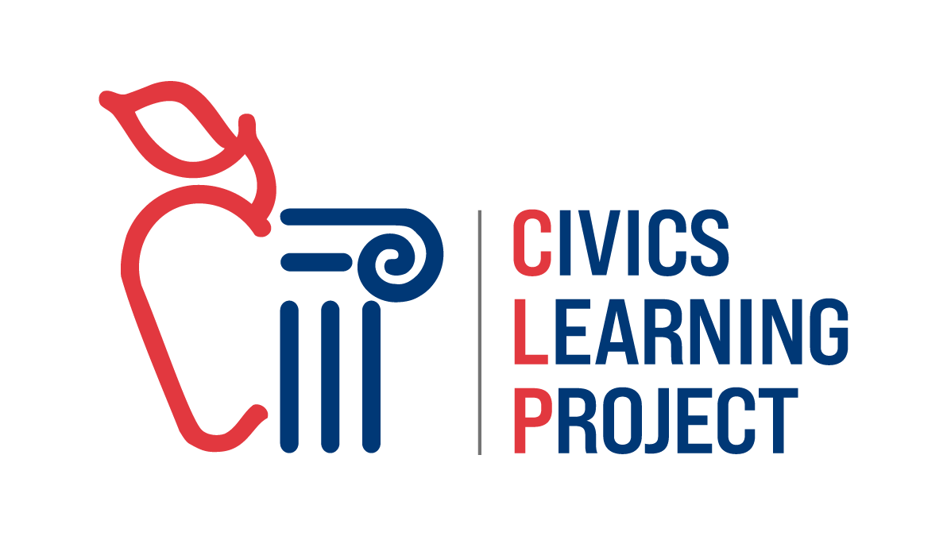

A Guide for Community Action Projects

Authentic Student Civic Engagement

Independent Learning Approach

Version updated: March 6, 2025

Table of Contents

Overview 3
Lesson Plan 4-13
The Project - Step by Step (graphic) 14
Tips for Teachers 15-16
Oregon Standards Alignments with CAPs 17-18
Student Handouts 19
- Distinguishing Between Policy Solutions and Volunteerism 20-21
- Identify Problems 22-23
- Fist to Five 24
- Problem Pitch 25-26
- Research the Problem 27
- Interview Guidelines 28
- Interview Report Form 29
- Research Notes 30
- Analyze Solutions 31-32
- Is it Constitutional? 33-34
- Choose a Policy Solution 35
- Our Solution Graphic Organizer 36
- Action Plan Checklist 37
- Portfolio Preparation Checklist 38
- Portfolio Evaluation Rating Sheet 39
- Presentation Preparation 40
- Hearing Evaluation Rating Sheet 41
- Project Summary 42
- Student Reflection 43

Overview
Introduction
Community Action Projects is an inquiry-based student action program adapted by the Civics Learning Project from Project Citizen, which was developed by the Center for Civic Education over 30 years ago. Every year thousands of students around the country research and collaborate together to develop new policies around issues that are important to them in their communities. Community Action Projects (CAPs) inspire civic engagement and foster a sense of empowerment and belonging. It is flexible in terms of content and grade level, providing meaningful application of skills for all types of learners. Civics Education Research Lab’s 2024 study showed doing Community Action Projects improved students’ civics content knowledge and skills, civic dispositions like election turnout, and STEM research skills! For support on implementing CAPs in your class, contact Civics Learning Project at programs@civicslearning.org.

The Process
- Students work together to conduct research about important issues in their community
- They choose one of the problems that they think most needs a solution
- Students evaluate the current situation through research and interactions with experts and government officials
- Students identify alternative solutions and weigh advantages and disadvantages of each
- Students then propose one policy solution and develop an action plan
- They document their process, research, and analysis in a portfolio
- Students present their findings and proposals at a simulated hearing to panelists where they are asked questions about their project. These panels can be made up of school staff, community members, stakeholders, or government employees.

Objectives - CAPs ask students to:
- Identify community issues that need government involvement to solve
- Gather and analyze evidence from a variety of sources and points of view
- Distinguish roles of various branches and levels of government
- Develop and evaluate solutions
- Strategize how to bring government attention to an issue and affect action
- Practice collaboration, problem solving, and civic participation
- Present and defend reasoned opinions to community members

Lesson Plan
Time Needed
There are many different ways to fit a Community Action Project into your year. The following are some variations that might work for you:

8 Week “Ideal Setting” Plan:
During school two or more times a week for an hour a day. This can be a combination of teacher-led lessons related to the CAP and student work time.
- Steps 1 & 2: 1-2 days each
- Steps 3 & 4: 2 weeks each
- Steps 5-7: 1 week each
- Step 8: 1 day

8 Week “Homeroom or Club” Plan:
Students meet for 30-45 minutes once or twice a week.
- Steps 1 & 2: 1 meeting each
- Steps 3 & 4: 4 meetings each
- Steps 5-7: 2 meetings each
- Step 8: 1 meeting

For this plan you will need to assign work (research) to the students to do at home. Allow students to work on research and writing during some meeting times. Enlist help from a volunteer, possibly a parent, to help make meeting times more effective.

4 Week “Tight Timeline” Plan:
Students meet every day for 45-60 minute lessons.
- Steps 1-2: 1 day each
- Steps 3-7: 3 weeks total
- Step 8: 1 day

In the “Tight Timeline” plan, you may not be able to contact and get responses back from experts, but you may be able to coordinate some guest speakers.

Regardless of which schedule you pick, plan the hearings early. You may also want to host a school showcase where students can exhibit their work to more than just the panelists. For guidance on how to organize and structure a showcase, contact programs@civicslearning.org.

Materials Needed:
- Tablets or computers with internet access
- Chart Paper
- One Folder or Binder for each group
- Tri-Fold Board (optional)
- Student copies (digital or paper) of the activity sheets provided in this packet:
  - Distinguishing Between Policy Solutions and Volunteerism
  - Identify Problems
  - Fist to Five
  - Problem Pitch
  - Research the Problem
  - Interview Guidelines
  - Interview Report Form
  - Research Notes
  - Analyze Solutions
  - Is it Constitutional?
  - Choose a Policy Solution
  - Our Solution Graphic Organizer
  - Action Plan Checklist
  - Portfolio Preparation Checklist
  - Portfolio Evaluation Rating Sheet
  - Presentation Preparation
  - Hearing Evaluation Rating Sheet
  - Project Summary
  - Student Reflection

Procedures:
The implementation of CAPs will vary depending on readiness of your students, size of your class, and how much assistance you get from other adults. Project based learning goes much smoother if you can recruit a partner teacher, educational assistant, parent, or community volunteers when students have group work time.

START HERE - What is public policy?
- Introduce CAPs to students by telling them they are about to embark on a real world task to improve a situation they care about. Share the graphic on page 14 and review the steps of the
project. Clarify that a community action project is not a volunteering or community service. A community action project requires research, creation of a public policy solution, assembly of a portfolio, and a presentation to a group of panelists.
- Tell students that before they pick a topic they must have a clear understanding of what is public policy. Write this definition on the board: Public policy refers to the use of laws and regulations adopted by the government to solve problems.
- Distribute one copy per student of the Distinguishing Between Policy Solutions and Volunteerism handout. As a whole class, review the first page and check for understand by discussing the following question:
What are the differences between public policy and volunteer action solutions?
- Then in small groups, have the students complete the back side and share out. Once student groups complete, discuss the following as a whole class:
What are the pros and cons of public policy and volunteer action solutions?

NOTE: If you are having students keep their activity sheets, have students place them in their Portfolio Folder in a secure location. Alternatively, you may choose to collect and review the activity sheet as a check for understanding or formative assessment and store it yourself until students are ready to compile their portfolios.

Step 1 - Identify Problems
- As a class, brainstorm problems students care about addressing in their city, county, or state. You or a student can record the responses for all to see on either a board or chart paper.
If your students don’t have much to say yet or aren’t very aware of issues, here are some ways you can stimulate their thinking:

- Bring in members of the community to discuss their organizations and issues they address
- Go on a field trip or virtual field trip of the community to simply observe the environment to identify gaps or problems
- Have students interview others in the community about what problems they observe
- Browse the local news for what issues are being discussed
- Once your students have generated a substantial list (at least 10 problems), have students go up to the board or chart paper and indicate the three topics they most care about by putting a star or tally next to them.
- Break students into smaller groups and distribute the Identify Problems handout.
- Review the example as a class then direct each small group to use the criteria to select and evaluate three issues of their choice from the whole class brainstorm.
NOTE: Students may have different ideas and beliefs of the role of the government and when they should get involved in solving an issue. What some people consider responsible oversight others think of as overreach.
- After each group has finished, have groups compare their findings with another. Have students share what they had in common with the other group.
- It’s now time for students to pick the problem to their CAP. You may need to support students to come to consensus using the Fist to Five method.
  - If you are planning for the whole class to do the same topic, see if you can narrow down to one issue OR have each small group ‘pitch’ the best topic the class should focus on, using the Problem Pitch handout.
  - If you are planning for each group to have their own topics, have each group narrow their list down to one issue.

Step 2 - Research the Problem
True learning happens when students are empowered to explore and solve problems that they care about. Depending on how much research you have

already done in your class, you may need to pre-teach, model, and support students in:
  - Forming a research question
  - Listing keywords that will help an internet search
  - How to use a search engine effectively
  - Finding local news sources
  - Evaluating the quality of a source
  - How to take effective research notes
  - Where to learn about government agencies and non-governmental organizations involved
The Oregon School Library and Information System has an online guide for research projects here: https://secondary.oslis.org/learn-to-research
- Distribute one Research the Problem handout per student and review the steps of research as a class.
- Using the Questions to Explore portion of the page, have students see what they already know and where they should begin their research. You may choose to have them save their responses so they can reflect at the end of the project to see how much they have learned.
- Distribute copies of the Interview Guidelines, Interview Report Form and Research Notes to each student and review as a class. Instruct students to use one form per source to record relevant information they will need when building their portfolios. If a source does not contain useful information, no form is needed. If you are using paper, have a stack of each form available in the classroom throughout the research portion of the project.
Note: Requesting an interview can be intimidating. We recommend recruiting a student to play the interviewee and you model a request by ‘calling them’ using a script such as:

“Good afternoon, is this Commissioner Chavez?”
“Why yes. How can I help you?”
“My name is Franky Jones and I’m a student at Douglas Fir Middle School researching the need for a new landfill in our county. Would you be willing to answer a few questions to help my research?
“Sure thing. I’m about to head into a meeting. Could we talk at another time?”
“Absolutely! I’m even willing to come to your office after school on Wednesdays.”

“Great. I’ll have my assistant arrange this. Expect a message from Janey. Please make sure to bring an adult with you when you come.”
“Wonderful. And I appreciate this so much, Commissioner.”

Afterward, brainstorm with students sample questions they would ask during the interview. You may also want to discuss how to ask follow-up questions for clarification. Remind them to end every interview by thanking the person for their time and asking if they have any recommendations on whom else to speak with.

Step 3 - Analyze Solutions
- Assist your students by giving suggestions where they can find current solutions being proposed by your city, county, or region. Governments have websites with adopted goals, news of recent developments, and other information on what they are working on. If your group is studying a statewide issue, perhaps the Oregon legislature is working on it or recently passed a new law. Their bills can be found here: https://www.oregonlegislature.gov/bills_laws
There may also be existing policy students can learn about from interviews with engaged government officials and organizations.
NOTE: Sometimes, students are innovating a solution where none exists, but this ‘problem’ has occurred somewhere else before. They could identify how other places might have dealt with the same issue.
- Once students have identified at least two existing solution proposals, suggest that they add one of their own creation. This could be a combination of the best parts of other proposals or simply improved implementation and/or funding of existing policies. But, if all great ideas have already been proposed, they can analyze three existing plans instead of adding their own.
- Distribute one copy per group of the Analyze Solutions handout to help them record the advantages and disadvantages of each option. Remind them to consider the fiscal implications of solutions as well as identifying who will be supporters and opponents of their policy proposal.
NOTE: Provide time for students to communicate across groups. Explaining what they are doing to others will help them understand their own work even better and may illuminate parts that need more attention.

- Once students complete the Analyze Solutions handout, it is time for them to determine if their policies are constitutional. Tell students that there is an entire branch of government devoted to interpreting law and ruling on the constitutionality of policies. This is a good time to show the students that there is a state constitution as well as a federal one!
Here are both:
Oregon’s Constitution: https://www.oregonlegislature.gov/bills_laws/Pages/OrConst.aspx
US Constitution:
https://constitutioncenter.org/the-constitution
- Distribute one Is it Constitutional? activity sheet per group for students to evaluate the constitutionality of their policy solutions. Once students have fully analyzed the three policy solutions, it’s time for the group to come to consensus on what policy to move forward with.

Step 4 - Choose a Policy Solution
- Distribute one copy of Choose a Policy Solution handout to each group. Some student groups may find they easily come to a full
consensus on what solution makes the most sense. Other groups, however, may need to deliberate and debate for a while before agreeing on one solution. Refer to the Fist to Five method, if students are having trouble deciding.
- Once decided, distribute the Our Solution Graphic Organizer to each group to complete. Meet with each group to review before giving them the green light to develop an action plan.

Step 5 - Develop an Action Plan
- Distribute one copy of the Action Plan Checklist to each group and review the process with the whole class. Show examples of persuasive Op-Eds from the newspaper, newsletters from interest groups, or video clips of public testimony.
- Allow the groups work time to brainstorm how to get their message out, to whom they need to get information, and which agencies hold hearings to take public testimony.
- During this phase of the CAPs, take time to teach components of writing and delivering a persuasive speech. This will come in handy for

their panel presentation later, but also for thinking through the language to use in their Action Plan.

Step 6 - Assemble the Portfolio
The inquiry part of the project is done. It’s now time to organize all the artifacts into a portfolio. Decide if you want students to use a binder or a digital platform. Either way, show and go through a finished portfolio with them as a model. There are usually some examples posted here: https://civiced.org/project-citizen/portfolios
- Distribute one copy per group the Portfolio Preparation Checklist and the Portfolio Evaluation Rating Sheet to guide the assembly of their work. You may have to pre teach tech skills if you are using a digital portfolio.
NOTE: You may want to recruit your media specialist to assist students creating a digital portfolio. If you chose the paper portfolio, you will need to provide students with binders, tabs for sections, and a way to print.
- Allow group work time and monitor students so all members are contributing effort.
- Once groups think they are finished, have them peer edit each other’s portfolios using a copy of the Portfolio Evaluation Rating Sheet. Tell students this is not an evaluation of the work quality, but is an opportunity to help their peers identify missing or incomplete parts.

Step 7 - Present at the Hearing
- Set a date for your hearings and arrange for school or community members to act as panelists. If you plan on holding the hearing in a different room, don’t forget to reserve it! Hand or email panelists the Overview page (from the beginning of this packet) when you invite them, so they know what to expect. You may also decide to provide the evaluation sheets ahead of time and coach them on providing constructive feedback.
- In class, distribute and review one Presentation Preparation handout as well as one Hearing Evaluation Rating Sheet per student. Review with the class. Stress the importance of all group members contributing to the presentation and being present on the hearing date.

- Hand each group a Project Summary sheet to fill out. This should help them distill the whole CAP into the most important parts to convey in the presentation. We recommend students hand a copy of the Project Summary sheet to each panelist at the start of the hearing.
- Revisit the elements of persuasive speaking from the lessons you did during the Action Plan stage.
- Coach students on public speaking essentials like eye contact, volume, pace, enunciation, and pronunciation. Though they may refer to their slides or text during the hearings, they should not be reading to the panel. Knowing their material will help them speak more naturally and be able to respond to questions.
- Plan at least one dress rehearsal for each group where you can give them tips on what additional information to provide or how to summarize parts that are too long. Allow classmates to ask questions to help them prepare responses.
- On the day of the hearings, have a trusted student escort panelists to the hearing room. Provide copies of the evaluation sheets to the panelists and remind them of time limits, the order of go, and what to be listening for.
- After the hearings, if there are particular middle or high school projects that were stellar, consider submitting them to our state showcase! The best projects from Oregon will then be eligible for national consideration and may win recognition! You can find more information about the state showcase on our website, www.civicslearning.org.

Step 8 - Reflect
- The process of doing CAPs is even more important than the final product. Distribute one copy of the Student Reflection handout to each student. Give every student quiet time to individually reflect on their experiences in this process. We do this work for the lasting impact it could have on student participation in shaping society and engaging in community.

Assessment
- Each of the student activity sheets serves as a formative assessment while portfolios and hearing presentations are summative assessments.

It is up to you to decide what to include for grading purposes versus what to review for feedback only.
- You may choose to use the Portfolio Evaluation Rating Sheet to do an internal evaluation yourself rather than having the panelists score the
Portfolio and/or the hearing. If you have a partner teacher implementing CAPs in their class, you may want to trade portfolios and grade their students’ work.
- For the hearings, you may have the opportunity to watch them all and score them yourself. Otherwise, you can decide how to use the panelist scores in the assessment formula.

Help
More resources, activities, and teacher supports can be found at the Center for Civic Education’s Project Citizen website:
- Resources: https://civiced.org/pc2/resources#type
- Webinars for teachers: https://civiced.org/project-citizen-curriculum-in-focus
- Resources in Spanish in the Level 1, 3rd edition materials: https://civiced.org/project-citizen/resources
The Project – Step by Step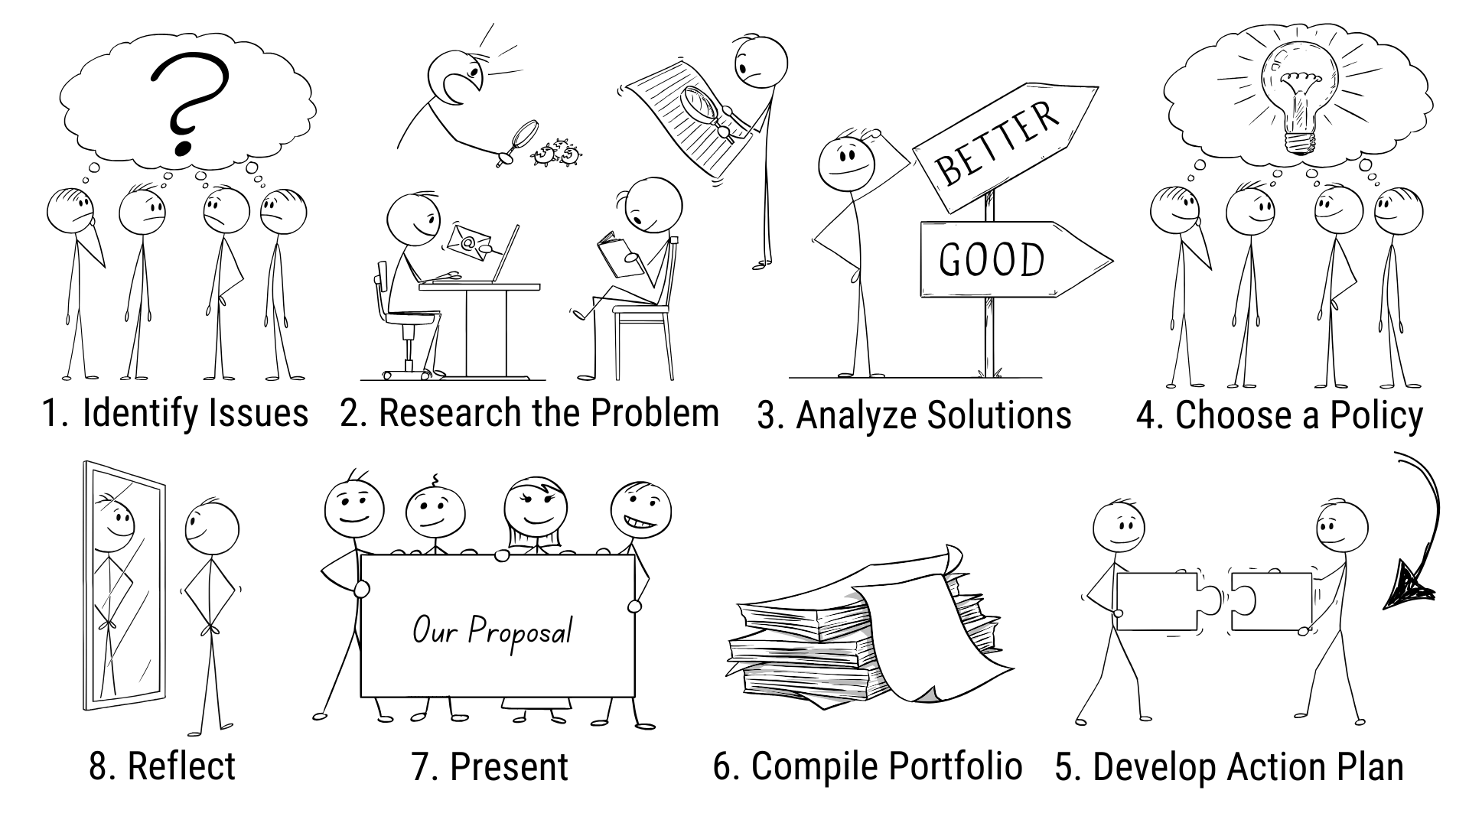

Tips for Teachers
- Make it student-centered: Having students choose and investigate a problem they want to address ensures they will be more invested in the project. Your job is to facilitate, be a sounding board, and provide guidance and suggestions as needed.

- Assist in source evaluation: Model media literacy skills like lateral reading and source analysis, so students can focus on quality information and not be relying on poor but persuasive content. You may choose to curate some sources for them to get started with some context and basic facts. We like News Literacy Project’s materials like this infographic called Is it Legit?

- Advise: Meet with each group often. You will likely need to coach them on narrowing their question or asking more specific research questions, assisting them identify agencies and non-governmental organizations involved in the issue. Also, students usually need someone to ask: Who is going to pay for that? Who would be doing the work? What makes this the best course of action?

- Recruit: Extra adults in the room can be helpful. If you can find some parents or volunteers from the community who are either experienced working with teens or experienced in the topic, it will help you keep all the student groups working effectively. Student teachers, educational assistants, and even admin can help. Also, library media specialists are excellent guests to invite in for the research portion. Speech and debate, drama, or mock trial coaches could be helpful in getting kids ready to present.

- Check for Understanding: Frequently assess where each student and group is at. Decide which parts of the project you will be giving feedback on and what you expect from each student, then let them know. You can also decide which parts to put in the gradebook and which are just part of the preparation. Prepare for absences and intervene when work imbalance happens in the student groups.

- Teach: In between student work times, you can teach content and skills they will need for the project itself. For example, you can display some data and model how you wonder aloud about sample size, survey questions used, and location of data collection. You could model integrating quotes from expert sources into a summary paragraph. Perhaps students also need to learn how to brainstorm keywords to use when using a search engine and how to sort findings.

- Make contact early. Start contacting community members, local civic leaders, experts, etc., as early as possible in the process. Correspondence with public officials can take some time. Be sure to help students brainstorm their contact list early enough that students will have time to include the interviews or email responses in their portfolio. Experts can also steer them toward excellent data and existing policy as well as other agencies and groups involved.

- Portfolio. Every CAPs needs a portfolio. Portfolios can be in a binder or digital. Teach students to carefully evaluate, summarize, and select sources for their portfolio. Evidence should be authentic, from your community, and associated with the problem. Surveys, interviews, and local media can be included. As students complete the activity sheets of this project, make sure their work is stored securely until time to compile portfolios. You may be collecting each piece as you go, or having them keep it all until the end, when they submit the final portfolio.

- Practice, practice, practice. Once they have made a portfolio, students can put the most important aspects of their portfolio into presentation slides or poster boards to use as visuals. This will help the audience understand their project better and will keep the presentation flowing when students get nervous. Have students practice their presentation as often as possible with each practice audience asking follow-up questions. Not only will this help students identify parts of the presentation that need fleshing out, they will become more comfortable and knowledgeable about what they are trying to convey.

Oregon Standards Relevant to Community Action Projects

✓ CAPs meet state standards for civics, social studies analysis, language arts skills, and other standards specific to the topic students may choose for their policy.

2024 Social Studies - High School
Essential Disciplinary Practices
I. Develop questions for social science inquiry.
III. Collect, interpret, evaluate, and apply information from primary and secondary sources to better understand and create historical narrative distinguishing between fact and opinion.
IV. Seek and analyze diverse perspectives to develop a more complete understanding of past and current events.
VI. Construct well-reasoned and logically coherent explanations, arguments, and solutions related to complex societal issues.
IX. Develop the necessary skills to critically analyze and evaluate digital and social media content, identify reliable sources, and become more informed and responsible digital citizens.
X. Apply the practices and knowledge of social science to determine the most effective ways to take informed civic action.
Civics
HS.C.PI.3 Examine and compare institutions, functions, and processes of government.
HS.C.DP.13 Argue and defend positions on contemporary issues in which foundational ideas or values are in tension.
HS.C.CE.17 Explain how active citizens and political or social movements can affect the lawmaking process locally, nationally, and internationally.
HS.C.CE.19 Compare the debate over a public policy issue from the past with a contemporary issue and evaluate the role of political parties, interest groups, social movements, and media in influencing public opinion.

2019 Language Arts - High School
Reading
9-10.RI.8 Delineate and evaluate the argument and specific claims in a text, assessing whether the reasoning is valid and the evidence is relevant and sufficient; identify false statements and fallacious reasoning.
11-12.RI.8 Delineate and evaluate the reasoning in works of public advocacy, including the application of constitutional principles and use of legal reasoning and the premises, purposes, and arguments.*

Writing
9-10.W.2a Introduce a topic; organize complex ideas, concepts, and information to make important connections and distinctions; include formatting, graphics, and multimedia when useful in aiding comprehension.*
9-10.W.2b Develop the topic with well-chosen, relevant, and sufficient facts, extended definitions, concrete details, quotations, or other information and examples.*
9-10.W.2c Use appropriate and varied transitions to link the major sections of the text, create cohesion, and clarify the relationships among complex ideas and concepts.
9-10.W.2d Use precise language and domain-specific vocabulary to manage the complexity of the topic.
9-10.W.2e Establish a style and tone relevant to the discipline in which they are writing.*
9-10.W.2f Provide a concluding statement or section that follows from and supports the information or explanation presented.*
9-10.W.7 Conduct short as well as more comprehensive research projects to answer a question (including a self-generated question) or solve a problem; narrow or broaden the inquiry when appropriate; synthesize multiple sources on the subject, demonstrating understanding of the subject under investigation.
11-12.W.1 Write arguments to support claims in an analysis of substantive topics or texts, using valid reasoning and relevant and sufficient evidence.
11-12.W.7 Conduct short as well as more sustained research projects to answer a question (including a self-generated question) or solve a problem; narrow or broaden the inquiry when appropriate; synthesize multiple sources on the subject, demonstrating understanding of the subject under investigation.
Speaking and Listening
9-10.SL.1d Respond thoughtfully to diverse perspectives, summarize points of agreement and disagreement, and, when warranted, qualify or justify their own views and understanding and make new connections in light of the evidence and reasoning presented.
9-10.SL.4 Present information, findings, and supporting evidence clearly, concisely, and logically, so listeners can follow the line of reasoning; ensure that the organization, development, substance, and style are appropriate to purpose, audience, and task.*
11-12.SL.1b Work with peers to promote civil, democratic discussions and decision-making, set clear goals and deadlines, and establish individual roles as needed.
11-12.SL.2 Integrate multiple sources of information presented in diverse formats and media in order to make informed decisions and solve problems, evaluating the credibility and accuracy of each source and noting any discrepancies among the data.*

Student Activity Sheets

Distinguishing Between Policy Solutions and Volunteerism

Public policy refers to the use of laws and regulations adopted by the government to solve problems.

Your first task in CAPs is to firmly establish that the problem you want to work on is, in fact, one which requires government involvement to reach a solution. Before you do that, practice distinguishing between longer-term policy solutions by a government agency and smaller-scale or shorter-term volunteer responses from members of the public.
Examples:
Public Policy Solution | Community Problem | Volunteer Action
Oregon’s state legislature expands its education budget to include free school lunch for any student. | Many Oregon families don’t have money for groceries, especially by the end of the month. | Members of a local church host a town-wide canned food drive and deliver to families in need each November.
The school district hires extra bus drivers to do an activities route to get kids home later in the afternoon. | Some students who stay after school for sports or activities don’t have transportation home. | Parents organize a carpool to get kids home after sports and clubs end.
The County Health Department establishes a senior fall response service to take the burden off first responders. | Emergency responders (9-1-1 dispatch, fire, EMS) are not able to respond to major emergencies when they are routinely called to help with elderly folks who fall at home. | Meals on Wheels adds ‘pick up’ to their ‘drop off’ and recruits strong folk to volunteer to staff the program to respond to falls.
The Irrigation District introduces a ballot measure so voters can decide about raising taxes to fund a grant program for farmers to install efficient irrigation systems. | Drought is making it harder for farmers to irrigate their fields. There’s not enough water to go around. | The Future Farmers of America youth group installs water conservation equipment.
The Parks Department installs more baggie stations with garbage cans to make clean up more convenient for dog owners. | Dog feces is frequently found on city sidewalks and park trails. | Neighbors sign up for shifts to be on duty, cleaning up their local area.
The State Department of Fish and Wildlife establishes a Keep Oregon’s Rivers Clean program that oversees the collection, recycling, and proper disposal of fishing tackle, including monofilament line, fluorocarbon leaders, lines, lead weights and lures. | Old fishing line on river banks is killing birds and other wildlife who get caught in it. | The ‘river stewards’ volunteers do a once-a-month clean up day of the river banks at popular fishing spots in their area.
Discuss: What are the differences between public policy and volunteer action solutions?

Distinguishing Between Policy Solutions and Volunteerism
Student Name_______________________________

As a class, brainstorm problems in your community. Then, in smaller groups, fill out the left and right columns with potential solutions for both public policy and volunteer action.
Public Policy Solution | Community Problem | Volunteer Action
Discuss: What are the pros and cons of public policy and volunteer action solutions?

Note: It’s ok to start with a topic and realize it won’t work for CAPs. Not every problem can or should be solved with public policy and some ‘solutions’ could violate people’s constitutional rights. However, volunteerism often isn't an adequate fix for problems that need the organization and enforcement of a government. Finding the right issue to focus on is one of the most important steps in your CAPs process.

Identify Problems
Name(s):______________________________________________________________

For each problem you brainstorm, complete the following checklist to see if it would be a good challenge for the group to take on. In order to be a good community problem for us, it should meet all four requirements in the list.

Example:
Issue:
People waste too much money on fancy coffee drinks.

Criteria for a ‘good problem:’ | Yes | No
Does any part of the government have a responsibility to deal with it? |  | X
Is the problem important to the community and our class? | X
Is it a problem that we might be able to solve? |  | X
A good topic for CAPs requires a “yes” for all three criteria.

Students: Now take your top three issues and see if they fit the criteria for CAPs
Issue 1:

Criteria for a ‘good problem:’ | Yes | No
Does any part of the government have a responsibility to deal with it?

Is the problem important to the community and our class?

Is it a problem that we might be able to solve?

Identify Problems

Issue 2:

Criteria for a ‘good problem:’ | Yes | No
Does any part of the government have a responsibility to deal with it?

Is the problem important to the community and our class?

Is it a problem that we might be able to solve?

Issue 3:

Criteria for a ‘good problem:’ | Yes | No
Does any part of the government have a responsibility to deal with it?

Is the problem important to the community and our class?

Is it a problem that we might be able to solve?

Did people in your group disagree on whether or not the government should get involved in the solution? Explain.

Will any of these work for a Community Action Project? If yes, which issue would you like to see your group or the class create a public policy solution for? Explain.

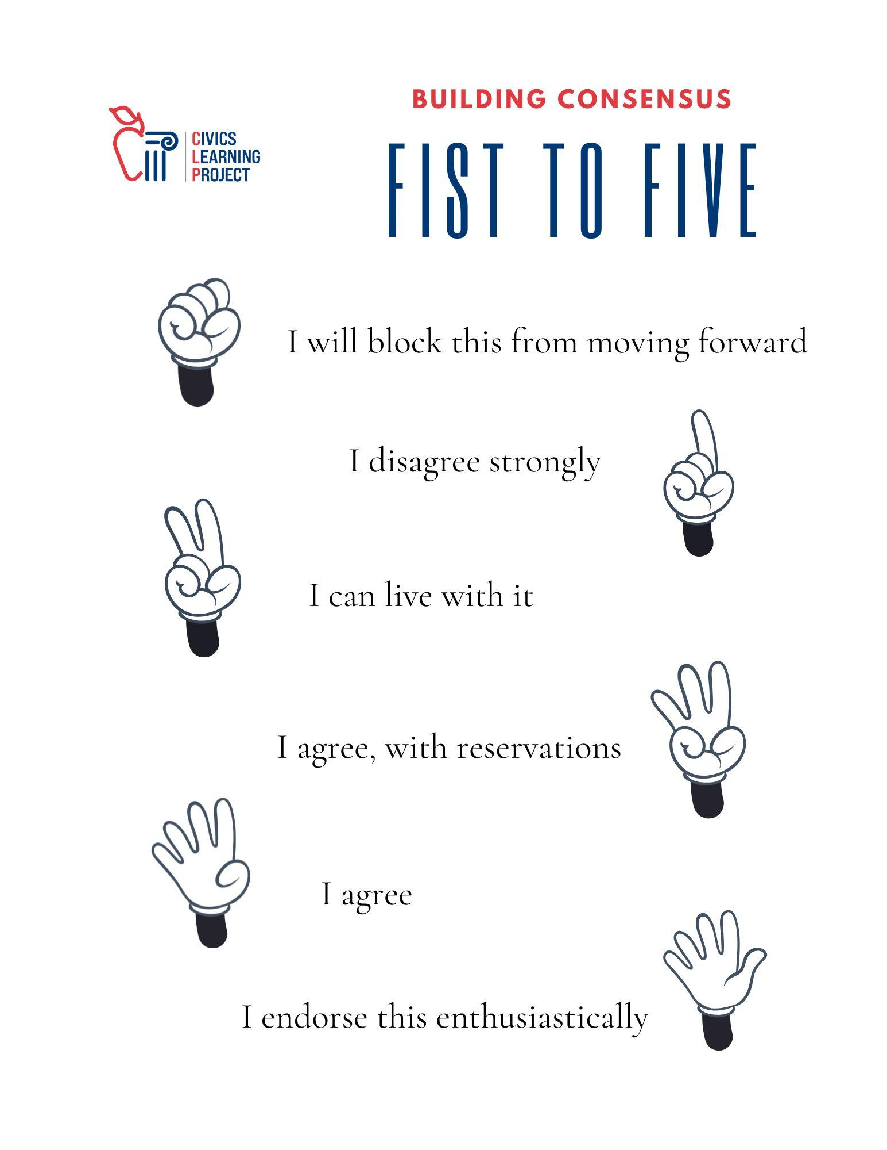
Problem Pitch

Objective: Your group’s task is to convince the class that your problem is the one we should choose for a Community Action Project.

You need to show that:
- this problem is actually a problem
- people care about this issue
- there is evidence this issue is a problem
- this issue falls under the “good problem” criteria:
  - government has a responsibility to deal with it
  - a policy is needed or an existing policy needs improving
  - there is enough information
  - it’s solvable (at least partially)

Collect evidence to prove your problem is a good problem, such as:
- Interviews or surveys with concerned residents, students, parents, school staff, or other community members
- Articles / stories from local newspapers, newsletters, or other news media
- Interviews with scholars, legislators, or judges who work with this issue
- Interviews with non-governmental organizations working on this issue
- Articles that support a similar issue in other places
- Maps that show how your issue is a problem
- Other data collection to support your argument

Presentations should include:
- A visual poster or digital presentation that presents the problem and why it is a “good problem”
- A 1-minute oral presentation that explains and persuades your peers to select your problem for CAPs
- A 5-minute question-answer time: all group members should participate and be prepared to answer questions
- Data sheets or tables with complete labeling

Problem Pitch Rubric

 | 4 | 3 | 2 | 1-0
Evidence | The team did an outstanding job presenting your argument using several pieces of clear, well-documented evidence | The team clearly proved that your issue is a problem using evidence (interviews, surveys, etc.) | The team made some good points to support your argument. Much of the argument was supported by some evidence. | The team made a few good points to support your argument. There is little or no evidence to support your argument.
Teamwork | Team members communicated regularly to create a comprehensive group approach | Team members communicated well to create a group plan and share work | Some effort was made for group members to communicate and create a plan | Little or no effort was made for decisions to be discussed or made as a group
Presentation | The presentation was outstanding, tremendously persuasive, and all members took part | Team members all presented and made a good argument for your problem | The presentation was adequate and the argument was mostly clear. Most members participated. | The argument was not clear or not persuasive. Only a few members participated.
Documentation | The team handed in several well-constructed, easy to read documents. The documents serve as further evidence to support your argument. | The team handed in all needed documentation for your work. Documents are neat and complete. | The team handed in most of the needed documents. The documents are mostly neat and complete. | The team handed in few or no documents. The documents are messy, hard to understand, or incomplete.

Research The Problem
Names: ___________________________________________________________
Research Guide
The Oregon School Library and Information System has an online guide for research projects here: https://secondary.oslis.org/learn-to-research

Steps of Research
Your group will:
- Explore the broader problem
- Narrow your search to a single research question
- Identify key words to use in your research
- Learn the context of the problem (what, where, when, why, who, how)
- Develop a list of potential sources
- Conduct interviews, make phone calls, read articles, editorials, and studies
- Take notes on what you learn and which source you learned it from
- Revisit your research question and revise it if needed
- Generate questions you still have
- Analyze your findings

Questions to Explore:
WHAT? What is going wrong? How serious is it for the community? How concerned are people about the problem?

WHERE? What is the geographic extent of this issue? Is it growing or shrinking?

WHEN? Is this new or has it been ongoing? When did it start or start to get worse? What is expected to happen in the future if nothing is done?

WHY? What are the root causes of the problem? Why is this still a problem?

WHO? Who does this issue most affect? How many people are affected by it? In what ways are they affected? Who are the people working to solve this problem? Are there any folks who think this isn’t a problem?

HOW? Which level of government (federal, state, local) is best suited to solve it? Which agencies should be involved? Which non-governmental organizations should be involved or are already? Are there disagreements about the way this problem is being handled? Is there already an existing law or policy around this issue? If so, why isn’t it adequate to solve the problem?

Interview Guidelines
As a group, brainstorm a list of 3 - 5 people or roles you’d like to interview.

Interview Procedures
- Once you have found possible sources, call them and ask if you can setup an interview.
“Hello. My name is ____________________. I am a student at ___________________________ working on a policy project for __________________________. We are studying local problems, possible policy solutions, and how people can participate in their community. I am interested in learning more about ____________________________. Would you be willing to be interviewed?
- Once you have an interview scheduled, make a list of questions for that person.
- Before you start the interview, introduce yourself and explain the problem you are researching.
“Thank you so much for meeting with me. Again, my name is _________________ and I am studying ______________________ for my class at __________________________. I have a few questions for you.”
- Ask your questions.
- Listen carefully during the interview and record your notes on the Interview Report Form. If you take notes while the interview is happening, remember not to write the whole time. It's important to look at the person you are talking to. You can take short pauses to write down important things and then return to the conversation. If you want, you can also ask if you can record the conversation.
- End the interview by thanking the person for their time and asking if they have any recommendations on who else to speak with or where to find additional information.

As a group, write down potential interview questions:
Interview Report Form
Use one form per interview.
Name(s) _______________________________________________

Date and location of interview:

Name and role:

What is this person’s connection with the issue?

Position on the issue:

Key Takeaways:

Recommendations for who else to speak with or where to find more information:

Research Notes
Use one of these for each quality source.

Name(s): _____________________________________

Source Information:
Author(s): | Title:
Publisher: | Volume/chapter/page:
Date published: | Date accessed:

Notes on what we learned from this source that helps us answer our research question:

Analyze Solutions
Name(s): _____________________________________
When searching for policy solutions, you might find:
- Proposals that have been suggested by different political parties or interest groups
- Bills put forward by elected officials
- Policy ideas put forth in speeches or editorials by elected officials or community members
- Current policies in other towns, cities, states, or countries
- Proposals generated by your group or class
- An existing policy that hasn’t been implemented or funded
Of all the solutions you find, pick the three your group likes best and analyze them below:

Alternative #1
Policy Name/Title: | Description:
Advantages: | Disadvantages:
Supporters: | Opponents:

Analyze Solutions
Alternative #2
Policy Name/Title: | Description:
Advantages: | Disadvantages:
Supporters: | Opponents:

Alternative #3
Policy Name/Title: | Description:
Advantages: | Disadvantages:
Supporters | Opponents:
Is it Constitutional?
Name(s): _____________________________________________________
Who decides if a policy is constitutional?
Generally, the courts weigh the responsibility of governments to fulfill their duties and the rights inherent and retained by the people and the states. Governments have ‘police powers’ to protect health, safety, and the general welfare of the public. In other words, governments provide ‘law and order.’ However, the people retain basic rights like life, liberty, and property. If a policy is designed to protect it is allowed to infringe on a person’s right, if it’s considered constitutional by the courts and isn’t excessive.
Example of balancing freedom and order
You may think you have the right to leave trash all over your own property. However, Oregon law ORS 164.805 prohibits this if it produces a ‘stench,’ ruins the ‘beauty,’ or interferes with the ‘natural cleanliness and safety.’ Therefore, a person can be fined for not taking care of garbage on their property. The penalties increase with the amount and severity of the trash and proximity to water.

Goals of the Constitution of 1787
A preamble is an introduction that states the goals of a document. What are the general goals of the 1787 Constitution according to its preamble? This source can help you: https://constitutioncenter.org/the-constitution/preamble/interpretations/37

Which of these goals best relates to the problem you are focusing on with your CAP?

Bill of Rights
Shortly after the Constitution was approved, the first Congress proposed some amendments to clarify what the government could not do and what rights the people and the states had. Looking at the first ten amendments, list some of these restrictions on government power:
The government cannot:

Do any of the solutions to your project problem violate these individual rights?

Is it Constitutional?
Just Compensation
If the government needs to take someone’s private property for the benefit of the group, the 5th amendment requires ‘just compensation.’ In other words, you have to pay them a fair price.
Example of a ‘takings’ which requires ‘just compensation’
The city needs to build a bridge for the railroad so traffic doesn’t keep getting backed up whenever the train comes through. You live right next to the site where the bridge will be built. Your big yard is about to become a smaller yard (a ‘takings’), so you will be paid for your loss (compensation).
Do any of the CAPs solutions require the government to use or take someone’s private property?

Equal Protection Clause
One of the most important additions is when the 14th amendment gave “the equal protection of the laws” to “ to any person within [any State’s] jurisdiction.”
Would any of the policy options in your CAP create an unequal application of the law?

State Laws
The Tenth Amendment added this reminder that even though the national government is supreme, there are things not specifically assigned to the US government, nor forbidden by it that states can do. This amendment clarifies that states can make their own laws, in addition to US laws. Every state even has its own constitution.
Example of an Oregon-specific law
In Oregon, the public has access to the entire coastline from the water to the vegetation line. This is not the case in all states.
Are you aware of any Oregon state law that your proposed solution would violate?.

Choose a Policy Solution

You must now come to agreement on the final direction of your policy project. In deciding which solution to pursue, you may:
- Support one of the alternative policies above
- Modify one of those policies
- Combine aspects of several of the alternatives, or
- Develop an entirely new public policy solution

Steps:
- Have each member of your group share what policy or parts of policies they like and why. Then, as a group, come to a consensus and determine which policy you want to move forward with and present.
- Discuss in order to build consensus to determine your group’s policy solution for the problem. Consensus-building is about picking something everyone can live with. This is different from majoritarian voting where minority opinions lose entirely.
- Finalize the chosen policy solution using the form below.

Our Solution Graphic Organizer
Name(s): _____________________________________________________
Summarize your policy solution in 5 sentences or less:

Title/Name of your Policy: | List of sources where you got the ideas for this policy:
What level of government is involved? Name the agencies. | List of sources where you got the ideas for this policy:
What are the advantages of this policy? | What are some disadvantages?
Why are you confident this policy is a good solution to our problem?

Action Plan Checklist

Implementation - The Action Plan
Think through and discuss how your group can get your proposal to come to fruition. Consider:
- How will you get the appropriate government entity to support the policy?
- Will there be a hearing and a vote needed by any agency or does it already fall into their scope of work?
- How will this project be funded?
  - Are there already agencies involved with this kind of work budgeted for or would they have to allocate new money?
- Will you have an educational campaign for the general public?
  - How will you convince likely supporters?
  - How will you convince the opposition?

Formalize the steps to your plan by calendaring them out.

Example:
Neighborhood Beehive Project Action Plan Calendar
May 1st - Gather interested parties to form an action team at a kick-off party at Hollinshead Park. Pick team leaders for subcommittees:
- Government relations team
- Media team
- Canvassing team
- Treasurer

May 10 - Subcommittees meet to schedule work

June 1 - Media team sends out press release to local media and does follow up interviews

June 3 - Canvassing team starts taking Bee Nice flyers door to door

June 7 - Media team meets with local agricultural co-op and tables at farmers’ market

June 15 - All member check in meeting with status reports

July 1 - Media team has booth at farmers’ market

July 15 - All neighborhoods canvas deadline

August 1 - Gov. Relations team testifies at City Council hearing on neighborhood associations and makes policy pitch. Treasurer gives a report of donations gathered to launch the first hive in Orchard District. Request for City to match donations to establish the next hive.

Portfolio Preparation Checklist
A portfolio demonstrates all the work you do as a group. It is a way to display and explain the policy solution you worked so hard to develop. You can use a binder or a digital folder to organize your documentation. The portfolio sections should be sequential as follows:

Introduction:
- Cover Page with names of students, teacher, and school
- Table of Contents with page numbers

The Problem:
- Summary of problem and explanation of existing policies and why they aren’t sufficient
- Graphics that support summary
- Problem identification form
- Include Evidence:
  - Interview report forms
  - Research notes
  - Printed sources that were useful
- Sources cited list

Alternative Policy Options:
- Summary of alternative policy solutions (with advantages & disadvantages)
- Graphics that support the text
- Analyzing Solutions form
- Sources cited list

Our Policy Solution:
- Narrative of your chosen policy
- Budget estimates - identify both costs and sources of funding
- Advantages and disadvantages
- Level of government responsible for approval and implementation
- Our Solution Graphic Organizer
- Is it Constitutional? form
- Source cited list

Our Action Plan:
- Narrative of strategies to gain support from:
  - Individuals impacted or interested
  - Groups impacted or interested
  - Government necessary for approval, funding, implementation
- Graphics and other media we would use to pitch our proposal presentation

Reflection:
- Student Reflection form for each member of the group
- Acknowledgement for people who helped
Portfolio Evaluation Rating Sheet
Excellent: 9–10 Above Average: 7–8 Average: 5–6 Below Average: 3–4 Insufficient: 1–2
Criteria for Evaluation | Rating | Comments
Panel/Section 1: Understanding the Problem
- States and explains the problem and its causes and presents evidence that there is a problem
- Demonstrates an understanding of issue(s) involved in the problem
- Demonstrates an understanding of existing or proposed public policies
- Explains disagreements about the problem that may exist in the community
- Explains why government should be involved in the solution
Panel/Section 2: Analysis of Alternative Policies
- Presents two or three alternative public policies to address the problem
- Explains advantages and disadvantages of each alternative policy presented
- Identifies controversies and conflicts that may need to be addressed for each alternative
Panel/Section 3: Public Policy Development and Persuasiveness
- States a public policy that addresses the problem and identifies the government branch or agency responsible for enacting their proposed public policy
- Supports their proposed public policy with reasoning and evidence
- Identifies and explains advantages and disadvantages of their proposed public policy
- Explains and supports why their proposed public policy is constitutional
Panel/Section 4: Implementation of an Action Plan
- Identifies individuals and groups, both supporters and opponents, who will need to be influenced
- Identifies government officials, both supporters and opponents, who will need to be influenced
- Outlines and explains an action process for getting their proposed public policy enacted
- Proposes action that builds and expands on evidence presented in previous panels
Overall Portfolio: Extent to which the complete portfolio does the following:
- Presents material in the display and binder that correlate to and support each other
- Constructs a clear and convincing sequence from one panel/section to the next
- Uses and documents research from multiple sources and provides appropriate notation for the sources and research evidence used
- Follows standards of good writing
- Uses relevant and appropriate graphics and written information
- Is visually appealing
- Includes evidence of student reflection that states what students have learned [this appears in Section 5 of the Documentation Binder only.]
TOTAL POINTS AWARDED
Evaluator: Date:

Presentation Preparation
You will present your project to a group of panelists to convince them that there is a problem, that you have researched it thoroughly and that your policy proposal should be implemented. Specifics:

Opening Oral Presentation - 4 minutes
The first four minutes will be when your group presents the most significant information from your portfolio. Make sure to include information from each section. All members of your group need to speak. There are four goals of your presentation:
- To inform an audience of the importance of the problem identified in your community.
- To explain and evaluate the alternative policies so that an audience can understand the advantages and disadvantages of each.
- To discuss your group’s choice as the best policy to address the problem and convince them it is the best solution. To explain that the proposed policy does not violate your federal and state constitutions.
- To demonstrate how your class could develop support for its policy in your community, as well as in the legislative and executive branches of the appropriate level of government.
Tip for success: Do not read to the panelists from your portfolio display. Select the most important information and arguments and present them in a conversational style.

Question and Answer Period - 6 minutes
Be prepared for panelists to ask your group to explain further, give examples, defend some of your points, and share what you learned from your experience.

Checklist for Presentation Visuals:
You may use poster boards or digital slides
- Title of the project, student names, teacher and school
- Titles for each section/panel
- Information included is only the most important from your project
- Government involvement is clear
- Well organized
- Appropriate graphics and pictures
- Attention getting
- Thanks to community supporters who helped
- Sources cited listed at end of slides or on back of posters

Note: Only materials included in your portfolio may be used during the oral presentation.

Hearing Evaluation Rating Sheet

Excellent: 9–10 Above Average: 7–8 Average: 5–6 Below Average: 3–4 Insufficient: 1–2
Criteria for Evaluation | Rating | Comments
Understanding the Problem
- Stated and explained the problem and its causes and presented evidence that there is a problem
- Demonstrated an understanding of issue(s) involved in the problem
- Demonstrated an understanding of existing or proposed public policies
- Explained disagreements about the problem that may exist in the community
- Explained why government should be involved in the solution
Analysis of Alternative Policies
- Presented two or three alternative policies to address the problem
- Explained advantages and disadvantages of each alternative policy presented
- Identified controversies and conflicts that need to be addressed for each alternative
Public Policy Development and Persuasiveness
- Stated a public policy that addresses the problem and identified the government branch or agency responsible for enacting their proposed public policy
- Supported their proposed public policy with reasoning and evidence
- Identified advantages and disadvantages of their proposed public policy
- Explained and supported why their proposed public policy is constitutional
Implementation of an Action Plan
- Identified individuals and groups, both supporters and opponents, who will need to be influenced
- Identified government officials, both supporters and opponents, who will need to be influenced
- Outlined and explained an action process for getting their proposed public policy enacted
- Proposed actions that build and expand on presentations by previous groups
Overall Hearing: Extent to which the entire presentation has:
- Constructed a clear and convincing sequence from one group to the next
- Used and documented research from multiple sources and made reference to sources and research used
- Referenced relevant and appropriate graphics and written information
- Used standards of good oral presentation (pace, projection, articulation, poise, eye contact)
- Shared speaking responsibility while making the presentation
- Included evidence of reflection that states what the students learned
TOTAL POINTS AWARDED

Evaluator: Date:

Project Summary

The Problem | Alternative Policy Options | Our Policy | Our Action Plan
The Problem: | Alternative:  Alternative: | Our Proposed Policy: | Steps we will follow:
Disagreements in the Community: | Issues with these two rejected alternatives: | Agencies involved: | Most important sources used:

Student Reflection

Student Name: _______________________________

Individually, respond to the following questions to reflect on your experience with the project.

    - Based on your own research and review of the alternative policies, which policy did YOU think would be the best choice for a policy solution and why?

    - Did you feel that the process for deciding the chosen policy was fair - why or why not?

    - How has your understanding of the issue you picked changed since the beginning of the project?

    - What skills did you develop as you worked on the project?

    - What did you learn about the government and how it works from this project?

