

Civics Learning Project Presents…

Drug Addiction:
A Town Hall Simulation

In this packet:
- Overview of a Town Hall Meeting Simulation
- Teacher Lesson Plan
- Teacher Resources
- Student Handouts

Last updated: Dec 2, 2024

Civics Learning Project Presents
Drug Addiction:
A Town Hall Simulation

Introduction:
Democracy requires public participation and compromise to solve problems as a community. By simulating a town hall meeting, students will be exposed to the multiple perspectives involved in a complex societal issue. They will identify evidence that best supports each role’s interest and will practice writing and delivering persuasive testimony to a policy workgroup. By researching and then taking on the perspective of those they might not necessarily agree with, students gain a deeper understanding and ability to critically think through one of the most controversial topics in the state. Finally, they will engage in deliberative and direct democracy as they seek a solution.

Objectives of Town Hall Meeting Simulation:
- Students will engage in inquiry to support claims with relevant and quality evidence
- Students will construct and present a compelling argument that represents a particular point of view on a current and complex issue that needs to be addressed
- Students will analyze and articulate various perspectives on drug addiction and treatment needs
- Students will develop and hone listening skills to better understand contrary positions
- Students will identify ways to compromise and collaborate
- Students will broaden their understanding of policy making
- Students will practice a key process in deliberative democracy

Town Hall Simulation Process in Brief:
Day 1
1. Anticipatory Set 10 min
2. Teacher Direct Instruction on Background of Issues: 20 mins
3. Students study background sources: 30 mins
4. Assemble in role groups to read overviews: 5 mins
Day 2
5. Research day to find evidence and write testimony class period
Note: Panel group will do more data study since they will not be writing testimony
Day 3
6. Town Hall Simulation 55 min
Options: Students can either testify as groups, or you could opt for a fishbowl format with only one student per group giving the testimony. If you have multiple adults to help, you could break into several town halls and jigsaw the student groups.
7. Whole Class Debrief: 15 mins
Days 4+
8. Extensions

Oregon Social Studies Standards Addressed

Social Studies Analysis
- 8.34 Analyze how a specific problem can manifest itself at local, regional, and global levels over time, identifying its characteristics and causes, and the challenges and opportunities faced by those trying to address the problem.
- HS.74 Analyze an event, issue, problem, or phenomenon, critiquing and evaluating characteristics, influences, causes, and both short- and long-term effects.
Civics and Government
- HS.8 Examine the institutions, functions, and processes of Oregon’s state, county, local and
- regional governments.

LESSON PREPARATION

Vocabulary to pre-teach:

town hall meeting: public meetings that are open to everyone where government officials invite the people to ask questions, and say what they think about specific problems or policies.

drug addiction: a chronic, relapsing disorder characterized by compulsive drug seeking and use despite adverse consequences. It is considered a brain disorder, because it involves functional changes to brain circuits involved in reward, stress, and self-control. Those changes may last a long time after a person has stopped taking drugs.

decriminalization: the removal of criminal penalties for law violations

punitive: inflicting, involving, or aiming at punishment

harm reduction: a range of intentional practices and public health policies designed to lessen the negative social and/or physical consequences associated with various human behaviors, both legal and illegal.

controlled substance: is generally a drug or chemical whose manufacture, possession, or use is regulated by a government, such as illicitly used drugs or prescription medications that are designated by law.

drug schedule: drugs and other substances that are considered controlled substances under the Controlled Substances Act (CSA) are classified into five ‘schedules’ based on the drug’s medical usefulness and how addictive it is.

Skills to pre-teach:
Media literacy and best research practices should be pre taught before the inquiry component. CLP’s Current Events page can help. Also check that students understand rhetorical structure and devices for persuasion, oral delivery techniques. See Claim-Evidence-Reasoning resource.

Instructional Materials
- Hard copies of roles for each student present.
- Access to internet-connected tablets or laptops for overview preloading and for inquiry part of lesson.
- Big enough space to comfortably fit all students and allow them to all see each other.
Initial Teacher-Led Discussion:
Inform students that the goal of this activity is to be able to analyze and articulate various perspectives on how to treat drug addiction and that this is not an attempt by the teacher to advocate for a certain position on a specific issue. Rather, you as the teacher hope students will see:
- There is no easy solution or it would have already been implemented
- Roles of governments, medical professionals, and service providers in assisting with the solution
- The difference between vision and implementation when it comes to policy work
- The need to adapt to changing circumstances like the prevalence of fentanyl

LESSON PROCEDURES

Anticipatory Set/Motivation/Hook, Time: 10 min start of Day 1
Teacher introduces a silent brainstorm for students to do in writing.
Brainstorm prompt: What are all the possible reasons a person might end up addicted to illegal drugs? Then, what are all the impacts of drug addiction on the individual, their families, their communities, and the country as a whole?

Focused Instruction (Teacher-as-Model), Time: Rest of class period Day 1

- Teacher introduces scenario:
Your county’s commissioners are attempting to address a host of challenges related to the problem of drug addiction in your community. Although some of these problems are similar in every area of the state, there are aspects of the issues unique to your region. Oregon voters decriminalized many formerly illegal drugs in hopes of getting people treatment rather than punishment. This approach has had mixed results, and Oregon captured the attention of the whole country with this experiment. Citizens are demanding action to fix the current state crisis. In an attempt to respond to the desires of the populace, the commissioners want public input to the question:

How should our community respond to drug addiction?

- Teacher walks students through source review via direct instruction of the issue, the background history and how federal and state law works regarding drug possession, distribution, and addiction. Teacher identifies multiple government agencies at the tribal, local, state, and federal levels to show the complexity of a federalist system. See teacher resource below.

Guided Instruction (Teacher-to-Student Joint Responsibility), Time: First 10 min period for Day 2

Teacher hands out roles to students for them to read role sheets. Give instructions on students brainstorming what information could support the role’s point of view and give them time to conduct research to find data. Students read roles. Teacher identifies how students are to conduct research and how to record their findings.
Note** Teachers do not have to use all the roles if they would like to pick and choose to shorten or simplify the town hall meeting.

Group Application (Student-to-Student Joint Responsibility)

Part I, Time: Day 2, 25 min, 35 min
Students work in groups to find evidence that supports their role’s point of view and fill out the student handout called Testimony Preparation. Then students work in groups during the second half of the period to write their role’s testimony. Teacher can decide if this will be a fish bowl with one student per group doing the oral testimony presentation or run multiple town halls simultaneously, jigsaw style in the room. Also, teacher can decide if any students will act as the decision makers afterwards or if the class will follow up with a consensus building style discussion like a Socratic seminar.

Part II, Time: Day 3, 55 min
Teacher Does/Students Do: Teacher gives instructions on how the town hall will run (either one or multiple simultaneously) and the order of go. Students who are listening should have some form of evaluation (rubric) or note taking sheet to respond in writing with as they are receiving the testimony. What teacher plans next will determine what the students should be doing.
Options: Students can either testify as groups, or you could opt for a fishbowl format with only one student per group giving the testimony. If you have multiple adults to help, you could break into several town halls and jigsaw the student groups.

Closure, Time: Day 3, 20 min
Teacher Does/Students Do: Have a debriefing discussion to hear how students’ understanding of the issue changed from doing the town hall meeting. How did their views expand as a result?

ASSESSMENTS

Formative Assessment(s)
Student written and oral testimonies from each role. Students use the rubric to score each other’s presentations.
Summative Assessment(s)
This is entirely up to teacher discretion. We recommend convening the students to work toward consensus on a policy solution as a group. Looking for common ground and a ‘next step’ solution everyone can live with is powerful direct and deliberative democracy practice. Make sure the discussion is collaborative, building toward consensus, rather than antagonistic. Their proposal could even be presented to elected officials!
This can lead to any of the following extensions:
- individual student position papers
- op ed to local newspaper
- make a video PSA for the public
- host a panel of professionals in the classroom
- attend a real town hall in the community and provide testimony
- propose policy to decision makers

Learning Supports
Accessibility: Teacher projector to display all the preloading information plus student devices for inquiry. Keyboards for ease of typing, speech to text apps to make writing the testimony more accessible.

Cultural & Linguistic Responsiveness: Depending on your student group, you may need to teach the academic vocabulary in addition to the topic terminology. Also, a student group that has not worked much in persuasive speaking and writing could use some instruction on rhetorical methods and devices.

Differentiation: Teachers could do a more scripted town hall to practice delivering testimony on one topic before diving into a more inquiry approach where they write their own testimony in a second. Some students may need help identifying good sources for the inquiry piece. A teacher could provide some resources. What comes after the town hall could be very in-depth, real-life policy making like a Community Action Project with students proposing policy to actual stakeholders. Students could do a community education campaign to spread awareness of drug treatment options. The sky’s the limit!

Socio-emotional supports: Preteach the importance of representing the role respectfully and not exaggerating the dramatic performance. Continually remind students that the point of the lesson is to broaden understanding of multiple perspectives and the complexity of solving a problem with so many stakeholders, not to have any particular point of view win an argument.

Also, students in the room are living the reality of this societal problem. Everyone needs to be mindful of their words.
Teacher Resource 1: Drug Regulation and Federalism

Federalism is a system where power is shared between national and regional governments. There are over 90,000 governments in the USA because of all the layers!
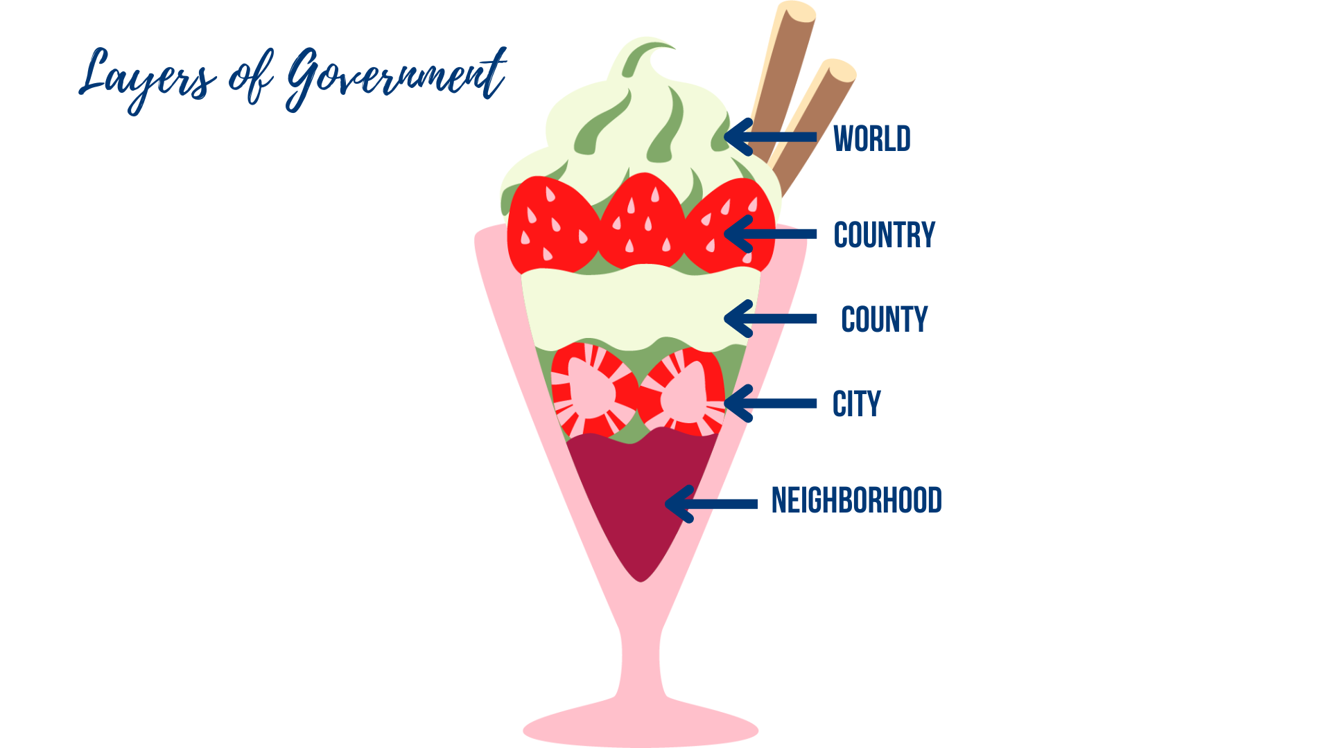
When it comes to regulating drugs and drug use, there are many many agencies involved. Here are some:

Country Level: USA’s Federal/National Agencies

ONDCP: The Office Of National Drug Control Policy leads and coordinates the nation’s drug policy. ONDCP is responsible for the development and implementation of the National Drug Control Strategy and Budget and coordinates across 19 federal agencies and oversees a $41 billion budget as part of a whole-of-government approach to addressing addiction and the overdose epidemic.

FDA: The U.S. Food and Drug Administration is the federal agency responsible for labeling medications and supplements. The FDA must regulate and approve new prescription drugs before they can be sold to the public.

HHS: The Department of Health and Human Services is the agency that can delete, add, or alter the classification of a drug. So, if something is more dangerous than originally thought or more useful than originally thought, they can change its status.

DEA: The Drug Enforcement Agency is a United States federal law enforcement agency under the U.S. Department of Justice that tries to stop drug trafficking and distribution in the US. Its mission is to ensure the safety and health of American communities by combating criminal drug networks bringing harm, violence, overdoses, and poisonings to the United States. Other federal law enforcement agencies that deal with illegal drugs: Federal Bureau of Investigation (FBI), The US Customs Border Protection (CBP), US Immigration and Customs Enforcement (ICE).

State Level: Oregon’s State Agencies

OHS: Oregon Health Authority has a public health division that works to reduce harms associated with substance use.

BHS: Behavioral Health Services Oversees ​​many addiction services resources and programs and is responsible for including drug treatment and recovery services in Oregon counties.

ADPC: The Alcohol and Drug Policy Commission is an independent state government agency that was created by the Oregon Legislature to improve the effectiveness and efficiency of state and local Substance Use Disorder (SUD) prevention, treatment and recovery services for all Oregonians.

OSP: Oregon State Police is the state law enforcement agency and has a Drug Enforcement Section.

County Level: Every county in Oregon has a…

Sheriff's Department to provide law enforcement in your county

Health Department overseeing the health of your county

County Board of Commissioners who are your elected decision makers

City Level: Every city in Oregon has a…

Police Department to provide law enforcement in your city

City Council who are your elected officials within city limits

Teacher Resource 2: Claim Evidence Reasoning for Testimony Drafting

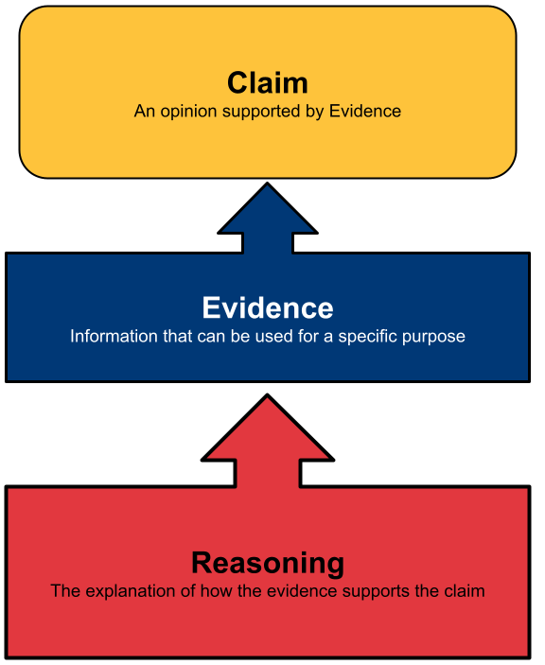

Teacher Resource 3: List of Sources on Issue
Note** This is a developing issue so there are new sources published daily. You may want to update this list for your own use.

- Drug Addiction Treatment and Recovery Act (Measure 110), Oregon Health Authority
- The Controlled Substances Act, US Drug Enforcement Agency
- Oregon Is Recriminalizing Drugs. Here’s What Portland Learned. NYTimes, April 2024
- Oregon recriminalized drugs. So now what? OPB, ongoing
- Special report: Oregonians speak out on Measure 110, Oregon Capitol Insider, Feb 13, 2024
- Harm Reduction, Substance Abuse and Mental Health Services Administration, 2023
- Save Lives Oregon, About Page
- Jails across Oregon struggle to treat substance use disorders amid funding challenges and medical staff shortages, The Bulletin, Nov 26, 2023
- The next chapter in Oregon’s fight against fentanyl starts next week, Oregon Capitol Chronicle, Aug 28, 2024
- Oregon deflection data will show how many people can't access drug treatment, KATU2, Oct 1, 2024
- Deschutes County drug deflection program shows 'early success', Bend Bulletin, Nov 29, 2024
- Kids Speak Out: Oregon’: The impact of drugs, KOIN, Jun 8, 2023
- In Portugal, seen as a model for drug decriminalization, some now have doubts, Washington Post, July 7, 2023

Teacher Resource 4: Rubric for Evaluation of Testimony

Group:
Exemplary | Proficient | Approaching | Does not Meet
Testimony is full of details such as statistics and quotes that illuminate the point of view accurately | Testimony had enough details to represent the point of view accurately | Testimony had some information but it was general or not tied to this role’s perspective | Lacked details or information did not match the role
Evidence is well chosen, up-to-date, and supports the specific role | Evidence supports the point of view and was accurate | Evidence was mismatched to the role or wasn’t recent or accurate enough | Testimony lacked research evidence or contained erroneous information
Delivery was vibrant, clear, compelling, and realistic | Delivery was clear and persuasive | Delivery was read, not performed, but was clear and audible. | Delivery was not persuasive, clear, or audible.
Score:

Strengths:

Suggestions:

Questions:

Teacher Resource 5: Consensus Building Fist to Five Method

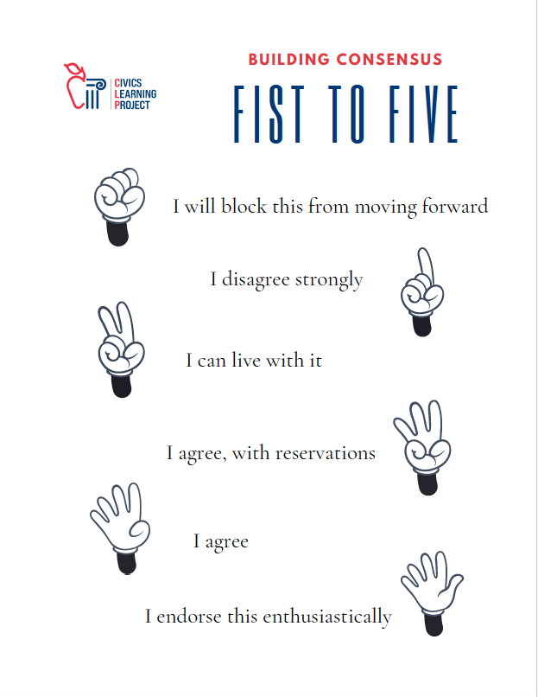

Student Handout 1: Town Hall Simulation Roles

Background:
In November 2020, voters in Oregon passed Measure 110, the Drug Addiction Treatment and Recovery Act, by a majority of 58% to 42%. Measure 110 embraced the idea that treatment and rehabilitation for drug addiction, rather than punitive measures such as jail time, would be better for society. The ballot measure reduced the penalties for possessing small quantities of certain drugs such as heroin, methamphetamines, PCP, LSD, and oxycodone. In addition, Measure 110 mandated the creation of treatment programs and help with housing and job placement for people struggling with addiction.

Since Measure 110 went into effect in 2021 the success of Measure 110 has been mixed and has placed extraordinary stress on an already strained system. Decriminalization happened before enough treatment was available causing a backlog of people wanting help who can’t access services. Crime rates and houselessness throughout the state are on the rise. The Oregon Legislature recently replaced the voter-approved decriminalization with ‘deflection,’ which will vary by county (see House Bill 4002).

Scenario:
Your county’s commissioners are attempting to address a host of challenges related to the problem of drug addiction in your community. Although some of these problems are similar in every area of the state, there are aspects of the issues unique to your region. Oregon voters decriminalized many formerly illegal drugs in hopes of getting people treatment rather than punishment. This approach has had mixed results, and Oregon captured the attention of the whole country with this experiment. Citizens are demanding action to fix the current state crisis, and each county now has an opportunity to try ‘deflection’ programs. In an attempt to respond to the desires of the populace, the commissioners want public input to the question:

How should our community respond to drug addiction?

Roles:
- Dr. Barb Brainnan, psychologist and expert on addiction
- Shirley Joshmum, parent
- Captain Dirk Lawman, County Sheriff
- Donna Houser, Director of Sanctuary
- Wanda Weller, person in recovery from addiction
- Shane Helper, Director of Recovery Center
- Craig Cooper, business owner
- Dr. Jenny Heeler, emergency room physician
- Kaycie Danka, child of an parent with addiction
- County Commissioners, elected officials

Student Handout 2: Student Directions:
Once you have been assigned your role, read the handout that gives an overview of your character’s point of view. Brainstorm what type of data could make your testimony strong in the town hall. Spend some time gathering evidence and then write up a one-page testimony that you will deliver at the town hall.
1. Read your role overview
2. Brainstorm what type of data you would want to support this point of view with the prep worksheet
3. Gather evidence that supports your character’s point of view
4. Write a 2 min testimony (about 300 words)
5. Deliver testimony orally in town hall simulation

Research Notes
Source | Evidence

Student Handout 3A:

Role 1: Dr. Barb Brainnan, psychologist and expert on addiction

I have spent my entire career studying how the brain responds to pharmacological substances. It’s a relief to see Oregon’s voters recognize that addiction is a disease that should be treated with a combination of mental and physical health support, overseen by qualified personnel. It does no good to throw people in jail for their illnesses. We should treat them and help them find productive and healthy alternatives.

Student Handout 3B:

Role 2: Shirley Joshmum, parent

My son Josh died of an overdose at 23 years old. He had been a star athlete who played for a D1 college team but fell into a deep depression after a career-ending injury. I tried to help him, but he wouldn’t go to therapy and I couldn’t make him, since he was legally an adult by then. It was horrible to be so helpless as a parent! I could do nothing when Josh started using, because he didn’t want to stop. I even offered to take out a second mortgage on my house to pay for rehab but he didn’t want me to go into debt for him. He didn’t feel he was worth it. If he were alive today I would tell him I would have done anything to help him.

Student Handout 3C:

Role 3: Captain Dirk Lawman, County Sheriff

I’ve never seen anything like this disaster we are in now. People are shooting up out in the open while school kids walk past on the sidewalk! Legalizing dangerous drugs was a reckless decision. If the voters saw what I see everyday, they would repeal that law. And with fentanyl pouring over the borders, there’s almost no way to keep our officers safe from accidental contamination. I can’t ask my deputies to spend all day gloved and masked because this dangerous substance is everywhere and expect them to stay on the job. Not to mention we can’t even fill vacant positions because of the housing costs. On top of that, crime is through the roof with all these addicts so desperate to find something to hawk to get their next fix. Sure, sending druggies to jail wasn’t a perfect solution but at least regular citizens were more protected. We need to change direction in Oregon.

Student Handout 3D:

Role 4: Donna Houser, Director of Sanctuary Center

My name is Donna Houser and I oversee the low-barrier shelter in our county, Sanctuary Center. That means we give temporary emergency shelter to the most vulnerable people in our region without requiring them to be clean (off drugs). I see the drug epidemic first hand on a daily basis. People who want to get clean can’t get into treatment. People who have worked hard to kick the habit can’t get a job or rent an apartment because they have a felony conviction. I’m glad Oregonians recognized we need to destigmatize and decriminalize addiction so people have a shot at a second chance. However, without enough affordable housing, employment reform, and adequate treatment options, decriminalization isn’t going to solve the problem. We have a crisis on our hands. Looking away won’t help.

Student Handout 3E:

Role 5: Wanda Weller, recovering addict

When I was 63 I tripped over the hose in the garden and shattered my wrist. It was my dominant hand. I had multiple surgeries to restore use of my hand and wrist, but the pain was constant. Prescription oxycodone was how I started managing my pain but I developed a tolerance so I sought out oxycontin, which was more effective. For a while. I couldn’t get enough of it fast enough. I thought because these were medications they were pretty safe. My performance at work really suffered. I lost a lot of weight and my kids started to notice. My son was visiting for Christmas two years ago and found me passed out in my arm chair. He begged me to get help and I agreed, for him. He did all the research, made all the arrangements, filled out all the applications and financed it all, between him and my daughter. I didn’t know how hard it would be to stop using, and it’s still a daily struggle. But I haven’t used in 415 days! I know how lucky I am to have the family support to fight this. If it weren’t for my children, I wouldn’t be here today.

Student Handout 3F:

Role 6: Shane Helper, Director of Recovery Center

I run the drug treatment center in this county. We are drowning. I have to turn people away every hour because we don’t have enough space for them. And I know how hard it is for them to be ready to get help so turning them away could be a death sentence. But we don’t have beds, we don’t have enough staff, we don’t have enough doctors and therapists. Even when we finally got the much-needed-though-quite-late funding from the State, we couldn’t hire enough people because it’s too expensive for them to live here. Decriminalizing addiction makes sense to me, but only if we have the support structure to get people healthy.

Student Handout 3G:

Role 7: Craig Cooper, business owner

What were those people thinking when they voted to legalize hard-core drugs? I have never seen this place so overrun with junkies. It’s not safe. My construction business is down the street from one of those ‘sanctuary’ places so there are addicts everywhere, and they steal! The copper piping we install in homes gets stolen as soon as it’s delivered. I had to hire a security guard and get a Doberman (guard dog) to watch over our supplies since the theft is so frequent, but it’s not holding back the tide of theft. I can’t afford to absorb the loss of materials. I’m a small business owner, not a corporation! I don’t have the kinds of margins to be able to survive how many of my supplies disappear when I need them the next day at a job site. Good people are going to go to other states where criminals are treated like they should be and thrown in prison.

Student Handout 3H:

Role 8: Dr. Jenny Heeler, emergency room physician

I used to spend most of my shifts on patients who suffered from heart attacks, strokes, and major trauma from accidents. Now it’s overdoses. The escalation of the frequency and severity of drug overdose is sobering. No pun intended. Infected needles are nothing compared to the dangers of fentanyl. I can’t save these people. It’s just too powerful a drug and it’s over too quickly. We don’t have the capacity to handle the number of cases we see every day and other patients are waiting too long for treatment as we are inundated with drug issues. This is a public health emergency.

Student Handout 3I:

Role 9: Kaycie Danka, child of an addicted parent

The best thing that ever happened to my dad was getting arrested and serving time. His addiction was so strong, it took something that severe to snap him out of it. He had DUIs before but didn’t spend more than a night in jail and then was back to using again. When he was finally locked up for 6 months he sort of woke up to the reality of how bad things had gotten. I hated having to leave my friends to go live with my grandparents out of state while my dad was in jail but I see now that it saved his life. He’s been clean since. He’s actually working again and I’m allowed to live with him as long as he stays clean and is employed. His Probation Officer checks in with him regularly and makes sure he’s going to his meetings. My dad says going through withdrawals while being locked up was the lowest time of his life and he’ll never let it get that bad again. I hope he’s right.

Student Handout 3J:

Role 10: County Commissioners, Elected Officials

Your role is entirely different from the rest of the groups. You will mediate and run the town hall. You are also going to study the problem with more depth. Your team needs to ask 2-3 questions of each character after each testimony so you will need to be listening closely.

You will start the town hall by giving the class some guidelines:
- Be courteous to others even when your character disagrees with someone
- Listen without interrupting while others are speaking
- Be open-minded; try to understand an issue from other points of view
- Write questions down for the other teams rather than asking them during testimony

Get started with a few extra resources:
Overdose Prevention Data Dashboard, Oregon Health Authority
Oregon decriminalization reveals possible solutions and challenges to addressing addiction, PBS, Oct. 2023
Building the Evidence: Understanding the Impacts of Drug Decriminalization in Oregon, RTI
Integrating Harm Reduction into Medical Care: Lessons from Three Models, The Journal of the American Board of Family Medicine, May 2023
Decriminalizing Drug Possession Not Linked to Higher Overdose Death Rates in Oregon or Washington, NYU Langone Health, Sept. 2023
With addiction bill passed, now Oregon faces biggest challenge, Oregon Capitol Chronicle, March 2024
Policy Brief: New Drug Deflection Plans Oversimplify Complex Issues, Oregon Business, Nov 1, 2024

Student Handout 4: Testimony Preparation

Name:
Part 1: Who are you in this simulation? Describe your perspective and the experiences or situations that impact your view on the topic:

With your Role Group, list facts and arguments you might use to answer the question before the Board from your Role’s perspective:

Part 2: List ideas you want to include your testimony. Write your 2-minute testimony here as you form it with your role group members:
Issues you might include:
- Why you are testifying
- Why this issue is important
- Your own experiences
- Your answer to the overall question before the board

Part 3: Anticipate. What ideas do you expect to hear from the other roles that testify? Thinking of these will help prepare you for counter arguments.

Part 4: Prepare for Questions. What questions might the Board ask you based on your testimony? How would you answer these questions?

Student Handout 5: Testimony Rubric

Use this rubric to prepare your own group’s testimony AND to evaluate other groups as they perform.

Group:

Exemplary | Proficient | Approaching | Does not Meet
Testimony is full of details such as statistics and quotes that illuminate the point of view accurately | Testimony had enough details to represent the point of view accurately | Testimony had some information but it was general or not tied to this role’s perspective | Lacked details or information did not match the role
Evidence is well chosen, up-to-date, and supports the specific role | Evidence supports the point of view and was accurate | Evidence was mismatched to the role or wasn’t recent or accurate enough | Testimony lacked research evidence or contained erroneous information
Delivery was vibrant, clear, compelling, and realistic | Delivery was clear and persuasive | Delivery was read, not performed, but was clear and audible. | Delivery was not persuasive, clear, or audible.

Excellent points made:

Questions you have for the group:

Student Handout 5: Looking for Shared Understanding

Use this graphic organizer to process what you heard in the town hall meeting and move forward with a policy solution that takes into account multiple perspectives. Use a Socratic seminar or other consensus building discussion to brainstorm policy solutions.

ISSUE ANALYSIS | We all agree that: | Most of us think that: | A few of us think that:
PROBLEMS:
SOLUTIONS:

