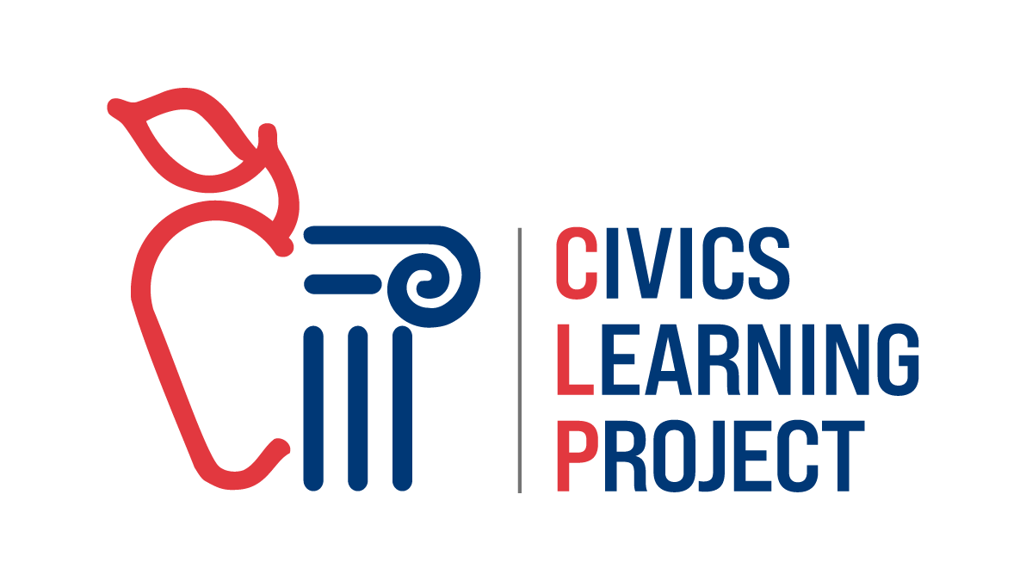

Civics Learning Project Presents

Deschutes Basin Water Rights:
A Town Hall Simulation

In this packet:
- Overview of a Town Hall Simulation
- Teacher Lesson Plan
- Background Information
- Student Handouts

Last updated: 11/4/24

Civics Learning Project Presents
Deschutes Basin Water Rights:
A Town Hall Simulation

Introduction:
Democracy requires public participation and compromise to solve problems as a community. By simulating a town hall, students will be exposed to the multiple interests involved in allocating scarce water resources in the Deschutes River watershed. They will identify evidence that best supports each user’s interest and will practice writing and delivering persuasive testimony to a policy workgroup. By researching and then taking on the perspective of those they might not necessarily agree with, students gain a deeper understanding and ability to critically think through one of the most controversial topics in the region: water.

Objectives of Town Hall Simulation:
- Students will engage in inquiry to support claims with relevant and quality evidence
- Students will construct and present a compelling argument that represents a particular point of view on a current and complex issue that needs to be addressed
- Students will analyze and articulate various perspectives on your topic here
- Students will develop and hone listening skills to better understand contrary positions
- Students will identify ways to compromise and collaborate
- Students will broaden their understanding of policy making with competing needs for scarce resources in our region in the face of a changing climate
- Students will practice a key process in deliberative democracy

Town Hall Simulation Process in Brief:
Day 1
1. Anticipatory Set/Hook:Water Uses Rankings 10 min
2. Teacher Direct Instruction on Background of Issues: 20 mins
3. Students study background sources: 15 mins
4. Assemble in role groups to read overviews: 15 mins
Day 2
5. Research day to find data and write testimony class period
Note: Panel group will do more data study since they will not be writing testimony
Day 3
6. Town Hall Simulation 55 min
Options: Use a fishbowl format with only one student per group giving the testimony or break into several town halls and jigsaw the student groups.
7. Whole Class Debrief: 15 mins

Teacher Lesson Plan: Drought and the Deschutes Town Hall Simulation

LESSON DESCRIPTION
Democracy requires public participation and compromise to solve problems as a community. By simulating a town hall, students will be exposed to the multiple interests involved in allocating scarce water resources in the Deschutes River Watershed. They will identify evidence that best supports each user’s interest and will practice writing and delivering persuasive testimony to the Deschutes Basin Water Collaborative. One student group will be pretending to be the panel.

LESSON GOALS AND OBJECTIVES

Oregon Social Studies Standard(s)

Social Studies Analysis
- 8.34 Analyze how a specific problem can manifest itself at local, regional, and global levels over time, identifying its characteristics and causes, and the challenges and opportunities faced by those trying to address the problem.
- HS.74 Analyze an event, issue, problem, or phenomenon, critiquing and evaluating characteristics, influences, causes, and both short- and long-term effects.
Civics and Government
- HS.8 Examine the institutions, functions, and processes of Oregon’s state, county, local and
- regional governments.
Geography
- 8.21 Explain how technological developments (such as the cotton gin, roads, railroads, canals, etc.), societal decisions, and personal practices interact with the physical environment in the United States (e.g sustainability, economics ecosystems).
- HS.40 Use geographic data to analyze the interconnectedness of physical and human regional systems (such as a river valley and culture, water rights/use in regions, choice/impact of settlement locations) and their interconnectedness to global communities.
- HS.48 Determine the influence of long-term climate change and variability on human migration, settlement patterns, resource use, and land uses at local-to-global scales.

LESSON PREPARATION
Vocabulary to pre-teach: see the list below

Skills to pre-teach: Media literacy and best research practices should be pre taught before the inquiry component. Also check that students understand rhetorical structure and devices for persuasion, oral delivery techniques.

Initial Teacher-Led Discussion:
Inform students that the goal of this activity is to be able to analyze and articulate various perspectives on water issues and that this is not an attempt by the teacher to advocate for a certain position on a specific issue. Rather, you as the teacher hope students will see:
- There is no easy solution or the allocation of water would already be resolved.
- Roles of governments vs. private interests in assisting with the solution
- There is opportunity to shape future policy to adapt to changing circumstances

Instructional Materials
- Hard copies of roles for each student present.
- Access to internet-connected tablets or laptops for overview preloading and for inquiry part of lesson.
- Big enough space to comfortably fit all students and allow them to all see each other.

LESSON PROCEDURES
Anticipatory Set/Motivation/Hook, Time: 10 min start of Day 1
Give students in groups of four an envelope full of cut up river uses and ask them to rank them in terms of importance from top to bottom.

Anticipatory Set Materials:
Have students work in groups to rank these river uses by importance before handing out the roles. Photo copy this list, cut up and put in envelopes for groups to manipulate.
- Irrigating for food crops
- Human drinking water
- Watering residential lawns
- Watering golf courses
- Watering business landscaping
- Irrigating pastures
- Irrigating for livestock feed (hay)
- Maintaining river water levels for fish and wildlife
- Maintaining river water levels for watersports
- Maintaining reservoir levels for watersports

Focused Instruction (Teacher-as-Model), Time: Rest of class period Day 1
Teacher introduces scenario:

The Central Oregon Intergovernmental Council helps regional governments coordinate responses to needs that go beyond city or county boundaries. One of the more recent projects is the Deschutes Basin Water Collaborative, a diverse group of stakeholders dedicated to working together “to achieve balance of water use in the Deschutes Basin.” They are holding a town hall hearing for all stakeholders to answer the following question:

- How do we plan for climate resiliency with scarce water resources in the Deschutes River watershed?

Teacher walks students through source review via direct instruction of the issue, the background history and how Oregon law works regarding water rights, and has students interpret the maps. Teacher identifies multiple government agencies at the tribal, local, state, and federal levels to show the complexity of a federalist system.

Guided Instruction (Teacher-to-Student Joint Responsibility), Time: First 10 min period for Day 2
Teacher hands out roles to students for them to read role sheets. Give instructions on students brainstorming what information could support the role’s point of view and give them time to conduct research to find data. Students read roles. Note** Teachers do not have to use all the roles if they would like to pick and choose to shorten or simplify the town hall meeting.

Group Application (Student-to-Student Joint Responsibility)
Part I, Time: Day 2, 25 min, 35 min
Students work in groups to find evidence that supports their role’s point of view and fill out the student handout called Testimony Preparation. Then students work in groups during the second half of the period to write their role’s testimony. Teachers can decide if this will be a fish bowl with one student per group doing the oral testimony presentation or run multiple town halls simultaneously, jigsaw style in the room. Also, teachers can decide if any students will act as the decision makers afterwards or if the class will follow up with a consensus building style discussion like a Socratic seminar.
Part II, Time: Day 3, 55 min
Teacher Does/Students Do: Teacher gives instructions on how the town hall will run (either one or multiple simultaneously) and the order of go. Students who are listening should have some form of evaluation (rubric) or note taking sheet to respond in writing with as they are receiving the testimony. What teacher plans next will determine what the students should be doing.
Options**: Students can either testify as groups, or you could opt for a fishbowl format with only one student per group giving the testimony. If you have multiple adults to help, you could break into several town halls and jigsaw the student groups.

Closure, Time: Day 3, 20 min
Teacher Does/Students Do: Have a debriefing discussion to hear how students’ understanding of the issue changed from doing the town hall. Return to the opening activity of ranking uses and compare that to the existing law in Oregon regarding water rights.

Extension: Individual Learning (Independent Practice and Application), Time: varies
This is entirely up to teacher discretion. Write a position paper, work as a class to propose a public policy solution to decision makers. Invite the actual professionals involved in the water resource distribution and have a panel discussion with students asking questions. Students could write an op-ed to the local newspaper or make a PSA for the public on water conservation.

ASSESSMENTS
Formative Assessment(s)
Student written and oral testimonies from each role. Students use the rubric to score each other’s presentations.

Summative Assessment(s)
This is entirely up to teacher discretion. We recommend convening the students to work toward consensus on a policy solution as a group. Looking for common ground and a ‘next step’ solution everyone can live with is powerful direct and deliberative democracy practice. Make sure the discussion is collaborative, building toward consensus, rather than antagonistic. Their proposal could even be presented to elected officials! This can lead to any of the following extensions:
- individual student position papers
- op ed to local newspaper
- make a video PSA for the public
- host a panel of professionals in the classroom
- attend a real town hall in the community and provide testimony
- propose policy to decision makers

Learning Supports
Accessibility: Teacher projector to display all the preloading information plus student devices for inquiry. Keyboards for ease of typing, speech to text apps to make writing the testimony more accessible.
Cultural & Linguistic Responsiveness: Depending on your student group, you may need to teach the academic vocabulary in addition to the topic terminology. Also, a student group that has not worked much in persuasive speaking and writing could use some instruction on rhetorical methods and devices.
Differentiation: Teachers could do a more scripted town hall to practice delivering testimony on one topic before diving into a more inquiry approach where they write their own testimony in a second. Some students may need help identifying good sources for the inquiry piece. A teacher could provide some resources. What comes after the town hall could be very in depth, real life policy making like a Community Action Project with students proposing policy to actual stakeholders. Students could do a community education campaign to spread awareness of drug treatment options. The sky’s the limit!
Socio-emotional supports: Preteach the importance of representing the role respectfully and not exaggerating the dramatic performance. Continually remind students that the point of the lesson is to broaden understanding of multiple perspectives and the complexity of solving a problem with so many stakeholders, not to have any particular point of view win an argument.

Also, students in the room are living the reality of this societal problem. Everyone needs to be mindful of their words.
Teacher Resource 1:

Federalism is a system where power is shared between national and regional governments. There are over 90,000 governments in the USA because of all the layers!
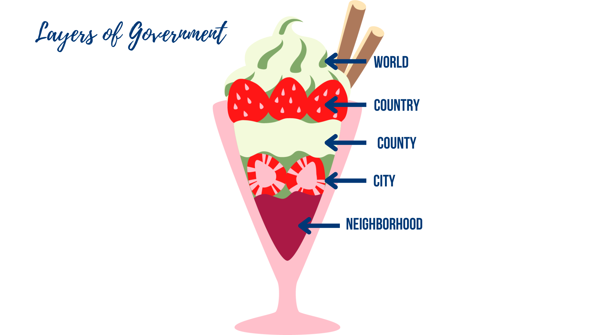

When it comes to regulating water use, there are many many agencies involved. Here are some:

Country Level: USA’s Federal/National Agencies

US Bureau of Land Management: The Bureau of Land Management's mission is to sustain the health, diversity, and productivity of public lands for the use and enjoyment of present and future generations.
Bureau of Reclamation: best known for the dams, power plants, and canals it constructed in the 17 western states. The BOR is the largest wholesaler of water in the country and reclamation is also the second largest producer of hydroelectric power in the United States.
U.S. Fish & Wildlife: Working with others to conserve, protect and enhance fish, wildlife, plants and their habitats for the continuing benefit of the American people.
US Department of Agriculture Farm Services Agency: Is equitably serving all farmers, ranchers, and agricultural partners through the delivery of effective, efficient agricultural programs for all Americans.
US Forest Service (under the USDA): manages the nation's 154 national forests and 20 national grasslands covering 193 million acres of land.
US Geological Survey: The science arm of the Department of the Interior. The USGS brings an array of earth, water, biological, and mapping data and expertise to bear in support of decision-making on environmental, resource, and public safety issues.
Environmental Protection Agency: Established to protect human health and the environment.

State Level: Oregon’s State Agencies

Oregon Water Resources Department: The Department's mission is to serve the public by practicing and promoting responsible water management through two key goals:
- To directly address Oregon's water supply needs
- To restore and protect streamflows and watersheds in order to ensure the long-term sustainability of Oregon's ecosystems, economy, and quality of life
Oregon State Police Fish and Wildlife Division: Ensures compliance with the laws and regulations that protect and enhance the long-term health and equitable use of Oregon's fish and wildlife resources and the habitats upon which they depend.
Oregon Department of Fish and Wildlife: Protecting and enhancing Oregon’s fish and wildlife, and the habitats they use, for the use and enjoyment of present and future generations
Oregon Dept. of Environmental Quality: DEQ's mission is to be a leader in restoring, maintaining and enhancing the quality of Oregon's air, land and water.

Tribal Governments:

Confederated Tribes of Warm Springs Water and Soil Department: monitors water, soil and air to protect human health and safety and maintain a healthy ecosystem for terrestrial and aquatic life

Regional Level:

Irrigation Districts:
Arnold Irrigation District; Central Oregon Irrigation District; Deschutes Soil & Water Conservation District; Lone Pine Irrigation District; North Unit Irrigation District; Ochoco Irrigation District
Soil and Water Conservation Districts:
Deschutes Soil & Water Conservation, Jefferson Soil & Water Conservation District

County Level:
Crook County, Jefferson County, Deschutes County, Wasco County

City Level:
City of Bend, City of La Pine, City of Prineville, City of Redmond, City of Madras, City of Maupin

Teacher Resource 2: Claim Evidence Reasoning for Testimony Drafting

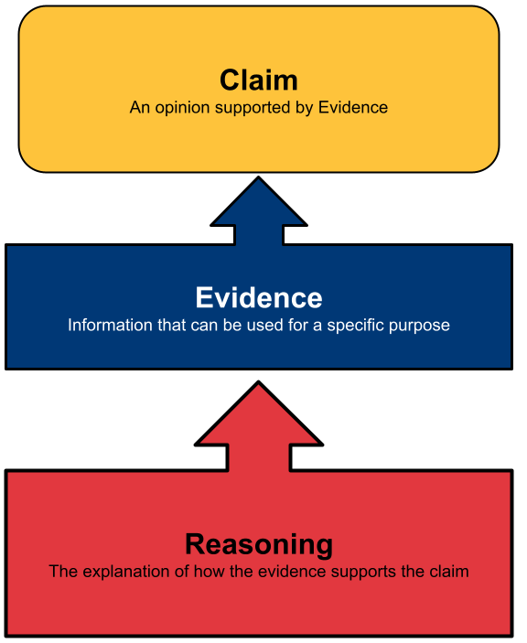

Teacher Resource 3: Sources for Inquiry

- Video: Water is Everything, Deschutes Soil and Water Conservation District
- U.S. Drought Monitor and NOAA Monthly Drought Outlook Map
- Water Rights: State of Oregon
- Maps | Central Oregon Irrigation District
- Deschutes River Conservancy Graphics
- Memo on relationship between ground and surface water, Water Resources Department
- Solutions to Oregon’s drought could be found in the Deschutes Basin, OPB
- City Reduces Water Use by Over 30% at City-Maintained Parks and Facilities, City of Redmond, July 2024
- Updated collection of articles related to water and the Deschutes Basin
- Bend Bulletin news stories
  - Deschutes Basin water users scramble to make ends meet in century-old system, Aug 14, 2022
  - Five years of drought behind them, Central Oregon reservoirs making a comeback, Feb 15, 2024
  - Lake Billy Chinook pumping project moves forward as North Unit tries to overcome water shortage, Feb 18, 2024
  - Declining aquifer levels raise alarm among hydrologists, officials, April 22, 2024
  - Jefferson County declares drought for record fifth straight year, June 27, 2024
- Editorial: A Change in Groundwater Allocation Rules is Long Overdue, The Source
- Videos
  - Deschutes Water Bank Farmer Video
  - New Deschutes River ‘water bank’ pilot program aims to ease shortages for junior irrigator

Teacher Resource 4: Rubric for Evaluation of Testimony

Group:

Exemplary | Proficient | Approaching | Does not Meet
Testimony is full of details such as statistics and quotes that illuminate the point of view accurately | Testimony had enough details to represent the point of view accurately | Testimony had some information, but it was general or not tied to this role’s perspective | Lacked details or information did not match the role
Evidence is well chosen, up-to-date, and supports the specific role | Evidence supports the point of view and was accurate | Evidence was mismatched to the role or wasn’t recent or accurate enough | Testimony lacked research evidence or contained erroneous information
Delivery was vibrant, clear, compelling, and realistic | Delivery was clear and persuasive | Delivery was read, not performed, but was clear and audible. | Delivery was not persuasive, clear, or audible.
Score:

Strengths:

Suggestions:

Questions:

Teacher Resource 5: Consensus Building Fist to Five Method

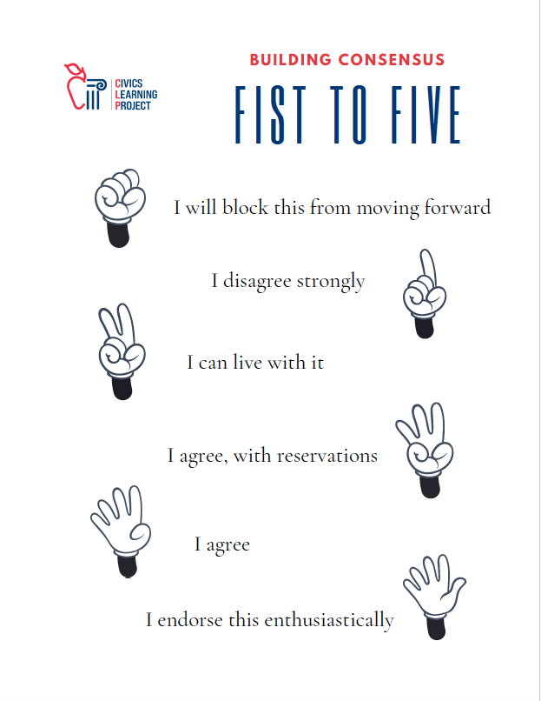

Student Handout 1: Ranking Water Uses

Irrigating for food crops
Human drinking water
Watering residential lawns
Watering golf courses
Watering business landscaping
Irrigating pastures
Irrigating for livestock feed (hay)
Maintaining river water levels for fish and wildlife
Maintaining river water levels for watersports
Maintaining reservoir levels for watersports

Student Handout 2: Town Hall Simulation Roles

Scenario:
The Central Oregon Intergovernmental Council helps regional governments coordinate responses to needs that go beyond city or county boundaries. One of the more recent projects is the Deschutes Basin Water Collaborative, a diverse group of stakeholders dedicated to working together “to achieve balance of water use in the Deschutes Basin.” They are holding a town hall hearing for all stakeholders to answer the following question:

How do we plan for climate resiliency with scarce water resources in the Deschutes River Watershed?

Roles:
- Mr. Freddy Drake, City Manager for Bend
- Sally Mustang, Horse stable owner in Tumalo
- Dan Driver, Golf Tournament Organizer, Redmond
- Heather Wildflower, Warm Springs Tribal Council
- Jonathan Deere, hay farmer in Madras
- Kristen Troutdale, fly fishing guide based out of Sisters
- Pat Powderly, Powder Corporation, owner of Mt. Bachelor Resort
- Jesse Cattleman, Rancher in Prineville
- Deschutes Basin Water Collaborative Panel

Student Directions:
Once you have been assigned your role, read the handout that gives an overview of your character’s point of view. Brainstorm what type of data could make your testimony strong in the town hall. Spend some time gathering evidence and then write up a one-page testimony that you will deliver at the town hall.
1. Read your role overview
2. Brainstorm what type of data you would want to support this point of view with the prep worksheet
3. Gather evidence that supports your character’s point of view
4. Write a 2 min testimony (about 300 words)
5. Deliver testimony orally in town hall simulation

Research Notes
Source | Evidence

Student Handout 3A:

Role 1: Freddy Drake, Bend City Manager

After the last mill closed in 1993, our city successfully transitioned from a timber-based economy to one built on tourism. The river is the most scenic aspect of this city as it meanders through the Old Mill District into the historic center of downtown. World renowned mountain biking trails, fly fishing, and a long ski season draw visitors in droves. Some of these people have decided to make Bend their home, leading to a population boom. There are now over 100,000 residents. Our city is unique in that we have access to both groundwater and surface water for our residents and businesses. Per person use of water is dropping as people become more efficient, but there are more people moving here so it seems to be evening out. The Deschutes River bisects our city and now features a white-water park with a surfable wave, calmer floater channel for innertubes, and a rowdy kayak area. Through downtown, the river widens into Mirror Pond before heading north through a hydroelectric power generator. During the summer irrigation months, the majority of the water in the river is siphoned off for agriculture near the intersection of Mt. Washington and HWY 97 Business. Most tourists only see the river before that diversion. The amphitheater on the river’s banks draws musical acts from around the globe and on warm days thousands of people cool off by playing in the water. The quality of the water in our region is directly related to the quality of Bend’s beer, which is why there are no less than 30 breweries in town. It is in the interest of this city to ensure this river provides water to residents and all the recreational and business needs here.

Student Handout 3B:

Role 2: Sally Mustang, Horse ranch owner in Tumalo

My property is 25 acres of the most beautiful vistas of the snowcapped volcanoes you can find in this area. Well, some-times they are snow-capped. The glaciers up there appear to be shrinking. The snowpack is erratic. My irrigation canal isn’t flowing as often, or for the full season. Sometimes the Tumalo Irrigation District doesn’t have enough water to grant us our full allocation even though we have senior water rights I inherited when I bought this property in the 90s. It’s been my lifelong dream to own my own training facility, but it sure has been hard to make it financially. In addition to the horses in my program, we have about 35 outside boarders who stable with us. Each of those horses gets turned out on pasture during the day, but I haven’t been able to keep the grass green the past two years. This year I took out a second on my mortgage to dig a bigger retention pond to get us by when the district shuts the water off. The drought is hitting us in the pocketbook too. Hay prices nearly doubled and with the economy like it is, I can’t double my rates, or I’ll lose half our boarders so I’m eating the losses for now. Sometimes I think I should just sell out to the destination resorts and their golf course dreams. But for now, I’m holding on.

Student Handout 3C:

Role 3: Dan Driver, Golf Tournament Organizer, Redmond

Sunshine and great views make Central Oregon ideal golfing. Redmond’s airport provides easy access for golfers to play the 26 courses that dot the High Desert from Sunriver to Sisters. As a tournament organizer, I have no shortage of amazing venues to draw in competitors. The irrigation of these golf courses is vital to bringing in the tourism dollars that keep this economy thriving. Each golfer pays for lodging, food, transportation, and entertainment while they are in the region. The destination resorts here also create revenue as tax-paying businesses. It’s only fair that the resorts get a share of the region’s water. Plus, as water becomes less plentiful and more expensive, golf course management gets more efficient. Some courses even use reclaimed water! Resorts certainly use far more sophisticated methods of distributing water than the old fashioned flood irrigation you see on some of these ranches. Let’s bring this area into the 21st century instead of using gravity and open ditches to move water. Central Oregon is one of America’s best playgrounds and we should invest in better water delivery and reclamation infrastructure here.

Student Handout 3D:

Role 4: Heather Wildflower, Warm Springs Tribal Council

When my ancestors ceded most of their traditional lands in the Warm Springs Treaty, they made sure to retain hunting, fishing, and gathering rights in perpetuity. My grandmother and mother followed the seasonal round, teaching me to collect camas root, which used to sustain our people with carbohydrates and protein. Now when we go gathering, there are fewer and fewer camas plants, and the roots are getting smaller. Also, my family fishes the salmon in our river and have noticed the catch is declining. The river water is lower each winter as snow melt gets diverted upstream for irrigation. As a result, the water we get here in the Lower Deschutes is getting warmer and the fish aren’t thriving. Dams make it hard for the remaining salmon to make it back to their historic spawning grounds. Many of the settlers who came in the prior century started channeling the streams, which dried out the meadows and fish nurseries where the camas used to grow. The state’s 1909 water law didn’t acknowledge our people’s need for water or that we were here first. We organized and quantified our rights in 1997 with an impressive Water Rights Settlement and now our tribal water rights are considered the most senior of all in the basin. We are also working with farmers and ranchers to restore the natural meander of the streams to help bring back our native foods by restoring the natural flows of our rivers. Our people are connected to this land and try to be good stewards. We know that water is life. We hope it’s not too late to save our sacred waters.

Student Handout 3E:

Role 5: Jonathan Deere, hay farmer in Madras

These days hay farming is like gambling. I’m betting when the rains will come, betting on the speed of the baling to beat the hailstorms, and betting on when the canal flows will stop. Last year the irrigation water didn’t make it long enough for us to bring in a third cutting. I know our situation was the norm around here. We are literally getting 20% of our historic average because of multiple years of drought in a row. This problem sent hay prices through the roof, but it’s not like I’m getting to pocket that increase… fuel prices went up even more and all the machinery runs on diesel, so I’m actually losing money now. It’s hard to imagine how I could be this tired, work this hard, and still be in the red. The prospects aren’t looking good given the trend of drought we are facing. Since we have junior water rights and the river water is oversubscribed, we here in the North Unit are basically at the mercy of what the upstream users are willing to let flow. Those hobby farms with their alpaca tax write-offs usually have some other source of income, but not us. I could switch to ranching, but beef isn’t much better financially because the four corporate meat-packing conglomerates set the prices nationally and keep the ranchers from getting premium pay for top notch grass-fed local beef. It feels like the odds are stacked against us here. We are doing everything we can to conserve water by installing drip irrigation, piping, and borrowing water rights from fields that are fallow. Me and my neighbors are often on the brink of losing our livelihood when some biologist will swoop in and claim some frog needs the water more than we do. It’s getting desperate. Our kids don’t want to move to the city but what kind of living can they make here without enough water?

Student Handout 3F:

Role 6: Kristen Troutdale, fly fishing guide based out of Sisters

Central Oregon is such a special place to fish. The mysterious sources of cold water brought into our rivers from lava tubes in some spots gives the species a bit of a chance in the face of inconsistent water levels and temperatures in the surface flows. I’ve been able to earn a living guiding here for the last twenty years, but I do worry about the future. Mammals can migrate to new areas, but fish are at the mercy of the stewards of the watershed they find themselves in. It’s alarming to see the human population boom at the same time as the climate warms. The drought has made it near impossible to keep water levels high enough for healthy fish habitat. My former favorite fishing spot on the Crooked River before it merges into the Deschutes is now too shallow to be any good – it’s warm and green with algae. Not enough oxygen for trout. Some of the remaining dams have fish ladders which help with the salmon runs, but only if there’s enough water in the river! I’m not sure golf courses and farming make sense in a desert, but everyone seems to want to be here. Another thing I worry about are the chemicals in the runoff that could really change the river ecosystems in the future. All the tourism brings in lots of customers for me but I’m not sure any of this is sustainable. Let’s hope the leasing and water rights transfers increase, but it depends on people volunteering to sell their water rights to other customers. Doesn’t seem likely anyone would give up their share of the water, especially when the law of the land is ‘use it or lose it.’ There’s not much incentive for the senior water rights holders to use less.

Student Handout 3G:

Role 7: Pat Powderly, Powder Corporation, Owner of Mt. Bachelor Ski Resort

What a wild ride it has been managing snow with winters that don’t act like winter! The Mt Bachelor ski season is traditionally mid-November through the end of May but lately it’s been unpredictable. Sometimes it’s too warm so we get rain, which turns to ice overnight, and leaves the slopes like a skating rink. Other times it dumps big lofty powder dumps in drifts too deep to navigate. Then the next week the sun will blaze it all back to slush again. It pains me to say this but what we’re really going to need going forward is more snow-making to keep the business going during the flux Mother Nature keeps throwing at us. Man-made snow isn’t nearly as fluffy as the epic natural stuff, but it’s better than having to take up knitting. Based on what Colorado is doing, it takes 135,000 gallons of water to make one foot of snow per acre. We have 4,300 acres of skiable terrain, so we are going to need one big holding pond or a bunch of tanks. But it’s worth it! Mt. Bachelor is the 6th largest ski resort in North America and is a major employer in our region. The snow that falls up here is put to good use with over 100 ski runs for people who love to play outdoors. Our company also owns a rafting outfitter, so we also see the importance of keeping water levels high enough in the river to play in. It’s pretty inconsistent though, especially right below Wickiup or south of town in Bend. Pray for snow, People! After we’re done playing in the snow, the river can have it!

Student Handout 3H:

Role 8: Jesse Cattleman, Rancher in Prineville

Crook County is an agricultural county. The Crooked River irrigates our lands and our lands feed America. If it weren’t for irrigation from the river, no one would live here. Bowman Dam holds water for those hot months when we need it most. Sure, folks love to play on Prineville Reservoir. I see people heading out with their speedboats for a day of wake surfing. But the reservoir was meant for irrigation, not recreation. In dry years there isn’t enough water for all of us. Sometimes I have to reduce my herd size if we can’t get enough water, and that means I’m not making ends meet. In good years, we all get what we need, but there aren’t as many good years anymore.

Student Handout 3I:

Role 9: Deschutes Basin Water Collaborative Panel of Members

Your role is entirely different from the rest of the groups. You will mediate and run the town hall. You are also going to study the problem with more depth using the extra resources below. Your team needs to ask 2-3 questions of each character after each testimony so you will need to be listening closely.

You will start the town hall by giving the class some guidelines:
- Be courteous to others even when your character disagrees with someone
- Listen without interrupting while others are speaking
- Be open-minded; try to understand an issue from other points of view
- Write questions down for the other teams rather than asking them during testimony

While other groups are preparing their testimonies, you all will learn more about the issue. Start by reading these:

2015 Deschutes Basin Study
https://www.deschutesriver.org/news-and-resources/upper-deschutes-basin-study/
Read the whole August 2021 memo from the Oregon Water Resources Department:
https://www.opb.org/pdf/OWRDMemo_DeschutesGroundwaterLevelDeclines_2021-09-01_FINAL_1657754829743.pdf
Overview of Water Rights in Oregon by the Water Resources Department:
https://www.oregon.gov/owrd/WRDPublications1/aquabook.pdf
Podcast: ‘The Evergreen’: Water rights in much of Oregon are still based on policies dating back to the 1900s, OPB, 2024
Update on proposal in review now:
https://oregonwatershedplans.org/north-unit-id
Reservoir levels:
https://www.usbr.gov/pn/hydromet/destea.html
History of Deschutes Plan:
https://www.usbr.gov/projects/index.php?id=445
Op ed from The Source in Bend:
https://www.bendsource.com/bend/water-wars-are-here-lets-work-together/Content?oid=15074253

Now develop questions for each stakeholder: produce these on a separate document

Decide on an agenda for the order of go at your town hall meeting: (here’s an example)
- Welcome the members of the community
- Introduce the topic of discussion
- Remind students that:
  - It is important to represent the stakeholder role respectfully and not exaggerate the performance.
  - The purpose of the town hall is to listen to multiple perspectives and understand the complexity of solving a problem with so many stakeholders.
- Call on each stakeholder to testify. (Testimony lasts 3 min max)
- Q&A - panel can ask questions of the group
- Panel calls on next stakeholder to testify
- Repeat until all groups have spoken
- Panel opens up Q&A to the whole group and moderates as students question other groups
- Panel closes town hall and gives estimated date for release of their policy proposal.

Student Handout 4: Testimony Rubric

Use this rubric to prepare your own group’s testimony AND to evaluate other groups as they perform.

Group Name:

Exemplary | Proficient | Approaching | Does not Meet
Testimony is full of details such as statistics and quotes that illuminate the point of view accurately | Testimony had enough details to represent the point of view accurately | Testimony had some information but it was general or not tied to this role’s perspective | Lacked details or information did not match the role
Evidence is well chosen, up-to-date, and supports the specific role | Evidence supports the point of view and was accurate | Evidence was mismatched to the role or wasn’t recent or accurate enough | Testimony lacked research evidence or contained erroneous information
Delivery was vibrant, clear, compelling, and realistic | Delivery was clear and persuasive | Delivery was read, not performed, but was clear and audible. | Delivery was not persuasive, clear, or audible.

Excellent points made:

Questions you have for the group:

Student Handout 5: Vocabulary to Know

resource: a useful or valuable possession

drought: a prolonged period of abnormally low rainfall, leading to a shortage of water.

scarcity: resource scarcity is the lack of availability of supplies required to maintain life, or a certain quality of life.

watershed: a land area that channels rainfall and snowmelt to creeks, streams, and rivers, and eventually to outflow points such as reservoirs, bays, and the ocean.

aquifer: an underground water supply — one found in porous rock, sand, gravel, or the like.

reservoir: a large natural or artificial lake used as a source of water supply.

irrigation: the artificial application of water to land to assist in the production of crops.

seasonal round: a form of calendar that shows tribal activities and movement along with seasonal food resources in an annual cycle.

channel: straightened course of a river or other waterway typically in order to improve the flow of water, protect against flooding, etc.

allocation: an amount or portion of a resource assigned to a particular recipient.

beneficial use: the reasonably efficient use of water without waste for a purpose consistent with the laws,
rules, and best interests of the people of Oregon (what is included has changed over time).

prior appropriation: water rights are determined by priority of beneficial use. This means that the first person to use water or divert water for a beneficial use or purpose can acquire individual rights to the water.

weir: a low dam built across a river to raise the level of water upstream or regulate its flow.

diversion: the act of diverting surface flow or hydrologically connected subsurface flow for use or storage.

adjudication: the process by which pre-1909 vested water rights are quantified and documented through an administrative and judicial procedure.

sustainability: avoidance of the depletion of natural resources in order to maintain an ecological balance.

spawning: to produce or lay eggs in water

fish ladder: a series of pools built like steps to enable fish to bypass a dam or waterfall.

Student Handout 6: Testimony Preparation

Name:
Part 1: Who are you in this simulation? Describe your perspective and the experiences or situations that impact your view on the topic:

With your Role Group, list facts and arguments you might use to answer the question before the Board from your Role’s perspective:

Part 2: List ideas you want to include your testimony. Write your 2-minute testimony here as you form it with your role group members:
Issues you might include:
- Why you are testifying
- Why this issue is important
- Your own experiences
- Your answer to the overall question before the board

Part 3: Anticipate. What ideas do you expect to hear from the other roles that testify? Thinking of these will help prepare you for counter arguments.

Part 4: Prepare for Questions. What questions might the Board ask you based on your testimony? How would you answer these questions?

Student Handout 7: Looking for Shared Understanding

Use this graphic organizer to process what you heard in the town hall meeting and move forward with a policy solution that takes into account multiple perspectives. Use a Socratic seminar or other consensus building discussion to brainstorm policy solutions.

ISSUE ANALYSIS | We all agree that: | Most of us think that: | A few of us think that:
PROBLEMS:
SOLUTIONS:

