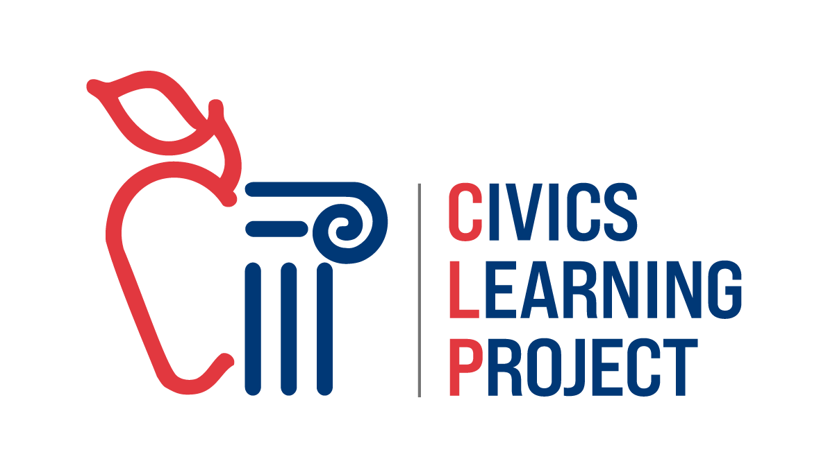
​

​

​

​

Hayden Honeycutt, Plaintiff
​v.
​Sammy Snow, Defendant

​

Table of Contents
The Case - 1 -
Case Summary - 1 -
Witness List - 2 -
List of Exhibits - 2 -
Charging Documents, Stipulations, Jury Instructions - 2 -
Prosecution Witness Statements - 11 -
Affidavit of Hayden Honeycutt - 12 -
Affidavit of Denny Nugget - 15 -
Affidavit of Morgan Dorf - 18 -
Defense Witness Statements - 22 -
Affidavit of Sammy Snow - 23 -
Affidavit of Charlie Baggins - 26 -
Affidavit of Rowan Wilson - 29 -
Exhibits 32
Exhibit 1: Sammy Snow’s May 31, 2024 Social Media Post & Example Comments 33
Exhibit 2: Social Media Follower Comparison 34
Exhibit 3: Honeycutt Carnival’s Profits & Loss Graph (September 2024) 35
Exhibit 4: (April 20, 2004) Newspaper Article 36
Exhibit 5: (1/24/24) Text Exchange between Charlie Baggins & Denny Nugget 37
Exhibit 6: Morgan Dorf’s CV 38
Exhibit 7: Rowan Wilson’s CV 40

The Case
Case Summary
The Honeycutt Carnival, founded in 1924, was a well-known local institution in Piper County, Cascadia. For generations, the carnival was a family-run business, cherished by the local community. By 2024, the great-grandson of the founder was running the carnival. Unfortunately, the carnival experienced financial difficulties in recent years due to rising operational costs and declining attendance.

On April 1, 2024, a mechanical failure occurred on the Zipper ride at the Honeycutt Carnival. Although no one was injured, the malfunction left patrons suspended in the air for 3 hours and 30 minutes. The incident was widely reported in the local media, which acknowledged that no patrons were harmed during the ordeal. However, the event caused some concern among the carnival's customer base.

Charlie Baggins, a former employee of the carnival, had created a post about the Zipper malfunction using AI software on April 20, 2024, and shared it on Instagram, hoping to capitalize on the popularity of the local story and build followers on social media. Baggins goal was to leverage the event to get one step closer in becoming a social media influencer.

On May 31, 2024, Sammy Snow, a popular social media influencer, reposted Charlie Baggins April post and added their own commentary. The post received millions of views and over 200,000 likes. This post implied a dangerous and potentially life-threatening experience at the carnival.

Following Snow's post, the carnival's business experienced a decline. Though Honeycutt Carnival had been facing financial difficulties and a steady decline in revenue prior to the post, the significant drop in attendance and income following May 31, 2024, was largely attributed to the viral nature of Snow’s misleading post. The financial losses ultimately led to the closure of the carnival in September 2024, marking the end of a 100-year family tradition.

Witness List
Plaintiff Witnesses:
- Hayden Honeycutt
- Denny Nugget
- Morgan Dorf

Defense Witnesses:
- Sammy Snow
- Charlie Baggins
- Rowan Wilson

List of Exhibits
- Exhibit 1: Sammy Snow’s May 31, 2024, Social Media Post
- Exhibit 2: Social Media Follower Comparison
- Exhibit 3: Honeycutt Carnival’s Profits & Loss Graph (September 2024)
- Exhibit 4: (April 20, 2004) Newspaper Article
- Exhibit 5: (DATE) Text Exchange between Charlie Baggins and Denny Nugget
- Exhibit 6: Morgan Dorf’s CV
- Exhibit 7: Rowan Wilson’s CV

Charging Documents, Stipulations, Jury Instructions

IN THE CIRCUIT COURT OF THE STATE OF CASCADIA
FOR THE COUNTY OF PIPER

HAYDEN HONEYCUTT  Plaintiff,  v.  SAMMY SNOW,  Defendant. | Case No. 24CV54321  COMPLAINT  (Defamation)  JURY TRIAL DEMANDED

INTRODUCTION

- Plaintiff Hayden Honeycutt (“Plaintiff”) brings this action against Defendant Sammy Snow (“Defendant”) for defamation inflicted by Defendant on Plaintiff.

PARTIES AND VENUE

- Plaintiff is an individual who resides in Piper County, Cascadia.
- Defendant is an individual who resides in Piper County, Cascadia.
- Venue is proper in this Court because Defendant is a resident of, and Plaintiff’s cause of action arose in Piper County, Cascadia.

FACTS

- Plaintiff is the former owner and Chief Executive Officer of Honeycutt Carnival.
- Honeycutt Carnival was founded in 1924 by the Plaintiff’s Great Grandfather Merriworth Honeycutt in Piper County, Cascadia. The Honeycutt Carnival had been run by a member of the Honeycutt family since its founding and until its closing in 2024.
- On April 1, 2024, a ride malfunction occurred on the Zipper at Honeycutt Carnival. All patrons on the ride were safe and unharmed but were suspended in the air for three and a half hours (3:30 hours) as Carnival staff addressed the mechanical issue.
- Local media outlets reported on the story and acknowledged that no patron was harmed during the ride malfunction.
- On May 31, 2024, the Defendant, Sammy Snow, a social media influencer with over 4 million followers on various social media platforms posted an image and caption of the Zipper ride at Honeycutt Carnival.
- The May 31, 2024, social media post, which read “Hayden & the Honeycutt Carnival got people [skull emoji] for a ride. Won’t be back.”, received millions of views and over 200,000 likes on the Defendant’s social media account.
- On June 5, 2024, the Plaintiff attempted to message the Defendant on Instagram requesting that the Defendant remove the May 31, 2024, post, as it was untrue. The Defendant never responded to the Plaintiff’s message.
- As a result of the Defendant’s statements, the Plaintiff and the Honeycutt Carnival has suffered emotional distress, damage to the Plaintiff’s personal reputation, as well as the legacy of Honeycutt Carnival, as well as loss of income and ultimately the closure of Honeycutt Carnival.

CLAIM FOR DEFAMATION

- Plaintiff incorporates and realleges paragraphs 1 through 12 above, each as if fully stated herein.
- The Defendant’s statements were defamatory in nature because they were false statements made that irreparable harmed the reputation of the Plaintiff and the Plaintiff’s family business, Honeycutt Carnival.
- The statements made by the Defendant were false and not subject to any privilege or defense.
- As a direct and proximate result of the Defendant’s actions, the Plaintiff has suffered damages, including but not limited to the closure of the $2,000,000 family business, Honeycutt Carnival.

PRAYER FOR RELIEF

WHEREFORE, Plaintiff prays for relief as follows:
1. An award of damages in an amount to be determined at trial; and
2. An award of the costs and disbursements that Plaintiff incurs in prosecuting this action; and
3. Such other relief as may be just and proper.

DATED: October 1, 2024. | CARLYLE, POLLARD & SCHMIDT LLP  s/Shannon Schmidt  SHANNON T. SCHMIDT, OSB No. 714520  ALLAN M. BEACH, OSB No. 911149  Telephone: (503) 234-4000  Attorneys for Plaintiff

IN THE CIRCUIT COURT OF THE STATE OF CASCADIA
FOR THE COUNTY OF PIPER

HAYDEN HONEYCUTT  Plaintiff,  v.  SAMMY SNOW,  Defendant. | Case No. 24CV54321  ANSWER

In response to Plaintiff Hayden Honeycutt’s (“Plaintiff’s”) complaint, Defendant Sammy Snow (“Defendant”) admits, denies, and alleges as follows:

INTRODUCTION

1. Defendant admits the allegations in paragraph 1, i.e., that Plaintiff is bringing this action against Defendant. Defendant denies any and all responsibility for the attack referenced in the complaint.

PARTIES AND VENUE

2. Defendant admits the allegations in paragraph 2.

3. Defendant admits the allegations in paragraph 3.

4. In response to paragraph 4, Defendant admits that venue is proper in this Court.

FACTS

5. Defendant admits the allegations in paragraph 5.

6. Defendant denies the allegations in paragraph 6.

7. Defendant denies the allegations in paragraph 7.

8. Defendant denies the allegations in paragraph 8.

9. In response to paragraph 9, Defendant admits that on May 31, 2024, the Defendant had posted on social media regarding the Zipper ride but denies the characterization of the post. The Defendant also denies they were the original poster of the post and that the post of reposted from Charlie Baggins another user of the Instagram platform.

10. Defendant denies that the statement in paragraph 10 is a false statement. Defendant asserts that the statement is an opinion and/or rhetorical expression not intended to convey factual information.

11. Defendant denies the allegations in paragraph 11, asserting that the Plaintiff’s message was not received, and further denies any obligation to respond.

12. Defendant denies the allegations in paragraph 12, asserting that any damages claimed by the Plaintiff are the result of other factors unrelated to the Defendant’s social media behaviors.

CLAIM FOR RELIEF
(Defamation)

13. Defendant incorporates and realleges Defendant’s responses to paragraphs 1 through 12 of the Complaint above, each as if fully set forth herein.

14. Defendant denies the allegations in paragraph 14.

15. Defendant denies the allegations in paragraph 15.

16. Defendant denies the allegations in paragraph 16, asserting that the Plaintiff’s claims of damages are speculative and unsubstantiated.

PRAYER FOR RELIEF

WHEREFORE, Defendant prays for relief as follows:
1. An order dismissing Plaintiff’s claim with prejudice;

2. An award of the costs and disbursements that Defendant incurs in defending this action; and

3. Such other relief as may be just and proper.
DATED: October 6, 2024. | McCOY & RUBEROSA LLP  s/Corrina M. Rubersoa  James J. McCoy (OSB No. 750046)  Corrina M. Ruberosa (OSB No. 083376) Telephone: (541) 871-7000  Attorneys for Defendant

IN THE CIRCUIT COURT OF THE STATE OF CASCADIA
FOR THE COUNTY OF PIPER

HAYDEN HONEYCUTT  Plaintiff,  v.  SAMMY SNOW,  Defendant. | Case No. 24CV54321  STIPULATIONS

The parties stipulate and agree to the following:

- Before commencing trial, a Piper County Judge ordered that HAYDEN HONECUTT v. SAMMY SNOW be bifurcated. Pursuant to that order, this trial is to be undertaken in two phases, (1) the liability phase, and (2) the damages phase, should it be necessary. All parties agree that during this litigation, arguments should be explicitly limited to those concerning liability. Should the defendant be held liable, damages will be assessed separately.

- Hayden Honeycutt was the owner and sole proprietor of the Honeycutt Carnival.

- Each exhibit has been numbered and labeled by court staff. Those numbers and labels should not be taken as part of each exhibit for evidentiary purposes, and they will remain consistent regardless of which party introduces them first in trial.

- Charlie Baggins has a known record of use and has held an account with Infill.ai since October of 2022. Through no fault of either party, that record is not available for evidence.

- Sammy Snow has a well-known fear of heights and rodents.

- Both parties waive any objections arising under the Constitution of the United States.

- No witness has, or has ever had, any mental condition that affects memory, cognition, or ability to respond to questions when asked on cross or direct examination.

- Both parties agree that no chain of custody issues with any numbered exhibit exist.

IN THE CIRCUIT COURT OF THE STATE OF CASCADIA
FOR THE COUNTY OF PIPER

HAYDEN HONEYCUTT  Plaintiff,  v.  SAMMY SNOW,  Defendant. | Case No. 24CV54321  FINAL JURY INSTRUCTIONS

The Court will now submit the case to the jury; you need to decide, based on the law and the evidence presented to you at trial, whether the prosecution has prevailed in proving the prosecution’s charges against the defendant.

EVALUATING WITNESS TESTIMONY
The term “witness” includes every person who has testified under oath in this case. Every witness has taken an oath to tell the truth. In evaluating each witness’s testimony, however, you may consider such things as:
(1) The manner in which the witness testifies;
(2) The nature or quality of the witness’s testimony;
(3) Evidence that contradicts the testimony of the witness;
(4) Evidence concerning the bias, motives, or interest of the witness; and
(5) Evidence concerning the character of the witness for truthfulness.

INFERENCES
In deciding this case you may draw inferences and reach conclusions from the evidence, if your inferences and conclusions are reasonable and are based on your common sense and experience.

PREPONDERANCE OF THE EVIDENCE
The plaintiff must prove the plaintiff’s claims by what the law refers to as a “preponderance of the evidence.” That means that the plaintiff must persuade you by evidence that makes you believe that the plaintiff’s claims are more likely true than not true. After weighing all of the evidence, if you cannot decide that something is more likely true than not true, you must conclude that the plaintiff did not prove it. You should consider all of the evidence in making that determination, no matter who produced it.

DEFAMATION
In this case, the plaintiff has brought a claim for “defamation.” To establish a claim of defamation, a plaintiff must prove that Sammy Snow:
1. Published a statement of fact concerning the plaintiff;
2. The statement was false;
3. The statement was defamatory in nature;
4. The defendant is “at fault” for the publication; and
5. The plaintiff suffered harm or injury as a result of the publication.

Definitions
1. A defamatory statement is a misrepresentation of facts that causes someone to be hated, ridiculed, shunned, or harm their business or trade, causing reputational damage to them.

2. “At fault” to mean making a statement with knowledge that it was false or with reckless disregard for whether it is was false.

DIRECT OR CIRCUMSTANTIAL EVIDENCE
There are two types of evidence. One is direct evidence—such as the testimony of an eyewitness. The other is circumstantial evidence—a chain of circumstances pointing to the existence or nonexistence of a certain fact. You may base your verdict on direct evidence or on circumstantial evidence, or on both.

WITNESS FALSE IN PART
A witness who lies under oath in some part of his or her testimony is likely to lie in other parts of his or her testimony. Therefore, if you find that a witness has lied in some part of his or her testimony, then you may distrust the rest of that witness’s testimony. Sometimes witnesses who are not lying may give incorrect testimony. They may forget matters or may contradict themselves. Also, different witnesses may observe or remember an event differently. You have the sole responsibility to determine what testimony, or portions of testimony, you will or will not rely on in reaching your verdict.

EXPERT OPINION EVIDENCE
An expert witness is a person with special skills or education in a particular field. Even though expert witnesses may testify about their opinions, you are not required to accept those opinions. To determine the value, if any, you will give to an expert’s opinion, you should consider such things as the expert’s qualifications, the expert’s opportunity and ability to form the opinion, the expert’s believability, and how the expert reached the opinion or conclusion.

Dated: November 30, 2024.

s/Ana Tuck
Hon. Ana Tuck
Judge of the Circuit Court of the State of Cascadia

Prosecution Witness Statements

Affidavit of Hayden Honeycutt
My name is Hayden Honeycutt, and I was the owner and Chief Executive Officer of Honeycutt Carnival, a title I never took lightly. I was born into this business, raised among its bright lights and joyous sounds, and I proudly carried the torch passed down from my great-grandfather Merriworth Honeycutt, who founded the carnival back in 1924. This wasn’t just a business to me—it was my family’s legacy, a part of who I am, and what made our family’s name known throughout Piper County, Cascadia.

I have spent my entire life with Honeycutt Carnival. As a child, I was part of every ride, every attraction, and every smile that we created. The carnival wasn't just my livelihood; it was the heartbeat of my family, a cherished institution where generations of Cascadians created memories with their children and grandchildren. My great-grandfather started it with a dream—to bring happiness and joy to the people of Cascadia—and my family had carried that dream forward for a century. We made sure to honor his legacy, by putting people first! And now, in 2024, we are set to celebrate 100 years of Honeycutt Carnival—or we were, at least

Unfortunately, that dream came to a crashing halt this year, and I believe it was a direct result of a damaging post made by social media influencer Sammy Snow and all this artificial intelligence, more like nonsense. Before I get into all that mess, though, let me explain what happened in the days leading up to the post.

April 1st of this year will forever be a day I can’t forget. The carnival was in full swing, and the Zipper, one of our most popular and long-standing rides, was operating as usual. Around midday, a malfunction occurred. I remember getting the call from the ride operator saying that something had gone wrong—the Zipper had stopped, leaving patrons suspended high in the air.

My heart sank. I’ve seen a lot of things in my time running the carnival, but safety is always our first concern. We have training sessions for new staff, run drills from time to time to stay fresh, and our motto “People, Safety, Fun” is etched on each chair in our conference room. After hanging up from the call I rushed to the scene, joining our mechanics and staff as they worked to resolve the issue. For three and a half hours, those people were stuck on that ride. It was a tense time, and I could see the fear in their eyes as they waited for us to bring them down. We kept communicating with them, reassuring them that they were safe, and we worked as fast as we could to fix the mechanical issue. As is protocol, (People, Safety, Fun) we also let the local authorities know of the incident. We had a great relationship with the Piper Fire Department. They knew we were a tip top organization and luckily their services weren’t necessary because we got the Zipper back online and let everyone off the ride like they got on. Yeah, the EMT’s took a look at the patrons from the ride, but everyone was okay.

Thankfully, and I mean this with every fiber of my being, no one was hurt. After a long and difficult afternoon, we managed to bring everyone down safely. There was no physical harm to anyone, though I’m sure it was a nerve-wracking experience for those who were stuck up there. The media covered the story. It was in the local news on TV that night and in our local paper the following day. Much to the real media’s credit, they made it clear that no one was injured. I was grateful for that, thinking we could move on, address the mechanical issue, and ensure nothing like this would happen again. We took a bit of a hit in attendance after the story broke, but we were all confident we’d bounce back soon.

Then, on May 31, 2024, everything changed. Sammy Snow, a social media influencer with millions of followers—4 million, to be exact—posted a photo of our Zipper ride. I think I recall Sammy from a few years back. Sammy was this spoiled kid trying to sell us some snake oil. Saying something to the effect that with Sammy’s help, Honeycutt Carnival can be the top attraction in all of Cascadia. That signing into something called an influencer sponsor contract, would ensure big business for many years. A bunch of malarkey I thought. When I let Sammy know as much, they turned around and started insulting our rides and bad mouthing my family’s legacy. I didn’t take too kindly to that and told Sammy to never come back, I think. To be honest, it's all a bit of a blur at this point.

Back to May 31st, the caption under the photo read, “Hayden & the Honeycutt Carnival got people [skull emoji] for a ride.” With a caption stating “Won’t be back.” It might have been meant as a joke, something to get likes and shares, but to me, it was a gut punch. Sammy’s post immediately went viral, racking up millions of views and over 200,000 likes in a matter of days.

Seeing that caption felt like a personal attack. The implication was that our carnival was lethal, that we were reckless with people’s lives, and that I—me, Hayden Honeycutt, the person responsible for continuing my family’s legacy—was putting our patrons in danger, or worse! That couldn't have been further from the truth. The incident was unfortunate, yes, but we did everything right to ensure the safety of our patrons. No one was hurt, and we took immediate action to fix the problem. But Sammy's post made it sound like we were running a death trap.

I was angry, frustrated, and above all, heartbroken. I reached out to Sammy on Instagram just a few days later, on June 5th, hoping to explain the situation. I wasn’t looking for an apology, just a correction. I asked to remove the post or at least clarify that it was misleading, but I never heard back. The silence spoke volumes, and the damage was already done.

What happened next was nothing short of devastating. The weeks following Sammy’s post were brutal. Our ticket sales plummeted. People who had been regulars for years—families who had grown up with our carnival, who brought their own children now—began canceling their plans to attend. We were branded as killers, all because of a flippant comment made on social media. You could see it right in the comments of the post (Exhibit 1), people literally thought people had died. All these people, fooled by AI and social media saying they weren’t coming back. My dear employees were even getting harassed. Some folks let me know they were getting screamed at on the street when they were walking to work in their uniforms. People said all sorts of crazy things like “how dare you murder those people!”, “you’re a carnival killer”, “I should zipp you in the mouth”. And all those misguided folks would end their tirades by yelling some nonsense about G’s and V’s, which I guess is a Sammy thing? It didn’t matter that we’d been transparent, that the media reported no injuries, or that we’d worked hard to resolve the issue. Sammy’s post was all people saw. It’s like the trust doesn’t even matter anymore, which I guess it doesn’t to most folks.

Before this, Honeycutt Carnival had seen its fair share of tough times. For example, we were investigated about twenty years back after one of our rollercoasters went on the fritz. (Exhibit 4). It was real similar to the Zipper, malfunction caused the ride to halt, and patrons were left stranded for a bit. Just like the Zipper accident, no one was hurt and we were able to fix the problem. Just like the Zipper accident, the local media covered the story, sharing the real story, with real facts. The carnival took a bit of a hit, but we bounced back no problem. We’d had expected the same thing after April, there would be challenges, but we would bounce back. The local economy had taken its toll on many businesses, and we were no exception, but we had plans in place to pull through. I had been optimistic that we would survive—after all, we were gearing up to celebrate 100 years of Honeycutt Carnival. That was going to be our comeback ticket, a chance to remind everyone why they loved us in the first place.

But after that post, it didn’t matter how hard we worked or how much we tried to communicate with our patrons. We took out ads in the local pennysaver, did a few radio spots, and even, brother help me, took out something called Google Ads. My tech guy told me they’d get in front of the right people. None of it mattered. The trust had been broken, and our reputation had been shattered. We watched as attendance dropped week after week, and eventually, we couldn’t keep the doors open any longer. In September 2024, just a few months shy of our centennial celebration, we were forced to close Honeycutt Carnival for good. It broke my heart, and I know it broke the hearts of our employees, who were like family to me.

Closing Honeycutt Carnival wasn’t just the end of a business—it was the end of a piece of my soul. My great-grandfather built this carnival from the ground up. My father, my grandfather, and now me—we all poured our lives into this place. I grew up there, spent my best years running it, and I had always imagined I’d pass it on to my own children someday. But now, that legacy is gone. What took generations to build was dismantled by a single social media post.

What hurts the most is the impact on our employees. Many of them had been with us for decades, and they were more than just staff—they were part of the Honeycutt family. We took care of each other, and they trusted me to lead the business through its challenges. Losing the carnival meant they lost their livelihoods, and I’ll never stop feeling responsible for that.

I know businesses have bad times, and maybe we could have made it through the tough years. But the damage done by Sammy’s post—by the false impression that spread to millions of people—was too great. Our reputation was ruined, and without the trust of the community, there was no coming back from that.

I’m not here for revenge. I’m here because I believe what Sammy Snow did was wrong. Sammy used a major platform to mislead people about what happened at Honeycutt Carnival, and the fallout from these actions destroyed a business that had been part of the community for a century. I’ve lost my family’s legacy, my employees have lost their jobs, and the community has lost a place that brought them joy for generations.

I respectfully ask the court to hold Sammy accountable for the damage caused to our carnival and to my family. This wasn’t just a post—it was the blow that ended a 100-year-old tradition.

I hereby attest to having read the above statement and swear or affirm it to be my own. I also swear or affirm to the truthfulness of its content. Before giving this statement, I was told it should contain all relevant testimony, and I followed those instructions. I also understand that I can and must update this affidavit if anything new occurs to me until the moment before I testify in this case.

s/Hayden Honeycutt
Hayden Honeycutt
Dated: October 1, 2024

Subscribed and sworn before me on October 1, 2024.
s/Roberta Bost
Roberta Bost

Affidavit of Denny Nugget

My name is Denny Nugget, and I’ve been working at the Honeycutt Carnival for the last 5-ish years as a ride attendant and hot dog chef. I started in June 2019, just before my junior year of high school. Working at the carnival had been a great experience. I got to see my friends, be part of the community, and earn money while doing something I enjoy. Plus, I got free hot dogs from my buddy who worked a couple of stalls down, and when it was slow, I got to ride the rides myself. In my last couple of years at Honeycutt Carnival, I called it “the HC”, I worked at the Zipper ride, which is one of our most popular attractions.

The Zipper is a classic carnival ride. It’s popular because of all the spinning and flipping motions. Riders really dig the unpredictable nature of the spins. The Zipper has a long, vertically rotating arm, resembling an elongated oval or a "zipper" shape. Attached along the sides of the rotating arm are several free-spinning cages (we called them gondolas). Each gondola can hold two riders, who we would securely fasten with restraints. Since the ride has a dual-axis, each gondola is able to flip and rotate independently. All the spinning and flipping makes for a fun, albeit sometimes disoriented experience. The Zipper is a staple at carnivals and fairs, and it attracts riders who crave an extreme thrill.

As I mentioned, just like all the carnival rides, the Zipper runs on a lot of machinery, and like with any machine, sometimes things go wrong. Usually, it’s small stuff we can fix right away. There’s never been a time where anyone has gotten hurt while I’ve been working here, and safety is always our top priority. I mean it's in the motto right: “People, Safety, Fun”. I have a special tee shirt with that motto, it was given to me to celebrate my one-year anniversary working at the HC. The carnival was super into safety, Hayden was always weird about having us watch training videos. For example, Hayden had us sit through a four-hour orientation video about "carnival etiquette" and "ride safety." I didn't really pay attention to the video, to be honest. But Hayden said it was important, so I sat through it anyway. It’s not that I didn’t care about safety, it was just so long, and the actors were terrible. I couldn’t connect with their motivation, and don’t get me started on the lighting. What did they use, fluorescents!? I’m off topic. Safety. When a bigger issue came up, we would take the time to make sure everything is safe before getting the ride running again.

Even with the strange video obsession, and calling everyone ‘family’, I’ve really enjoyed working for Hayden Honeycutt. Hayden has always been good to me and other employees, especially when it comes to working around school schedules or personal things. Hayden really cares about making the carnival a fun and safe place, and it’s obvious Hayden values Honeycutt Carnival staff. That’s a big reason why I’ve delayed starting my “real life”. See I want to go to film school, so I can make films and television shows. I feel like I have a lot of stories to tell and going to film school would give me the tools to do that. I want to create real edgy stuff, like my favorites, Boondock Saints, Reservoir Dogs, and Fight Club. My friends and I are always coming up with great ideas when we’re hanging out, and saying “this should be a movie!” The Honeycutt Carnival was really helping me save for school, since it's so expensive nowadays. With everything that’s happened, now I have to find a new job, so I can continue to save. I guess my real life is still on hold.

The weird thing is that I have met Sammy Snow before any of this happened. Sammy had come to the carnival sometime back in 2021. I remember because, not only was there a big ‘to do’ about Sammy getting kicked out, but I was also in a particularly bad mood that day because a friend of mine had ruined my director’s cut DVD of Donnie Darko and Hayden had denied my time off, I was planning on going to Cascadia Film Festival. Prior to Sammy and Hayden getting into it, and Sammy getting kicked out, I sold Sammy a hot dog. I was still working the hot dog stand back then.

Before Sammy was this pretty big deal online, with a lot of followers, Sammy was just trying to get things going, kind of like Charlie is now. Back in 2021, I was following Sammy, since a lot of content was around Cascadia, and I love this place. So, when I saw Sammy at the hot dog stand, I was a little taken aback. It’s not too often we got celebrities at the carnival, even C-level online celebrities. I remember asking Sammy, “What are you doing here?”. Sammy said something about creating content with a friend and being a brand ambassador for the carnival. I thought that was interesting and thought Sammy and their friend might want to learn a bit more about the carnival and its rides. I remember I had been studying up on the Zipper, because I was going to be transferring to that ride soon, so I started letting them know what I had learned. It clearly had an impact, because I saw them walk on over to it almost immediately, even before I finished my sentence!

I had bumped into Sammy a few more times over the years. Every time I came away from the interaction with the same feeling, there goes a fake person, who will do anything for attention. Like I said, I want to get into film and tv to tell stories, to shed insight on the human condition. Sammy only cares about likes, and retweets, and engagement, and followers. The content doesn’t matter, just the end result. Honestly, it's kinda gross. That being said, I still follow Sammy’s account, some of the things are pretty funny.

I also know Charlie Baggins, who I guess is the person who originally posted the image. So disappointing. Charlie and I started around the same time at the carnival, but it was clear from the beginning that Charlie wasn’t going to last long. Charlie would never stop complaining about every little thing the managers said or did. It was always “umm, actually” or real obvious eye rolls when a manager gave us instructions. Charlie was the best co-worker, that kind of negativity can get to you, but Charlie was pretty cool outside of work. We saw some midnight screenings, Repo Man, Seven, The Usual Suspects, things like that. We also both really like playing basketball down at the YMCA, so we would do that when we could.

To be honest, I wasn’t all that broken up when Charlie was let go, though I don’t think Charlie took it all that well. Charlie was fuming for weeks. We’d text now and then, and the only time I could get a response that wasn’t just angry, was when I bad mouthed the job. I didn’t really mean it. I actually liked the carnival and most of the people there, but I didn’t want to find another person for our pickup games, so I figure I’d stay on Charlie’s good side.
Yes, Exhibit 5 is a text chain between Charlie and I, but I don’t remember why I said those things. Like I said, I would just say stuff to Charlie to make them feel better about being fired from the easiest job in the world. Well second easiest job in the world, right after influencer. But Charlie can’t even do that right, just look at those numbers in Exhibit 2.

On April 1st, 2024, the Zipper had a mechanical issue that left riders stuck for about three and a half hours. I was there, and we worked as fast as possible to get everyone down safely. No one was hurt, and after we fixed the ride, everything was back to normal. Or at least that’s what I thought.

Then, on May 31st, Sammy posted a photo of the Zipper with the caption: “Hayden & the Honeycutt Carnival got people [skull emoji] for a ride. Won’t be back.” It blew up quickly and went viral. Suddenly, everyone was talking about it, and it seemed like the post made people think the carnival was dangerous, even though no one had been hurt. It was wild because the post didn’t even look that much like the ride. Yeah, it captured it pretty well, but the signage said Honeycutt Festival, we were a carnival!

At first, I didn’t think the post was a big deal, but then I started noticing the impact. One of my friends, who was supposed to come hang out with me at work, canceled at the last minute, saying people were dying at the carnival. I tried to tell him it was fine, but he didn’t believe me. I was so mad, because I know he was a big Sammy Snow follower.

While I was working the Zipper in early July, a couple came up and accused me of supporting a dangerous company that put profits over people’s safety. They threw a milkshake at me and filmed the whole thing on their phones. I was shocked—it was embarrassing and frustrating. They had started laughing as they walked away, and I could swear I heard them say “G to the V” in between cackles. I had never experienced anything like that before. Since about late-June, protesters calling themselves “The Snow Fall” began showing up, yelling all kinds of hateful things. It’s clear they were Sammy followers, since they were wearing shirts with Sammy’s face on it. It was really hard to keep going to work when the job I once loved had become so stressful. I even thought about quitting, but I felt loyal to Hayden for how much Hayden had helped me. Plus, I was trying to save money for film school, and I didn’t want to give that up.

I’ve overheard Hayden and the managers talking about how much the business had suffered since Sammy’s post. There were definitely fewer people coming to the carnival by the end of the summer. I was getting real concerned that the carnival was going to close because of bad business from Sammy’s post, so I wanted to set the record straight. I tweeted a little bit about how carnival rides work, explaining that machines can have issues sometimes, but no one has ever gotten hurt. Granted I don’t have a lot of followers, but me trying to get the truth out there definitely didn’t help. I just had “The Snow Fall”, I knew it was them because of the snow emoji in their profiles, they made comments like “you’re an accomplice!”, “shame for carrying Honeycutt’s water”, and “how does it feel to be a professional murderer?”. I spent so much time trying to respond to these people who clearly didn’t know any better, I don’t think a single person changed their mind. Social media, such a hellscape.

The carnival used to be a fun and exciting place to work, then it became a target for every terminally online lunatic in all of Cascadia. I was disappointed that the carnival closed down. It’s not just a job to me—it’s been a place where I’ve made memories and built relationships, and it means a lot to me. It is also just another story of the ills of social media. One day, when I graduate film school, I’m going to tell the real story of Honeycutt Carnival.

I hereby attest to having read the above statement and swear or affirm it to be my own. I also swear or affirm to the truthfulness of its content. Before giving this statement, I was told it should contain all relevant testimony, and I followed those instructions. I also understand that I can and must update this affidavit if anything new occurs to me until the moment before I testify in this case.

s/ Denny Nugget
Denny Nugget
Dated: October 1, 2024

Subscribed and sworn before me on October 1, 2024.
s/Roberta Bost
Roberta Bost

Affidavit of Morgan Dorf

My name is Morgan Dorf, and I have been the accountant for Honeycutt Carnival for the past 25 years. I graduated from the reputable Piper County University in Cascadia in 1995. In 1997 I became a Certified Public Account by the Cascadia State Board of Accountancy and have been licensed and in good standing ever since. Since 2001 I have also been a Certified Management Accountant certified by the Institute of Management Accounts. In addition to being the Head Accountant at Honeycutt Carnival, I am also the owner and operator of Dorf Accounting Services, a consultancy firm I run focused on providing tax and accounting advice to small businesses and business restructuring during crises. As part of the crisis management work, I offer consultation services to businesses dealing with defamation or public relation issues, like the Cascadia Zoo back in 2016. My CV can be found as Exhibit 6.

I started working for the carnival during the time Hayden Honeycutt's father was in charge, and I have seen the financial highs and lows of this family business. I was not just the accountant. I became part of the Honeycutt legacy, much like the rest of the staff. I felt a deep connection to the business, and I took pride in seeing it thrive as one of Piper County’s most beloved institutions. Honeycutt Carnival was founded in 1924 by Merriworth Honeycutt, Hayden’s great-grandfather. It was more than a simple traveling amusement; it became a hallmark of the community—a place where generations gathered for fun, laughter, and memories. It wasn’t just a business; it was a local tradition where people interacted with each other in real life, not through some phone or glowing rectangle. For nearly a century, the carnival ran smoothly, passing through the hands of different Honeycutt family members, each generation adding to its legacy. The carnival was a key part of Piper County's cultural landscape, and many in the community saw it as a family tradition, because that’s what Piper County is, a place of tradition and the carnival was a place where parents took their children, just as their parents had done before them. Tradition.

Over the years, there have been challenges, as with any business. From changing regulations to shifts in consumer habits. Sometimes those challenges are self-imposed, like the Cascadia Zoo, but that’s another story for another day. Sure, Honeycutt Carnival faced its share of obstacles. For example, we had a rollercoaster lock up on us back in the early 00’s. (See Exhibit 4) A machine failure, I believe. Which is befitting since its machines that are ruining everything. Despite the ups and downs, we always managed to keep the doors open, no matter what. But in 2024, that changed, and I believe the cause can be traced to a single event.

On April 1, 2024, there was a mechanical issue with the Zipper ride, one of the carnival's main attractions. The ride malfunctioned, and though it resulted in patrons being stuck for three and a half hours, no one was injured. Thankfully the patrons were able to make sure they were upright the whole time, the ride defaults to that for occasions like this, well not JUST like this. We, as the carnival staff, were relieved that the situation didn’t cause any injuries. I remember that day well, not just because of the incident itself, but because of the media coverage that followed. News outlets, meaning actual newspapers and tv & radio stations, reported the malfunction but also emphasized that no one was hurt. Respectable journalists like Jenny from Channel 5 and Kip from WAMT were even-handed. They talked about the malfunction, didn’t make light of it, and let us share our side of the story. Those people were true professionals, who understood traditional reporting and how important it is. With the news coverage being what it was, we were pretty confident that the story wouldn’t have any long-lasting impact on the business. It was nothing like 2016 and the Cascadia Zoo. They made mistake after mistake, not taking accountability, then trying to pass the blame off to the visitors, then finally to the monkeys! A real boondoggle that was. For Honeycutt Carnival, there was obviously a downtick in admissions and sales across the board, but we knew things were going to even out after an initial lull. But we were never able to get back on our feet, because of a single person and this social media nonsense.

Things changed drastically on May 31, 2024, when Sammy Snow, a social media influencer with over 4 million followers, posted an image of the Zipper ride with the caption, “Hayden & the Honeycutt Carnival got people [skull emoji] for a ride. Won’t be back.” What does that even mean? It's just a bunch of internet nonsense. The post immediately garnered attention, receiving millions of views and over 200,000 likes in a very short period. As someone who has been with this carnival for decades, I cannot express how harmful this post was. Sammy Snow's message was not based on the facts of the incident—it sensationalized the story and implied that our carnival was unsafe.

The post created a firestorm on social media, with the MyFace and Instachats and the like. Almost overnight, it seemed like people had made up their minds about the carnival. People started showing up just to yell at us, and the public perception shifted in a way I had never seen before. It didn’t matter that no one was harmed in the April 1st incident, or that we had taken all necessary precautions to ensure the safety of our patrons. What mattered to the public was the viral post. It made us look negligent with people’s lives and that perception stuck. People trust influencers like Sammy Snow more than they did the local media or our own words. And we shared them, we tried using the radio, newspaper, our website, a couple of employees used their own social media too.

I remember reviewing the numbers in the weeks following that post, and the decline was shocking. Our profits and attendance had been steady, even during difficult economic times. However, after that post, the attendance dropped drastically, and our income plummeted. It became clear that the post had created a lasting negative impression of the carnival.

As part of my job, I maintain the financial records for Honeycutt Carnival, and I have prepared a profits and loss sheet as evidence. Before May 31, 2024, the carnival had seen a slight decline in attendance, which is normal for any long-standing business. However, we had plans to bounce back. The summer season is traditionally our busiest, and we were looking forward to a profitable period.

That all changed after Sammy’s post. The financial records clearly show that the steep decline in revenue occurred right after the post went viral. There is no question in my mind that the social media attention caused irreparable damage. The public's trust in us was shattered, and it reflected in the numbers. I have presented these financial records as an exhibit to this affidavit, demonstrating the dramatic shift in income that directly followed the viral post. (see Exhibit 3)

I should know, as I’m something of a media critic and have plenty of experience in business crisis management. I started a Substack back in 2023 that focuses on the intersection of financial organizational health and media criticism. On my Substack I’ve written articles on defamation cases, the influence social media can have on business outcomes and the difference between traditional media and new media coverage on small businesses. And I’m not just blowhard with a blog, I have had my work published too. My buddy Roger at Cascadia Business Review published my piece “Social Media’s Influence on Small Business Financial Health” in 2022. And back in 2017, my dear friend Agatha at the Piper County Accounting Journal published my article, “PR Crises and Financial Fallout: Case Study of Cascadia Zoo”.

Some may argue that the carnival had been facing issues for a while, and while that’s true in a sense, the problems we experienced before were nothing compared to what happened after Sammy Snow’s post. I’ve worked through multiple challenges at Honeycutt Carnival, including a minor rollercoaster accident that occurred about 20 years ago. That incident was covered by the local newspaper at the time [Exhibit 4], and while it did draw attention, the lack of social media meant that the story faded quickly. The carnival recovered, and business continued as usual.

However, in today’s world, where social media influencers hold so much sway, the same cannot be said. If social media had been around 20 years ago, I believe we might have faced a similar catastrophic impact, but that wasn’t the case. The world has changed, and the power of one viral post can destroy a business, as I’ve unfortunately witnessed firsthand.

In my professional opinion, the closure of Honeycutt Carnival was caused solely by the attention and reaction to Sammy Snow’s post. The numbers support this conclusion. While we were experiencing a slight decline in attendance after the story of the malfunction broke, it was not enough to shut us down. In fact, we had plans in place to reverse the trend. We were gearing up for our centennial anniversary, which we believed would be a huge draw for the community. The blatantly defamatory May 31st post derailed all of that.

I strongly believe that the financial strain we experienced after Sammy’s post was too much for us to recover from. The public perception of the carnival had been tarnished, and no matter what we did to try and repair that, it wasn’t enough. The damage had been done, and it all stemmed from that single viral post.

When thinking about this case, from my perspective, the definition of "publication" has evolved in the modern age, and social media posts should absolutely be considered a form of publication. When someone with a large following, like Sammy Snow, makes a statement online, it has the same, if not more, reach than a traditional news article. The impact is immediate and widespread, and the influence these individuals have over public opinion is undeniable. Like I said, I should know, I have a Substack solely dedicated to this stuff, with plenty of subscribers.

In this case, Sammy’s post wasn’t just a fleeting opinion—it was seen by millions, shared thousands of times, and ultimately, it shaped the public’s perception of our business. In my view, Sammy Snow’s post was no different than publishing a damaging story in a newspaper or broadcasting it on television. And just like with traditional media, influencers must be held accountable for the impact their words and actions have on businesses and individuals.

I believe, without a doubt, that Honeycutt Carnival was forced to close due to the fallout from Sammy Snow’s social media post. While we had been experiencing minor challenges, we were well on our way to bouncing back, particularly with our 100th-anniversary celebration in sight. The viral nature of the post, the misleading implications it made around people dying, and the ensuing public backlash all contributed to the ultimate demise of a business that had been in operation for nearly a century.

I hereby attest to having read the above statement and swear or affirm it to be my own. I also swear or affirm to the truthfulness of its content. Before giving this statement, I was told it should contain all relevant testimony, and I followed those instructions. I also understand that I can and must update this affidavit if anything new occurs to me until the moment before I testify in this case.

s/Morgan Dorf
Morgan Dorf
Dated: October 1, 2024

Subscribed and sworn before me on October 1, 2024.
s/Roberta Bost
Roberta Bost

Defense Witness Statements

Affidavit of Sammy Snow

For those of you who don’t already know, my name is Sammy Snow. I’m a native Californian, and I went to the University of Southern California (Fight On!) for undergrad. There, I received a Bachelor’s Degree in Social Media Artistry. I moved to Cascadia a few years back. The nature is cool, I guess, but that’s not what I came for. I came for the love of the game. I’m an influencer. People in my field - those who specialize in the art of influencing - flock here. Anyone who hopes to be someone knows that Cascadia is the place to be. I mean, just think of legends like J.J. McCollum, Grace Oden, Mark Aldridge… Legends. And they’re all Cascadia products. Anyway, I’m getting off-topic. When it comes to fame, my head can get a bit cluttered.

I’m sure it is relevant to explain my presence on social media here. Even if it’s not, I feel like explaining it anyway. I’ve been called the country’s most famous “Gemini Vegetarian” (G to the V). My PR manager, Bruiser Callahan, likes to say that my posts are so well-worded, funny, charming, thoughtful, and inspiring, that I should consider writing a book one day. I’m still thinking that one over. “Publishing” seems like a lot of work; I think I’d rather stick with social media. I generally post things like restaurant recommendations, short vlogs about my antics around Cascadia, and wellness recipes that my best friend Paulette and I cook up together. It’s always my recommendations that get the most engagement.

When I told my parents that I wanted to pursue influencer work full-time, they were skeptical. My only response was, “What, like it's hard?” To be fair, things were difficult at first. But it eventually picked up and became a very sustainable form of income. Today, I have just over 4 million followers across five (5) accounts. My main one on Instagram has 996k followers (@sammysnowofficial - feel free to give it a follow). My four other accounts both @sammysnowoffical are on TikTok, YouTube, Threads, and X, which used to be called Twitter. Those accounts combined total about 3.2 million followers.

Before this mess, I was well on my way to becoming the next big thing. I was nearing 1 million followers on Instagram, I was making brand deals left and right, and I was even becoming pretty familiar with the local businesses in my area through promotions that I, graciously, offered. I liked to make it a practice to give back to the… needier… businesses. It was the least I could do given my popularity. That is actually how I became familiar with Hayden Honeycutt and Hayden’s infamous carnival.

In the summer of 2021, it was clear to me that the Honeycutt Carnival was struggling. I think some local news outlet (I have no idea really; I don’t read the news) mentioned that the Carnival had some kind of fatal accident. Or it could have been Paulette telling me a story of the carnival having a pretty big deal accident. I am told that this is referenced in Exhibit 4. Sounded pretty rough to me, but being the sympathetic community leader that I so obviously am, I decided to offer my services as a local influencer and promoter. I approached Hayden back then to offer a series of promotional Instagram posts. When I described to Hayden that I planned on promoting the Honeycutt Carnival on my page, Hayden laughed me off, calling me “unserious” and “just a kid.” Not only that, but Hayden even said, “You will never be famous.” I took that personally. It turned out that Hayden needed my help, too.

After that little snafu, I doubled down on my efforts as an influencer. My page skyrocketed and businesses began to crave my approval. I mean, I practically had the State of Cascadia in the palm of my hand. Today, I have over 4 million followers across all of my accounts. In a way, I guess you could say I have Hayden Honeycutt to thank for that. As my online presence grew, so did the paychecks. Since I had student loans, and one of my parents was suffering from a serious medical condition at the time, my income really helped my family and me. Without it, I’m not sure where I’d be today. My lawyers told me that this was my chance to tell the world my side of what happened. Now, I’m never one to turn down an opportunity to get my opinion out there, but I have to say, this isn’t opinion. This is simply what happened. To start, I think it would be fun to give everyone a little lesson in “Influencer 101!”

Every influencer worth their salt knows that providing a constant stream of content is the key to consistent engagement. More engagement means more likes, which brings more followers, which, at the end of the day, gets me paid. So, every morning, I like to sit back with a nice cup of cold-pressed supergreen juice and comb through whatever is trending online in hopes of finding some easy reposts. Generally speaking, my go-to is Instagram, since that’s what brings in most of my revenue. On May 31st, 2024, I was scrolling through my feed, and I came across a post made by someone with the handle @inthebaggins. The post was a square photo of a ride at the Honeycutt Carnival that I had previously been on. It wasn’t very fun. It is called “The Zipper”. The ride looks like a death trap. It’s made of rusty steel, the cars on the ride look like they could fall apart at any moment, and it was notorious for breaking down multiple times per day. A friend of mine had said that she even saw one of the ride operators pick up a bunch of loose nuts and bolts that fell out of one of the ride’s steel support beams, look at them, give a shrug, and start the ride anyway. Insane, right? Personally, I like to keep my feet firmly planted on the ground.

Back to the post. When I saw it, I immediately recognized the ride. Not only had “The Zipper” traumatized me, but I’m sure it had inflicted emotional damage on plenty of other people in Cascadia. When I took a closer look at the post, I noticed something strange. I couldn’t tell who, but there was someone clearly hanging on the outside of the ride, looking like they were about to fall to the ground! The caption on the post said “Hayden and the Honeycutt Carnival got people [skull emoji]. I gave a small chuckle and decided that my followers would too. So, I reposted the image, and added my own caption to the original reading “Won’t be coming back.” You can see the reposted image on my page in Exhibit 1. The post has since been deleted. I’m not sure when, I think once the lawyers told me I should, I don’t really remember.

The post did well, but not any better or worse than anything else on my page. People engaged with it, so that’s key. That and I only post good content. It received a few million impressions and around 200,000 likes. I had no idea of @inthebaggins’s true identity until this lawsuit was brought against me. My lawyers introduced Charlie Baggins to me, and I have since learned that Charlie is a big fan of mine. What can I say, I guess I’m a bit of a household name now. For about a week, I thought nothing of the post. Then I started getting DMs (direct messages, for the uninitiated) from people around Cascadia about it. If I were to respond to every DM I got, I’d never have free time, so I ignored them. After a while, I stopped checking the DMs. The next thing I knew, I was served with this lawsuit by a couple of guys while I was at my weekly yoga class. At that point, I contacted my lawyers who, I’ve been assured, are the best in the state.

I want to make sure that a few things are absolutely crystal clear. I was not the original poster of that photo. I have no control over what people do once they see the content on my page. Having done this kind of thing for a few years now, I have a pretty good sense of when content is “real” and when it’s “fake”. I’ll be honest, I never even thought to ask the original poster, Charlie Baggins, whether the photo that Charlie posted was real or not. When I saw it, and I remembered my own experience at the Carnival, the media coverage of the fatal accident there, and my knowledge of Hayden Honeycutt, I figured the post was just a joke. I had no reason to believe that anyone actually died or was hurt at the Carnival in any way. When I reposted it, I expected nothing to come of it other than a healthy number of likes. I guess I was wrong.

In the past, I have made similar reposts to the one I made here. In 2012, I reposted a photo from a local movie theater that showed frightening levels of uncleanliness and told my followers that I personally wouldn’t go there. In 2023 I retweeted a thread that had a detailed explanation of a local coffee shop’s history selling non-organic coffee beans that they claimed were organic. I have never received any kind of official communication from either of those businesses asking me to remove my posts. At USC, I was “asked to leave” my position in the school newspaper because I used artificial intelligence to write a paper and claimed that it was entirely my own. Not my finest hour. Since then, I have made a point to always be truthful in what I put out there to the world.

I have met Denny Nugget, an employee of Hayden Honeycutt, a few times before. The first time I met Denny was at the Honeycutt Carnival. Denny was staffing a hot dog stand. Denny had recognized me from Instagram and struck up a conversation. Denny asked me “What are you doing in a dump like this?” I responded “My friend Paulette dragged me here. Do you have any recommendations? Which rides should we go to?” Denny immediately told us “Whatever you do, avoid “The Zipper.” It’s nothing but bad news. Every time we reopen the Carnival for the year, we have to fix it. We’ve hired the same guy to fix it 7 years in a row. There are routine inspections as well. I haven’t seen him this year though.” Concerned, I asked about what they check on in the inspections. Denny said, “The inspector checks the rails of the track, examines the electrical panels, and maintains air pressure and oil levels in all moving vehicles.” Paulette and I were bored by that answer and went to go ride “The Zipper” anyways. I hated it.

After I became aware of this lawsuit, my life has been nothing but lawyers, courtrooms, and expensive legal fees. Hayden Honeycutt reached out to me through my attorneys to let me know that, even though Hayden claims “The Zipper” is completely safe, Hayden was having the ride completely refurbished. I have no idea why Hayden would refurbish the ride if it really were safe, but c’est la vie. At the end of the day, I’m just trying to support myself, my family, and admittedly, my love for overpriced, celebrity-branded smoothies. I do not claim to be a public official, and I would never post anything that I truly believed to be damaging in any way.

On a final note, I have to say that I’m tired of influencers being sued for their work. I know of countless people who have been sued by companies claiming things like defamation for no real reason other than to get a quick payday out of a well-off social media personality. When people like Hayden see an up-and-coming young person like me, all they see are dollar signs. Hayden is asking for over $2,000,000 in this lawsuit. Even if I had that much money, which I don’t, there is no way that Hayden would be getting a penny. I did nothing wrong. If anyone should be being sued, it’s that nutjob Charlie Baggins.

I am familiar with Exhibits 1a, 1b, and 5. I have also seen Exhibit 2& 4, but I cannot speak substantively of its contents.

I hereby attest to having read the above statement and swear or affirm it to be my own. I also swear or affirm to the truthfulness of its content. Before giving this statement, I was told it should contain all relevant testimony, and I followed those instructions. I also understand that I can and must update this affidavit if anything new occurs to me until the moment before I testify in this case.

s/Sammy Snow
Sammy Snow
Dated: October 7, 2024

Subscribed and sworn before me on October 7, 2024.
s/Sam Kang
Sam Kang
Affidavit of Charlie Baggins

My name is Charlie Baggins, though most people online know me as @inthebaggins. I am an aspiring social media influencer, currently trying to make a living by gaining as many followers as possible to eventually attract sponsors and brands to support me. I worked at Honeycutt Carnival for five years, but that job ended after I was fired, supposedly for "poor performance," though I don’t believe that was the real reason. I think I was fired because I questioned some of the shady business practices that went on behind the scenes at the carnival.

Honeycutt Carnival has been around forever—it was founded in 1924 by Merriworth Honeycutt, Hayden Honeycutt’s great-grandfather. It’s a family-run business, and I guess it’s been a big part of Piper County for a long time. I worked there, so I know how people saw it as a local institution. It was a place where families went for generations. But while it might’ve had a good reputation on the outside, working there, I saw things that made me question whether it deserved that kind of respect.

I started working at Honeycutt Carnival hoping it would be a decent job, but it wasn’t long before I realized things were not as they seemed. From the poor conditions in the concession stands to the questionable safety standards, I always felt like things could have been run better. But anytime I brought up these issues, I was ignored or brushed off. My managers didn’t want to hear it, and they told me that Hayden didn’t care, which is typical for these big corporate types. Eventually, they fired me, and while they said it was for my performance, I think it’s because I spoke out about these problems.

On April 1, 2024, I was scrolling through reddit trying to see what new meme templates people were using. You have to stay current if you hope to make it in the influencer biz. I scrolled by the r/cascadiaishome subreddit and saw something both so unsurprising but shocking at the same time. Low and behold there was a malfunction on the Zipper ride at the carnival. People were stuck in the air for three and a half hours. Local news covered it, and they said no one was injured, so at first, it didn’t seem like that big of a deal. But for me, knowing what I knew about how the carnival was run, this was just another example of how poorly things were handled there.

From my time working at the carnival, I knew that things were not all sunshine and roses behind the scenes. For example, I saw food at the concession stands that should’ve been thrown out being reused. Employees were letting people on rides even if they didn’t meet the height requirements. These are safety issues that could have caused serious problems. I also heard rumors—though I don’t have proof—that Hayden Honeycutt was skimming money from the business and that they were bribing local officials who were supposed to be inspecting the rides for safety.

So, when I heard that the Zipper ride had malfunctioned, it didn’t surprise me. I had already seen corners being cut in other areas of the carnival. I wasn’t shocked to hear from people, including Denny, that the carnival was already struggling financially before any of this social media stuff happened. In fact, Denny told me that the carnival had been in bad shape for a while, long before Sammy or I posted anything online. It was only a matter of time before it went under.

I wasn’t working at the carnival anymore when the Zipper malfunction happened, but I still stayed in touch with some of the employees, including my friend Denny Nugget. Denny and I started roughly around the same time at the carnival. We got along, we liked similar movies and tv shows. The classics, Borat, Family Guy, and early seasons of South Park, later ones lose their edge. We also both like to blow off steam by playing basketball. We're not good, but we like cardio and started having pickup games when we could when we weren’t working. We were cool, but definitely had different vibes at work. Like I said, I wasn’t afraid to let folks know what was wrong about the place, and try to get people to fix things, so they run better. Denny was much more laid back, it was clear that Denny didn’t care too much about the job, it was a paycheck, but for me, why work somewhere and not crush it every day. That is the only way to be on top, 100%, 24/7, 365.

Denny and I stayed in touch when I was let go in March 2023. We’d text about movie trailers, what shows we were watching, and Denny would keep me up on the latest carnival drama. Denny and I still will play pickup basketball every now and then. Denny had told me that things at the carnival had been going downhill for a while, financially speaking. In January 2024 Denny straight up told me that people weren’t showing up to the carnival that much anymore. That is Exhibit 5. Of course they weren't. It was a bush league place that employed people without the heart of a champion. Why would someone want to go to some mid carnival to hop on unsafe rides?

On April 20, 2024, I made a post on my Instagram account, @inthebaggins, about the Zipper ride incident. When I saw that it was trending on social media with all these hashtags, I thought it could be a good opportunity to get more followers. I used AI to help me create the post, which was meant to be funny and attention-grabbing. I asked AI to make me a photo of the Zipper ride with everyone stuck on it... and, yes, I asked it to add someone falling off of it to make it look more scary. I thought it was funny! And I didn't think it was too inconsiderate considering, hey, no one actually died! I didn't feel too bad. Anyways, you can tell it's AI because the person falling doesn’t even really look like a person and the colors are also supersaturated, like it clearly couldn’t be a photo. I’m pretty sure it even says Honeycutt Festival somewhere, like come on, who would believe this? It's just funny, ya know?

The post was something like, “Hayden & the Honeycutt Carnival got people [skull emoji] for a ride.”

I didn’t think much of it—it was just a joke, something I thought would get me more followers. That’s how social media works. You make posts that grab attention, and people follow you. But then on May 31, 2024, I saw that Sammy Snow, a much bigger influencer with over 4 million followers, reposted the same image I had created and added a caption. Sammy’s version went viral, racking up millions of views and over 200,000 likes. I have to admit, I was a little jealous that Sammy’s post got so much attention, but that’s the game. Bigger influencers can take something small and blow it up.

I know some people might be wondering why I made the post in the first place. Honestly, it was just about trying to get more followers. I’d seen a lot of popular hashtags about the incident, and I figured if I made a post that was funny or a little edgy, it might get people to follow my account. The goal wasn’t to harm the carnival—it was just about building my platform. Social media is like that. People make posts all the time that are exaggerated or not entirely serious. That’s just part of the culture. Most people my age know that you can’t take everything online too seriously, especially social media posts. They’re meant to be fun, over-the-top, or sometimes ridiculous.

I didn’t think that people would take it so seriously, and I definitely didn’t think it would lead to the carnival closing. I honestly don’t believe that Sammy Snow’s post—or mine—was the reason the carnival went out of business. From what I saw and heard; the carnival was in financial trouble long before any of us posted anything online. The fact that Sammy’s post got so much attention doesn’t change the fact that the carnival was on its last legs already.

Another thing that’s important to note is that I had heard some things about the incident that turned out not to be true. Someone—I don’t remember who—told me that people had been injured in the Zipper accident and that the ride had to be destroyed. I also heard that the carnival was shut down for a week afterward. I don’t know if any of that was true, but I posted what I had heard because it seemed to fit with what I already knew about the carnival’s bad practices. If some of that turned out to be wrong, I didn’t mean to mislead anyone—it was just what I had heard from people who I thought knew what they were talking about.

To be honest, I still don’t understand why everyone is making such a big deal about the social media post. In my opinion, nothing online should be taken too seriously, especially when it comes to social media. It’s all fake or hyperbolic, and most people know that. Young people, like me, understand that influencers and content creators often exaggerate or joke around to get attention. It’s part of the game. I didn’t think anyone would take it as fact or believe that the carnival was actually unsafe because of a funny post.

In the end, I think it’s ridiculous to blame Sammy or me for the carnival going out of business. The carnival was already on a downward spiral, and it had been for a while. Financial problems, bad management, and poor safety standards were the real reasons it failed, not a social media post. The post was meant to be a joke, something to gain followers—not something to ruin a business. Social media is a place for entertainment, not something that should be taken so literally.

I am familiar with Exhibits 1, 2, and 5.

I hereby attest to having read the above statement and swear or affirm it to be my own. I also swear or affirm to the truthfulness of its content. Before giving this statement, I was told it should contain all relevant testimony, and I followed those instructions. I also understand that I can and must update this affidavit if anything new occurs to me until the moment before I testify in this case.

s/Charlie Baggins
Charlie Baggins
Dated: October 7, 2024

Subscribed and sworn before me on October 7, 2024.
s/Sam Kang
Sam Kang

Affidavit of Rowan Wilson

Good afternoon. My name is Rowan Wilson. I am a Professor of Digital Communication & Emerging Technologies at Cascadia Institute of Technology. I also work as an independent consultant with EmergingTech Consulting Group, offering workshops and advice on AI, social media, and its intersections with the law. Additionally, I provide expert testimony in legal cases, typically centered on social media, AI, and at times, defamation. I am also a Certified Digital Ethics Professional through the International Association of Digital Ethics and in 2017 I was certified as a AI-Human Interaction Analyst by the Global Council on Artificial Intelligence and Human Interaction. For a full list of my qualifications please refer to my CV, which is Exhibit 7.

I have always been fascinated by how humanity engages and communicates with one another. I am fortunate enough to live in a time where communication comes in so many forms. Specifically, I’ve always been fascinated with how we use technology as a tool. When I was young, that looked like walkie talkies, rotary phones, and even pagers. Obviously, I knew that these tools were going to evolve, and with that, how we communicate would grow, expand and radically change. I wanted to engage with that change, so I studied Information Systems at Piper College for my undergraduate degree. From there, I continued my studies, receiving a Communication Studies masters and finally a Ph.D. in Emerging Technologies, with a focus on the intersection of artificial intelligence, social media, and the evolution of digital spaces.
My work has been published in numerous academic journals. For example, one of my first publications, for Proceedings of the International Conference on Emerging Media, was about the accountability in AI-enhanced content generation, focused primarily on the ethical and legal aspects of that accountability. I have also written a very well-regarded piece entitled “Generative AI and Defamation: Why Online Spaces Should be Legally Reconsidered” for the Global Review of Emerging Technologies in 2020. That often-cited article investigates the legal challenges of applying traditional defamation law in the new world of AI-generated content. More recently, I have been grappling with the concept of truth and technologies' effect on humanity’s definition thereof. This was a driving force in my 2021 piece, “The Post-Truth Paradigm: Navigating Social Media in an Era of AI and Hyper-Reality”.

My work and writings have extensively addressed how the concept of truth has shifted in online spaces, and how generative AI platforms, by producing or amplifying content, complicate the legal landscape of defamation. In traditional defamation cases, clear lines exist between fact, opinion, publication, and personal speech. However, with the evolution of social media and the rise of generative AI, those lines have become blurred. Content shared online often lacks the editorial oversight that traditional media exercises, and statements on social media platforms should not be held to the same legal standard as traditional forms of publication.
Modern social media posts often rely on algorithms and AI tools to generate, enhance, or amplify content. Generative AI software has the ability to manipulate data, images, and text, crafting posts that appeal to engagement-driven algorithms without necessarily adhering to truth or factual reporting. Given the likelihood that Charlie Baggins, who initially created the post, used generative AI to aid in the creation of the content in question, this further distances the original poster and subsequent reposter, Sammy Snow, from being responsible for any direct factual misrepresentation.
We are currently living in a post-truth era, where facts are no longer the primary driver of online discourse. Social media, by design, rewards content that is engaging, not necessarily truthful. Hyperbolic or exaggerated statements are commonplace, and both influencers and their audiences understand this dynamic. When creating or sharing content, the primary goal is not always factual accuracy, but rather the generation of engagement and interaction.
As a social media influencer with over 4 million followers, Sammy Snow operates within this post-truth framework. Influencers create content that entertains, provokes, or resonates with their followers. The repurposing of Charlie Baggins’ original post by Snow is part of this common social media behavior—using trending, shareable content to maintain or grow audience engagement. Snow’s use of the post does not imply endorsement of its factual accuracy, but rather shows their intent to participate in the trending conversation around the Honeycutt Carnival incident.

The original post, which was shared by Charlie Baggins on April 20, 2024, was later reposted by Sammy Snow on May 31, 2024. Baggins, a former employee of the Honeycutt Carnival and aspiring social media influencer, is known for leveraging AI tools to create posts designed to boost follower engagement. Baggins admitted to creating the original post using AI, which shows that the content in question was likely a mix of exaggerated statements and popular online narratives, rather than a factual recounting of the Zipper ride incident.
Baggins’ use of AI to create the initial post introduces another layer of complexity. AI can distort facts, embellish details, and blend multiple narratives to generate attention-grabbing content. In this case, Baggins’ post likely capitalized on the buzz surrounding the Zipper ride malfunction but exaggerated the situation by implying greater harm than actually occurred. The claim that the Zipper had been lethal and that injuries had occurred were likely distortions influenced by the AI tools used to generate the post. Snow’s reposting of this AI-influenced content must be understood in this context: both Snow and their followers would have seen the post not as a factual statement, but as part of the digital noise that surrounds online trends.

It is important to analyze whether the reposting of Charlie Baggins’ original content by Sammy Snow had a direct influence on the closure of Honeycutt Carnival. By the time of the post on May 31, 2024, the Carnival was already experiencing significant financial troubles. Based on what Baggins had heard from other carnival workers, there were long-standing issues, including unsafe business practices, poor financial management, and deteriorating conditions. These issues predate the social media post in question.
While Sammy Snow’s repost undoubtedly garnered significant attention, leading to increased public scrutiny of the Carnival, the closure of the Honeycutt Carnival was not a direct result of this post. The financial instability of the Carnival was evident well before the post, as the business was already in decline due to years of alleged mismanagement and other issues. A quick forensics of the Honeycutt Carnival's social media accounts showed me that the carnival’s account’s likes and impressions have been on a steady decline since early 2023. It is unreasonable to attribute the closure to one social media post, particularly in a landscape where online commentary is often viewed as performative or hyperbolic. Based on my expert analysis, the Carnival was on the verge of collapse long before May 31, 2024.

Moreover, generative AI and its pervasive influence on social media content must be considered. Both Baggins and Snow were using the Carnival incident as part of a broader conversation that was already in motion. The social media post was not an independent or original catalyst but rather a reflection of ongoing negative perceptions of the Carnival’s management and safety practices. Look at the carnival’s own employees speaking of the dire situation. See Exhibit 5. The economic failure of the Carnival can be attributed to these deeper, systemic issues, not the amplification of a single online post.

In today’s world, where social media and AI dominate the discourse, truth is an increasingly fluid concept. Content creators, including both Baggins and Snow, are not bound by traditional journalistic standards. Their audiences understand that much of what is posted is meant for engagement rather than accuracy. It is essential to consider the context in which the post was shared. The emoji-laden, informal nature of Snow’s repost indicates that the statement was meant to be seen as commentary rather than fact.
Given these factors, I argue that defamation law must adapt to account for the realities of modern social media. Holding influencers accountable for every repost or exaggerated statement disregards the fact that generative AI and algorithmic amplification have fundamentally changed the way content is created and shared. Defining what is factual or defamatory is increasingly difficult when such content is viewed through the lens of entertainment, social interaction, or digital culture.
Based on my professional expertise, it is clear that Sammy Snow’s May 31, 2024, post, which was a repost of Charlie Baggins’ AI-influenced original content, should not be considered defamatory in the traditional sense. The post was created and shared in the context of a social media ecosystem where hyperbole and AI-enhanced exaggeration are commonplace.

Furthermore, the decline and eventual closure of the Honeycutt Carnival cannot reasonably be attributed to this one social media post. The Carnival was already facing significant financial and operational challenges long before the post went viral. Therefore, while the post may have contributed to a negative public perception, it was not the determining factor in the Carnival’s failure.

In preparation for my participation in this case, I have reviewed all the Evidence Exhibits as well as the Affidavits of the other witnesses. In the spirit of transparency and truth, I have been paid $8,500 by Sammy Snow’s attorney to work on this case and be a witness.

I hereby attest to having read the above statement and swear or affirm it to be my own. I also swear or affirm to the truthfulness of its content. Before giving this statement, I was told it should contain all relevant testimony, and I followed those instructions. I also understand that I can and must update this affidavit if anything new occurs to me until the moment before I testify in this case.

s/Rowan Wilson
Rowan Wilson
Dated: October 7, 2024

Subscribed and sworn before me on October 7, 2024.
s/Sam Kang
Sam Kang

Exhibits

Exhibit 1: Sammy Snow’s May 31, 2024 Social Media Post & Example Comments
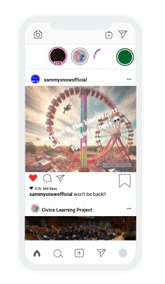
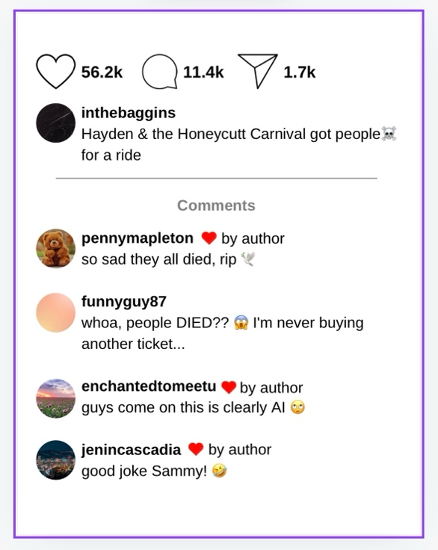

Exhibit 2: Social Media Follower Comparison

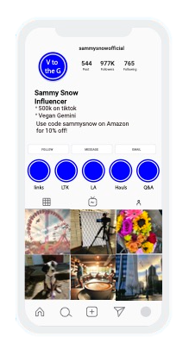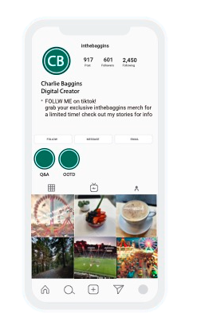

Exhibit 3: Honeycutt Carnival’s Profits & Loss Graph (September 2024)

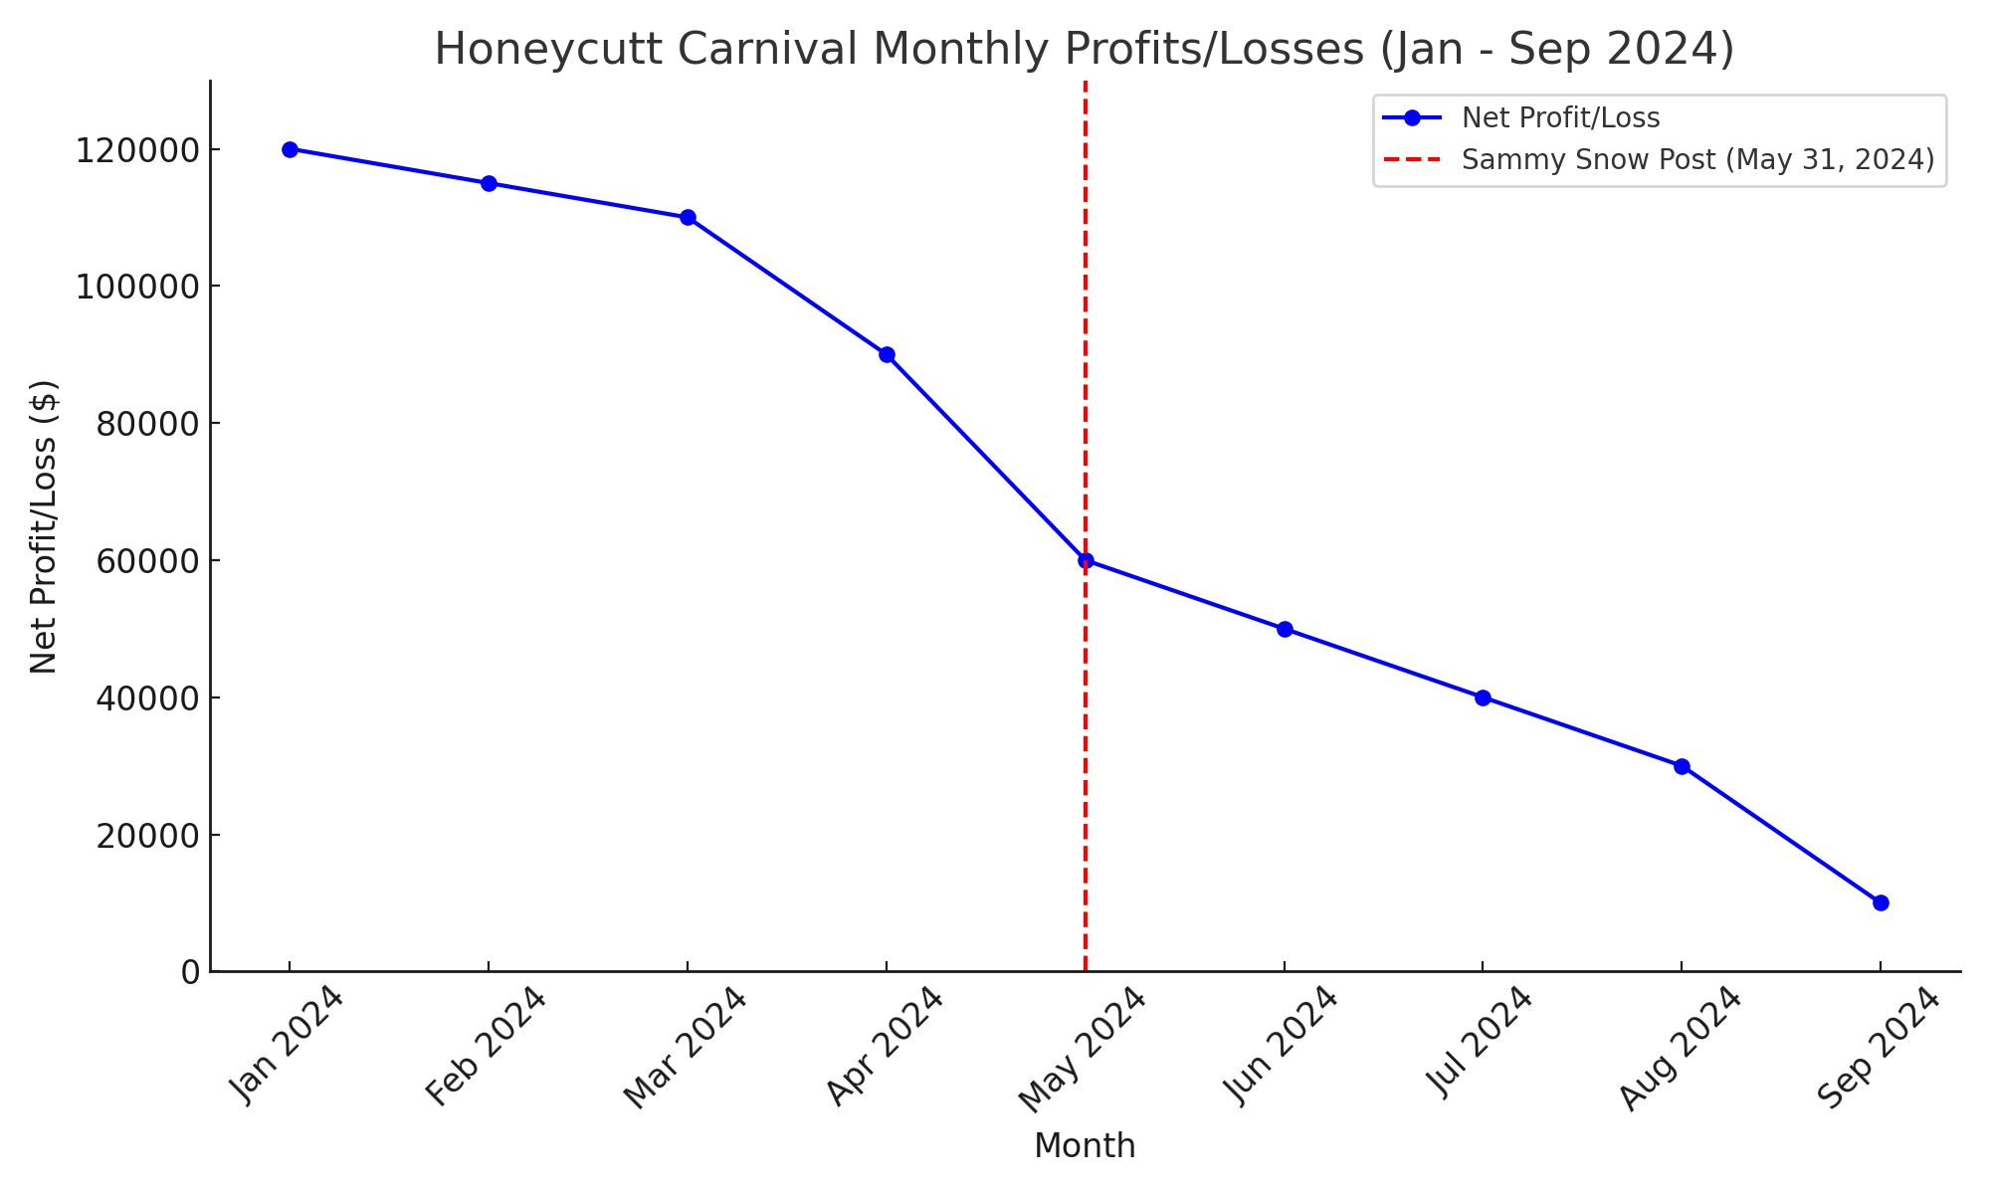

Exhibit 4: (April 20, 2004) Newspaper Article

Cascadia Times
April 20, 2004

Thrills Turn to Chills: Rollercoaster Accident at Honeycutt Carnival

Piper County, Cascadia – A routine day of fun turned frightening at the Honeycutt Carnival yesterday when a mechanical failure caused a rollercoaster to malfunction, leaving riders suspended in the air for nearly two hours. Fortunately, all passengers on the ride were safely brought down without any injuries, but the incident has raised serious concerns about safety practices at the long-standing local amusement park.

The incident occurred around 2:00 PM on the carnival’s popular ride, the “Thunderbolt.” Witnesses reported a sudden stop, causing the ride to jam with approximately 15 patrons trapped at its peak. Carnival staff quickly mobilized to assist the riders, and emergency services were on-site within minutes.

“We were scared at first, but the staff were really helpful. They kept us calm,” said Amanda Richards, a mother who was riding with her two children. “It was just a long wait before we got down.”

Despite the quick response, the incident has sparked scrutiny over the safety protocols in place at Honeycutt Carnival, a local institution that has been family-owned since its founding in 1924. The carnival, operated by Hayden Honeycutt, has been a staple of community gatherings for generations, drawing families for its rides, games, and food stands.

“It’s alarming to hear about this type of malfunction,” said local safety inspector, Bill Turner. “We will be conducting a thorough investigation into the carnival’s safety records and maintenance procedures.”
In a statement issued by the Honeycutt Carnival, owner Hayden Honeycutt expressed relief that no injuries occurred but acknowledged the need for a review of safety measures. “The safety of our patrons is our top priority. We will cooperate fully with the investigation and work to ensure that our rides meet the highest safety standards,” he said.

The rollercoaster incident comes on the heels of other minor mechanical issues reported at the carnival over the past few years, raising questions about the upkeep of aging rides. Local residents have expressed concerns, noting that while the carnival is a cherished part of the community, its safety must come first.

“I grew up going to this carnival; it’s been a part of our family traditions,” said Piper County resident, Linda Martinez. “But I hope they take this seriously. We don’t want to see any accidents.”

As the investigation unfolds, carnival officials assure the public that they are taking immediate steps to enhance safety measures. Meanwhile, the Honeycutt Carnival remains open, hoping to reassure patrons that their enjoyment and safety is paramount.

For now, families can continue to enjoy the attractions, but many will be keeping a closer eye on the rides and the assurances of safety from those in charge.

Exhibit 5: (1/24/24) Text Exchange between Charlie Baggins & Denny Nugget

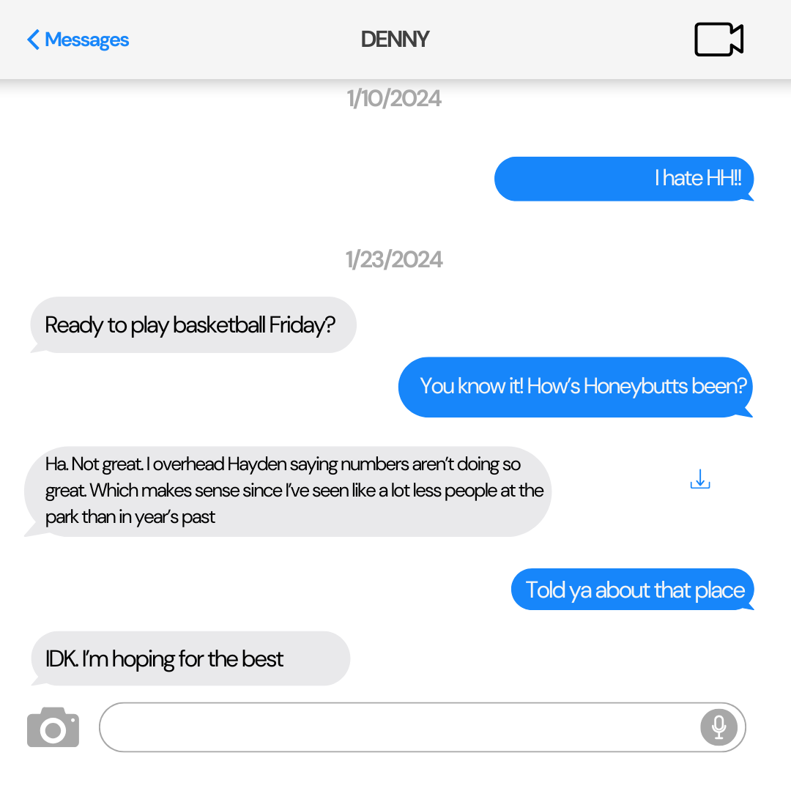

Exhibit 6: Morgan Dorf’s CV
Curriculum Vitae
Morgan Dorf
Certified Public Accountant (CPA)
Email: morgan.dorf@honeycuttaccounting.com
Phone: (555) 987-6543
LinkedIn: linkedin.com/in/morgandorf
Website: www.morgandorfaccounting.com

EDUCATION
Bachelor’s Degree in Accounting
Piper County University, Cascadia
Graduated: 1995
Certified Public Accountant (CPA)
Cascadia State Board of Accountancy
Licensed: 1997

PROFESSIONAL EXPERIENCE
Head Accountant
Honeycutt Carnival, Piper County, Cascadia | 1999 – 2024
- Managed all financial operations for the Honeycutt Carnival for over 25 years, from its peak profitability to its eventual closure.
- Oversaw budgets, payroll, and financial statements to ensure compliance with state and federal laws.
- Maintained profit and loss statements, which documented the steady decline of business leading up to the closure of the carnival in 2024.
- Provided financial reports to upper management and the Honeycutt family regarding the carnival’s long-term financial health.
- Played a key role in managing the transition when the business faced legal and financial challenges.
Owner & Operator
Dorf Accounting Services, Piper County, Cascadia | 2005 – Present
- Provide accounting, tax, and advisory services to small businesses and individuals across Cascadia.
- Specialize in financial planning, budgeting, and business restructuring for companies in crisis.
- Offer consultation services for businesses dealing with defamation or public relations issues that impact financial outcomes.
- Maintain long-term relationships with clients by providing tailored financial advice based on unique business needs.

PROFESSIONAL CERTIFICATIONS
- Certified Public Accountant (CPA) – Cascadia State Board of Accountancy
- Certified Management Accountant (CMA) – Institute of Management Accountants (IMA), 2001

NOTABLE CASES AND CONSULTATIONS
- Hayden Honeycutt v. Sammy Snow
Expert Witness for the Plaintiff
Provided testimony regarding the financial losses Honeycutt Carnival experienced after Sammy Snow's social media post. Presented detailed profit and loss statements showing that despite prior decline, the social media attention was a critical factor in the carnival’s closure.
- Honeycutt Carnival Financial Crisis
As the lead accountant during the final years of the carnival, I advised Hayden Honeycutt on financial restructuring strategies and alternative methods for boosting revenue. Despite these efforts, external factors, including the social media controversy, contributed to the eventual closure.

FINANCIAL ANALYSIS & REPORTING
- Expert in analyzing profit and loss trends to identify the impact of external events on business health.
- Proficient in preparing financial statements that comply with industry standards and regulations.
- Skilled in identifying areas of financial mismanagement and implementing corrective actions.
- Experience in preparing and presenting financial evidence for legal cases, including defamation, bankruptcy, and business closure scenarios.

SIDE PROJECTS
Substack Writer: Media Criticism & Financial Impacts
Author of a Substack blog analyzing the intersection of media, finance, and business reputation.
- Write articles on the influence of social media on business outcomes, especially related to PR crises and defamation cases.
- Offer analysis on how media coverage, whether traditional or digital, can shape financial realities for small businesses.

PROFESSIONAL SKILLS
- Financial statement preparation and analysis
- Tax planning and advisory services
- Profit and loss forecasting
- Budgeting and financial restructuring
- Business and personal tax filings
- Legal testimony in finance-related cases

SOFTWARE COMPETENCIES
- QuickBooks
- Microsoft Excel (Advanced)
- Xero Accounting Software
- Intuit ProConnect Tax
- Sage Business Cloud Accounting

PROFESSIONAL MEMBERSHIPS
- American Institute of CPAs (AICPA) – Member
- Institute of Management Accountants (IMA) – Member
- Cascadia Association of Accounting Professionals – Member

COMMUNITY INVOLVEMENT
- Volunteer Treasurer – Piper County Youth Sports League
- Accounting Mentor – Cascadia Small Business Development Center
- Financial Literacy Speaker – Various local high schools and community groups in Cascadia

RESEARCH AND PUBLICATIONS
- "Social Media’s Influence on Small Business Financial Health" – Cascadia Business Review, 2022
Analyzed how social media controversies can drastically impact the financial stability of small businesses, with case studies on carnival and entertainment industries.
- "PR Crises and Financial Fallout: Case Study of Cascadia Zoo" – Piper County Accounting Journal, 2017
Explored the intersection of public perception, financial mismanagement, and external media influences, using Cascadia Zoo as the key example.

Exhibit 7: Rowan Wilson’s CV

Curriculum Vitae

Rowan Wilson, Ph.D.
Expert in Social Media, Generative AI, and Emerging Technologies
Email: rowan.wilson@emergingtech.com
Phone: (555) 123-4567
LinkedIn: linkedin.com/in/rowanwilson
Website: www.rowanwilson.com

EDUCATION
Ph.D. in Emerging Technologies
Cascadia Institute of Technology, Cascadia, USA
Dissertation: "Navigating the Post-Truth Era: The Role of AI in Social Media Content Creation and Public Perception"
Graduated: 2018
Master’s Degree in Communication Studies
University of Cascadia, Cascadia, USA
Graduated: 2013
Bachelor’s Degree in Information Systems
Piper College, Piper County, Cascadia, USA
Graduated: 2010

PROFESSIONAL EXPERIENCE
Professor of Digital Communication & Emerging Technologies
Cascadia Institute of Technology | 2019 – Present
- Teach courses on social media ethics, generative AI, and emerging technologies.
- Lead research on the influence of AI on social media content creation.
- Advise graduate students on research in digital ethics, media studies, and AI.
Independent Consultant
EmergingTech Consulting Group | 2015 – Present
- Provide expert testimony in legal cases involving social media, AI, and defamation.
- Consult with media companies on ethical standards and AI content creation.
- Offer workshops on navigating the post-truth environment for legal professionals.
Social Media Strategist
TechVerse Communications | 2013 – 2015
- Developed social media strategies for tech startups focusing on brand engagement.
- Analyzed data on audience behavior to optimize content creation.
- Collaborated with AI developers to integrate generative AI tools into marketing campaigns.

PUBLICATIONS
- "The Post-Truth Paradigm: Navigating Social Media in an Era of AI and Hyper-Reality", Journal of Digital Ethics (2021).
Analyzed how the rise of AI-driven content affects public perception of truth in digital spaces.
- "Generative AI and Defamation: Why Online Spaces Should Be Legally Reconsidered", Global Review of Emerging Technologies (2020).
Investigated legal challenges of applying traditional defamation law in the context of AI-generated content.
- "When the Algorithm Decides: Understanding Influence and Accountability in AI-Generated Content", Proceedings of the International Conference on Emerging Media (2019).
Focused on the ethical and legal accountability in AI-enhanced content creation.

EXPERT TESTIMONY AND LEGAL CONSULTATION
- Hayden Honeycutt v. Sammy Snow
Expert Witness
Provided analysis on the role of generative AI in social media defamation cases, focusing on the blurring lines between fact and fiction in influencer culture and post-truth discourse.
- Valerie Cook v. MirrorMind Media
Consultant
Provided insights on social media practices, AI content generation, and public perception management for a media company accused of spreading misinformation through AI tools.

CERTIFICATIONS
- Certified Digital Ethics Professional
International Association of Digital Ethics (IADE) – 2018
Certified to provide expert advice and analysis in cases related to digital content ethics, social media, and AI-driven platforms.
- Certified AI-Human Interaction Analyst
Global Council on Artificial Intelligence and Human Interaction (GCAIHI) – 2017
Expertise in understanding the relationship between AI-generated content and its societal and ethical implications.

SPEAKING ENGAGEMENTS
- Keynote Speaker
International Conference on Digital Media & AI – "AI, Truth, and Accountability in the Digital Age" – 2022
- Guest Speaker
Legal Tech Forum – "Social Media Defamation: Navigating New Frontiers in AI Content" – 2020
- Panelist
AI & Society Symposium – "Generative AI and Its Impact on Public Trust" – 2021

PROFESSIONAL AFFILIATIONS
- International Association of Digital Ethics (IADE) – Member
- Global Council on Artificial Intelligence and Human Interaction (GCAIHI) – Fellow
- Association for Media and Communication Research (AMCR) – Member

RESEARCH INTERESTS
- The influence of generative AI on social media and content creation.
- Defamation law and its evolution in the context of AI and social media platforms.
- Post-truth discourse and its implications on public trust and ethics.
- Digital ethics and algorithmic accountability in media.

SKILLS
- Generative AI content analysis
- Social media and influencer culture
- Legal consultation on defamation and digital ethics
- Digital media strategy
- Public speaking and expert testimony

References available upon request.

