Political Cartoon Analysis
Ever notice that political cartoons are not funny... Not, like, funny-funny...
Actually, political cartoons served to communicate important political rhetoric to the illiterate masses of our country in a time when many people were not well-educated. Political Cartoons still serve a role in American politics today, satirizing many of our elected officials, and expressing views on hot-button issues, much like an editorial would.
Check out this cartoon on voting in the November U.S. election:
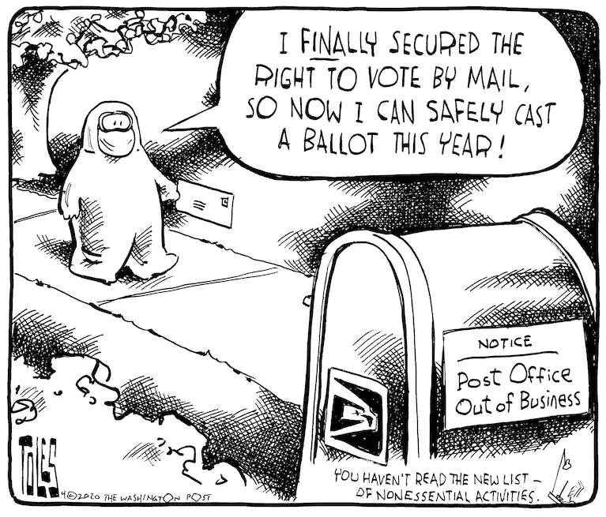

What to look for:
1. Symbolism -- Everything in a political cartoon means something; your job is to figure out what each symbol means. Common motifs include the Elephant to represent Republicans, Donkey for the Democrats, and Uncle Sam representing America.
2. Words tell us what things are supposed to be. The labels and call-outs help to clarify the symbolism.
3. Actions tell us what is being done -- or should be done, or in some cases shouldn't be done -- about the issue.
3. Message. The overall message is conveyed through the symbols, words and actions in the cartoon. It should be obvious what the author is saying about the issue, as long as you are interpreting all-of-the-above correctly!
Cartoon Analysis: here's an example for the one above
In this cartoon, the person in the hazmat suit is clearly a disenfranchised voter (we can tell this by the call-out) who has recently received the right to vote. He is excited and hopeful that he will finally get to count his vote in this year's election, but obviously still concerned about contracting COVID-19, hence the symbolism of the hazmat suit and mask. He's attempting to vote in the election with a mail-in ballot -- controversial to some, esp. the Republicans this year -- without realizing that the Post Office Box he is trying to use to vote is out of business (he cannot see the sign posted on the back.) This is referring to the de-funding of the Post Office under the Trump administration which preceded the election. The overall message is that disenfranchised voters faced even more barriers to voting in this year's presidential election.

Your Turn
Choose one political cartoon to analyze.
- Symbols: Describe all the objects and people you see and what they represent
- Words:
- Actions:
- Message:

