Classroom Law Project Current Event

The Vocabulary of Climate Change

Here is a brief explanation of the specific concepts and terms you will find throughout news reports and other resources on this topic.

Climate Change

Climate change is the long-term shift in weather patterns over many decades. The rising average temperature of the planet (often called “global warming” is one result of climate change. The primary cause of climate change is the burning of fossil fuels, which leads to more heat in the atmosphere. The extra heat held in by the atmosphere leads to the average temperature rising around the world. This also causes temperature rise in the oceans as well.

The widespread use of fossil fuels since the beginning of the Industrial Revolution in the 1700s has led to a rise of a full 1 degree Celsius in average global temperature. You can see the difference in the graph below.*

Scientists agree that humans can still avoid the worst climate impacts if fossil fuels emissions can be cut to hold overall global warming to 1.5 degrees.

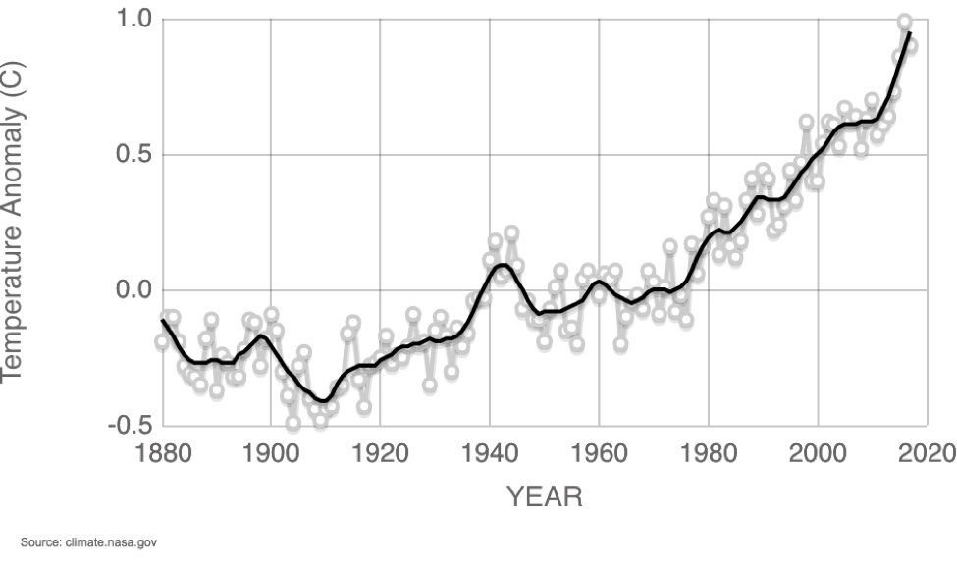

Greenhouse Effect

Every day, the sun shines down about 120,000 terawatts of energy onto the Earth – about 10,000 times what humanity currently uses in all our daily and industrial processes. The Earth absorbs some of this radiation as heat but it also gets reflected back into the atmosphere. Though some of this heat goes back into space, most of it stays trapped in our atmosphere because of gasses like carbon dioxide and methane that surround the earth. That “blanket” of heat around the earth is called the “greenhouse effect” because it’s similar to how glass greenhouses trap heat in order to help plants grow. But in the case of the whole planet, it changes the average temperature that makes existence for living creatures dangerous.

Fossil Fuels

Fossil Fuels are fuel sources that include oil, natural gas, and coal. They are formed by millions of years of earth’s pressure on organic matter (fossils of plants and animals). They are forcefully extracted from the earth because they are trapped between thousands of tons of rock beneath the earth’s surface. Humans have used fossil fuels for hundreds of years for power, transportation, industrialization, and plastics, among other things. The United States Energy Information Administration, the burning of fossil fuels was responsible for 76 percent of U.S. greenhouse gas emissions in 2016.

Clean or Renewable Energy

“Clean” or “Renewable” energy refers to sources of energy other than fossil fuels. These sources of energy are obtained from naturally occurring sources that renew themselves. They include:

- Solar: Uses technology to turn radiation from the sun into electricity.
- Wind: Harnesses the wind to turn turbines and generate electricity.
- Geothermal: creates steam from the hot rocks deep in the core of the earth.
- Tidal/Wave: Converts the movement of water driven by powerful tides and waves into electricity.
- Hydro: Primarily uses the motion of water descending through dams to create electricity

