CLP Current Events: April 30, 2019

Topic: Citizenship Question on 2020 Census

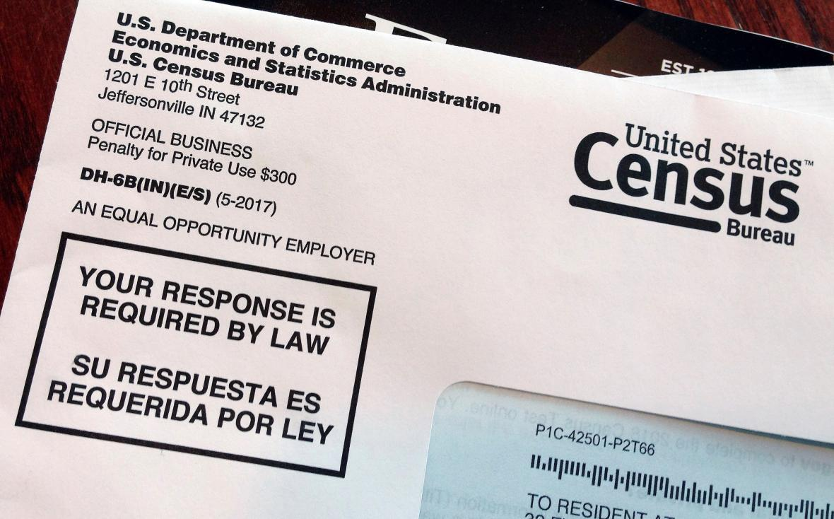

https://abc30.com/politics/judge-bars-citizenship-question-from-2020-census/5082205/

NEWS SOURCES (4 total)
Counting America in 2020, The Economist, April 27, 2019
“The census dictates how the 435 seats in the House of Representatives are allocated, and thus how many electoral-college votes should go to each state. Hundreds of billions of federal dollars are divided up according to state population, too. Areas where people are undercounted will suffer until at least 2030.”
https://www.economist.com/united-states/2019/04/27/counting-america-in-2020
CLP: Requires log in to read in entirety.

Supreme Court Appears To Lean Toward Allowing Census Citizenship Question, by Hansi Lo Wong and Nina Totenberg, NPR, April 23, 2019
“Population counts from the 2020 census will determine how many congressional seats and Electoral College votes each state gets for the next decade. The data also guide the distribution of an estimated $880 billion a year in federal funding for schools, roads and other public services.”
https://www.npr.org/2019/04/23/705210786/a-decade-of-implications-at-stake-supreme-court-hears-census-citizenship-questio

The Supreme Court Will Soon Consider Whether the Census Will Include a Citizenship Question, by Adam Liptak, The New York Times, April 15, 2019
“Next week, the Supreme Court will consider whether the Trump administration may add a question about citizenship to the 2020 “short form” questionnaire — the one that goes to every household in the nation. Nobody seriously disputes that this will cause fewer people to participate and will undermine the basic constitutional goal of counting everyone.”
https://www.nytimes.com/2019/04/15/us/politics/supreme-court-citizenship-census.html

Supreme Court will decide census citizenship question, by Todd Ruger, Roll Call, February 15, 2019
“The high court’s decision ultimately could affect congressional delegations and appropriations. The census is used to determine the total population of the United States, regardless of immigration status, to fairly distribute federal funds to states and localities, and to reapportion congressional seats and districts, among other things.”
https://www.rollcall.com/news/congress/supreme-court-will-decide-census-citizenship-question

QUESTIONS TO CONSIDER (6 total)
- What is the purpose of a Census every 10 years?
- Why does it matter that everyone be counted?
- What could be affected by the population numbers? Impact on voting. education, business?
- Why did the Framers include the Census in the Constitution?
- Why is a citizenship question proposed? How might it affect voting?
- Could a citizenship question jeopardize census results?

BACKGROUND AND MORE (2 total)
This Is How The Federal Government Can – and Can’t – Use Census Information, by Mireya Navarro, Brennan Center for Justice, February 20, 2019
https://www.brennancenter.org/blog/how-federal-government-can-and-cant-use-census-information

What to know about the citizenship question the Census Bureau is planning to ask in 2020, by D’Vera Cohn, Fact Tank, Pew Research Center, March 30, 2018
“For the first time since 1950, the U.S. Census Bureau is planning to ask everyone living in the United States whether they are citizens when it conducts its next decennial census in 2020. Anticipating that some immigrants might avoid answering the question, the Trump administration wants to try using other government records to fill in missing responses.”
https://www.pewresearch.org/fact-tank/2018/03/30/what-to-know-about-the-citizenship-question-the-census-bureau-is-planning-to-ask-in-2020/

LESSON PLANS (2 total)
Citizenship and the 2020 Census, by Mark Engler, Morningside Center for Teaching Social Responsibility, April 24, 2018
https://www.morningsidecenter.org/teachable-moment/lessons/citizenship-and-2020-census
CLP: High school or advanced 8th grade

It’s About Us, Scholastic, 2010
http://www.scholastic.com/browse/article.jsp?id=3752139#7-8 (grades 7-8)
http://www.scholastic.com/browse/article.jsp?id=3752139#9-12 (grades 9-12)

CONSTITUTIONAL CONNECTIONS (2 total)
SCOTUS And The Census: Taking Up The Citizenship Question, by Meghna Chakrabarti, OPB, April 22, 2019
https://www.opb.org/news/article/npr-scotus-and-the-census-taking-up-the-citizenship-question/

Argument preview: Justices will review challenge to census citizenship question, by Amy Howe, SCOTUSblog, April 16, 2019
https://www.scotusblog.com/2019/04/argument-previewjustices-will-review-challenge-to-census-citizenship-question/

OREGON (1 total)
Oregon begins prepping for 2020 census, by Alex Paul, Covallis Gazette-Times, March 27, 2019
https://www.gazettetimes.com/news/oregon-begins-prepping-for-census/article_1265c8db-60cc-5ffa-a304-9eddff76880d.html

FOR OREGON SOCIAL SCIENCE STANDARDS
8.8 Evaluate information from a variety of sources and perspectives.
8.17 Examine the development activities of political parties and interest groups and their affect on events, issues, and ideas.
8.21 Analyze important political and ethical values such as freedom, democracy, equality and justice embodied in documents such as the Declaration of Independence, the United States Constitution, and the Bill of Rights.
8.26 Examine a controversial event, issue, or problem from more than one perspective.
HS.27 Examine functions and process of United States government.
HS.30 Analyze the roles and activities of political parties, interest groups, and mass media and how they affect the beliefs and behaviors of local, state, and national constituencies.
HS.33 Explain the role of government in various current events.
HS.35 Examine the pluralistic realities of society (e.g., race, poverty, gender and age), recognizing issues of equity, and evaluating need for change.
HS.59 Demonstrate the skills and dispositions needed to be a critical consumer of information.
HS.60. Analyze an event, issue, problem, or phenomenon from varied or opposing perspectives or points of view.

FOR CONNECTIONS TO LESSONS IN WE THE PEOPLE: THE CITIZEN & THE CONSTITUTION TEXTS

Middle School, Level 2
- Unit 6, Lesson 29: What are the rights and responsibilities of citizenship?
- Unit 6, Lesson 30: How might citizens participate in civic affairs?
High School, Level 3
- Unit 6: What challenges might face American constitutional democracy in the Twenty-first century?

