Classroom Law Project Presents

Guns & Gun Violence:
A Town Hall Simulation

In this packet:
- How to run a Town Hall Simulation
- The Second Amendment
- Town Hall Simulation Role Sheets
- Appendices:
        - Gun Statistics
        - Links to Current Gun Laws & Policies
        - A list of possible Gun Policies
        - A Case Review of DC v. Heller
        - Oregon Gun Laws
        - Types of Guns

Classroom Law Project Presents

Guns & Gun Violence:
A Town Hall Simulation

Introduction:

This town hall simulation gives students the opportunity to take on different roles of people who have a stake in the conversation about guns and gun violence in the United States. By researching and then taking on the perspective of those they might not necessarily agree with, students gain a deeper understanding and ability to critically think through one of the most controversial topics in contemporary American culture.

This method of active learning teaches students about civil discourse, respecting each other, and developing a deeper understanding of the issue. This simulation lesson plan provides all the components needed by students, as well as resources and materials for teachers that can help students build their critical thinking.

Objectives of a Town Hall Simulation:

Students will:
- Engage and participate in mock town hall discussing gun & Second Amendment issues
- Analyze and articulate various perspectives on guns in the United States
- Develop and hone listening skills to better understand contrary positions
- Identify ways to compromise and collaborate
- Understand that their voices matter

Initial Teacher-Led Discussion:
- Points to make before introducing activity:
  - Guns, gun violence, and gun laws affect us all very individually and uniquely. It will be extremely important to inform the class that this is simply a way to raise issues on multiple perspectives of the issue, and that this is not an attempt to advocate for a certain position on a specific issue.
  - Remind students that this is not a forum for making personal or generalized attacks
  - Inform students that the goal of this activity is to be able to analyze and articulate various perspectives on gun issues
  - American contemporary culture is highly impacted by gun policy and beliefs about guns and gun violence. The policy options are as diverse as the opinions about the topic.
- Intentions of this roleplaying exercise:
  - Raise issues and perspectives
  - Learn to listen and understand other points of view (gain empathy)
  - Collaborate and come to consensus in a diverse community of thought

Town Hall Simulation Process in Brief:

1. Student Research and/or Review of Gun issues Pre-Activity Option

2. Explain students’ Goal: Approx. 5-10 mins
a. In a townhall format, explain to your town council members what gun policy you think is best for your community.

3. Distribute student roles: Approx. 10-15 mins
Students silently read and prepare for the part
(can be done ahead of time)

4. Assemble in role groups: Approx. 15-20 mins
Discuss who you are, what you believe and why. Students become the character in these discussions with their colleagues. Everyone has a chance to speak their part and everyone listens.

5. Assemble in jigsaw groups with one role from each group: Approx. 20 mins
Each student speaks and listens and determines the most important point from the other members.

6. Report back to role groups: Approx. 15 mins
Discuss key features of the others’ positions, the best way for your role
group to address those concerns?

7. Plan Testimony for each role: Approx. 20 mins
What are your group’s most persuasive points?
What can you propose in your testimony that will be most likely to
support your position but take into account others’ views?

8. Town Hall: Approx. 30 mins
Testimony taken from each role. Questions asked of the students by mock town council members.

9. Debrief: Approx. 20 mins

Town Hall Simulation Process in Detail:

Instruct students that this is a role-playing activity in which students will act out various perspectives by members of a community at a town hall meeting. Each role is based on real life people or groups of people, uses real facts, and so mocking or making light of the roles is not appropriate.

During the town hall meeting, each student will play the role of a person with strong opinions about the question being considered: What should our community’s gun policy be? Each role is designed to explore a specific perspective.

Discuss the purposes of town hall meetings, and how they allow members of the community to express their ideas and individual concerns and how this type of expression is used to develop public policy.

1. Roles provided in this townhall - you can use as few or as many as fits your class but try to evenly divide perspectives

Pro-Gun Freedom:
1. Rural Resident
2. Gun Store Owner
3. Sportsperson
4. Survivor of Mugging

Neutral:
5. Sociologist
6. Medical Researcher

Pro-Gun Regulations:
7. Urban Mayor
8. Emergency Room Radiologist
9. Exchange Student
10. Survivor of School Shooting

Town Council:
(can use students or bring in outside guests - 3-4 folks on the council is a good number)

Some roles are meatier than others because they are designed to communicate important facts and information about these issues.

Students may need to define some terms and do close readings to make sure they understand the information and arguments.

2. Collaboration with students in the same role

Students with the same roles first meet in groups and discuss their character’s perspectives and experiences. Give each group a profile of the role that they will be playing, but make time to review each role with the entire class. This allows for class discussion and deliberation on the varying perspectives.

Discuss with the class that their primary duty is to articulate the specific viewpoint of the role they are playing, and that it is their job as an engaged citizen to collaborate with those that share similar viewpoints, and to negotiate compromises with those that possess different perspectives.

Where the profiles contain a lot of information, instruct students that they may choose the most important points to make within the time limit—they are not required to use all the information and points. Be sure to communicate how much time each group will have to present, including 1-2 minutes for questions from the town council panel.

The town council panel should remember that their role is not to grill or argue with the speakers but rather to clarify points so as to better understand each speaker’s perspective. If students are playing the roles of the town council, they should use this time formulate questions they might want to ask of each character.

3. Meeting other viewpoints

In this part of the simulation, students will move into groups where there is one of each role and take turns sharing their perspectives/experiences with the group. Each character can explain their view of guns but do not need to propose any particular policy. Each member of the mixed group should take notes as they listen to each viewpoint. Once everyone has had a chance to share their perspectives, you may give time for them to ask each other respectful questions - no character needs to answer a question that does not fall within the information given in the role sheet.

4. Forming Testimony

Back in role groups, the students now want to share what they learned from other characters and plan what he testimony of their group will be to the town council panel. Each group should pick 1-2 students to give the testimony, and the testimony should be no more than 2-3 minutes.

Testimony should:
- give a clear background on who you are,
- what your values are, and
- what your policy proposal is for your community.

5. Townhall Meeting

Arrange a table at the front of the classroom where the city council members will sit. The panel members can be adults in the community, other teachers, administrators, or other groups of students. The panel members should be prepared prior to hearing testimony.

Explain the ground rules for the meeting:
- Each role group should have 1-2 students act as the speaker(s)
- Be courteous to others even when your character disagrees with someone
- Listen without interrupting while others are speaking
- Be open-minded; try to understand an issue from other points of view
- Write questions down rather than asking them during testimony
- Council panel can ask 2-3 questions of each character (max 5 minutes)

The “town council” can begin the town hall by posing the overarching question of: “what gun policy is best for our community” and providing follow up questions, or by simply opening the floor to those that want to speak. It is recommended that students not on the panel do not ask questions—when questions are opened up to the full class, the Town Hall can easily turn into a debate, which is a different activity with different objectives. Leave the questioning to the panel. Panel members need to be conscious of allowing all parties to speak and articulate their perspectives.

6. Debrief

Begin the class debrief by facilitating discussion on the town hall simulation. Ask question that address how each student felt while playing their role. Let the students express their thoughts and encourage them to ask each other question. Points of discussion may include topics such as:

- Challenge of taking a position other than your own
- Challenge of persuading others to your position
- Process of town halls and local government
- How youth can be involved in local government
- Have their views or perspectives on guns changed after completing this exercise

Note: Town Hall lessons are extremely modifiable. Teacher should consider how to best use this framework with their students.

Possible modifications include:
- Reducing the number of witnesses—pick the roles you believe will have the most impact on your students’ understanding of the issues involved
- Providing more or less information about the various roles depending on how much your students need their talking points scripted vs. their ability to be extemporaneous
- Providing less information about the various roles so as to have students perform individual or group research on their positions
- Inviting professionals in the community to visit the classroom to talk about these issues
- Extending the lesson based on particular areas of interest to the students—these often emerge during the exercise

United States Constitution
Second Amendment
(ratified December 15, 1791)

A well regulated Militia, being necessary to the security of a free State, the right of the people to keep and bear Arms, shall not be infringed.

Town Hall Simulation – Role
Read through this person’s perspective and prepare to become this person as your role in the Town Hall

Rural Resident

People who live in rural areas have a different view of guns than urban people, for historical, cultural and practical reasons. To explain some practical reasons: Prowlers and burglars sometimes target homes and other buildings in isolated areas – and it can take law enforcement a long time to respond to calls in a rural county. Just as they often own large dogs, people living in such places often own guns to safeguard the security of their families, homes, farms, or businesses. In addition, rural people keep guns as practical tools. They use them to control pests that threaten their crops, home gardens, chickens, pets, livestock, and even children – pests ranging from rabbits and deer to wolves, coyotes, bobcats and bears.

Sometimes guns are even used to put down sick or injured farm animals, to spare them suffering. Large-animal veterinarians are few and far between, and often can’t arrive quickly. Finally, many residents of the countryside use guns in hunting – not only as a recreational pastime, but to procure a significant portion of the food on their dinner tables. This is a near-necessity for some low-income rural people who not only have limited budgets, but who also may live far from well-stocked grocery stores.

Because guns have different meanings in rural and in urban contexts, “one size fits all” gun laws are inappropriate. Laws should be flexibly tailored to fit different kinds of circumstances. This can be accomplished by allowing each locality to develop its own approach to the subject.

- Guns play different roles in rural and urban life, so they should have different rules
- Rural dwellings and property are often relatively isolated and remote; law enforcement is often lightly staffed; as a result, police can’t always respond promptly
- Rural people have practical needs / uses for guns which may not apply in urban settings
- These include pest control, euthanizing of animals, and hunting for food

Town Hall Simulation – Role
Read through this person’s perspective and prepare to become this person as your role in the Town Hall

Gun Store Owner

The US Supreme Court has found that the Second Amendment to the Constitution guarantees the right of individuals to own firearms. The idea that this right only applies to members of an organized militia has been rejected by the Court. True, the Court also said that the government can still impose reasonable regulations on gun ownership, but I think any regulations should be minimal.

People have the right to own weapons with which they can protect themselves, their family, and their property. The police can’t be everywhere. Would-be rapists and armed burglars will think twice before attempting to break into any house where the owners may keep firearms for self-defense.

Stores like mine employ many people – sometimes in neighborhoods where there are few jobs. Gun manufacturers and gun related businesses contribute to the national and state economies. The vast majority of gun owners enjoy using their guns in peaceful, harmless pursuits like target practicing at shooting ranges – and these activities also stimulate the economy, providing jobs and benefits as well as wholesome recreation.

Guns are so deeply ingrained in American history, culture, and tradition that they can’t be simply legislated away, as in some other nations with different traditions. Banning guns would not make them disappear. Instead, it would be better to focus on teaching gun safety and responsible gun ownership and making sure there are serious penalties for anyone who uses guns in a crime.

- Despite whatever arguments are made, the Supreme Court has ruled in favor of the constitutional right of individuals to own guns
- Defense of one’s home and one’s self is a fundamental right
- Police can’t protect everybody; each person has to take some responsibility for their own defense
- Guns may deter crime in some cases
- Guns are a longstanding part of our culture, and that won’t change soon or easily
- The gun industry is an important part of the economy
- The dangers posed by guns can be mitigated by proper training and precautions

Town Hall Simulation – Role
Read through this person’s perspective and prepare to become this person as your role in the Town Hall

Sportsperson

I am very proud of my gun collection, which includes historical pieces and guns that I use regularly in target shooting and hunting. I enjoy going to gun shows to see other people’s collections, trading information and items with other enthusiasts, and visiting my local gun range regularly to improve my skills. Most gun control laws limit perfectly normal gun owners who would like to build gun collections and use guns for sporting. Those laws don’t keep bad guys from getting guns, but usually good guys don’t have the access they should under the Second Amendment. No law is better than bad laws about guns.

It’s a huge pain to have to know the states where you can and can’t carry a gun – so I think the country should enact laws that force states to recognize other states’ gun permissions. If I have a right to carry a weapon, concealed or open carry, in my state, then other states should give me that same right. It limits my freedoms to have to switch back and forth just because I cross into another state. Defending myself is my Constitutional right and I should be able to do that wherever I go.

America is proud of its guns and we have a unique history of gun making and design. Collectors love this legacy in our country. Hunting, angling, and fishing are also part of America’s legacy of conservation efforts. The outdoor life is wholesome and teaches excellent skills. In addition, it can be an excellent source of natural food for families. Being able to purchase, own, and use different kinds of guns in this effort is an important right that must be protected for sportsmen and sportswomen so we can pass these values and skills on to our children.

- Gun control laws harm legal gun owners

- Sportspeople use guns responsibly

- There should be reciprocity – recognition of states of other states’ gun laws so people have the freedom to travel with their guns

- People should be able to defend themselves wherever they go

- People should be allowed to go to gun shows and get together with people they share hobbies and sportsman stories with

Town Hall Simulation – Role
Read through this person’s perspective and prepare to become this person as your role in the Town Hall

Survivor of a Mugging

I never really thought about guns until a couple of years ago when I had the scariest experience of my life. On my way home from the movies one night, a guy stopped me and a friend in the street and held a gun up at us and demanded we hand over our wallets and phones. I had never been mugged or known anyone who had been mugged before that night. I honestly thought he was going to kill us and at first, I just froze. But after he yelled at us again, we quickly gave him our wallets and phones and he ran away. It took us a few minutes to find someone to help us call the police and the rest of the night was us trying to tell the police what happened. The whole night was surreal, but I was so scared after the mugging, I don’t remember a whole lot about interacting with the police.

They never did catch the mugger, and my friend and I experienced a ton of effects from that night. Not only did I have to go through the really long process to cancel and get all new I.D.s and credit cards, and phones, but I started having terrible nightmares. I couldn’t sleep and I felt vulnerable everywhere I went. So I bought a handgun and got some lessons at the local gun range. I have a license to carry my gun and now I carry it with me where ever I go. I feel safer and able to defend myself.

A study from Pew Research Center says that 48% of people who own guns own them for personal protection purposes. I am now a member of that group and glad I have the right to do so.

- Many people own guns for personal protection

- The Second Amendment clearly says people have a right to bear arms

- I should have the right to protect myself if I feel the need.

- Criminals shouldn’t be the only ones who can easily access guns.

Town Hall Simulation – Role
Read through this person’s perspective and prepare to become this person as your role in the Town Hall

Sociologist

The issue of guns is dominated by emotion and ideology. Activists on both sides – whether they are gun owners whose self-image is wrapped up with guns, or gun violence victims with horrifying personal experiences to relate – tend to appeal to feelings, rather than to reason. Policy on this issue should be based on actual, reliable data generated by solid, objective research, not on preconceptions, untested assumptions, and simplistic slogans.

My recommendation: unshackle the Centers for Disease Control. Restore the CDC’s freedom to study this issue and provide science-based guidance. The CDC, the nation’s public health agency, is now restricted from making recommendations on sensible ways to reduce gun violence. This must change. In order to make the needed research possible, the federal government should lift its ban on funding research about gun violence. We must be able to examine the facts and dispassionately derive workable policies from the facts.

From the limited data that we do have, there are some indications as to what works and what doesn’t. For instance, gun buy-backs, and stiffer sentences for gun crimes, don’t seem to work much, at least not by themselves, or in the ways they’ve been tried so far. The data is inconclusive about whether background checks, or bans on specific types of weapons, have much effect on levels of gun violence – these are questions that should be investigated further.

Some policies that do actually seem to reduce gun violence, at least somewhat or in some cases, include: more intensive probation strategies, involving increased cooperation between police, probation officers, and social workers; and programs featuring cooperation between police and community leaders. But, these are only tentative indications – much more research is needed in this area. Reducing gun violence is important and deserves attention from policymakers. And, policymakers need empirical facts to create sound policy.

- The gun issue is too emotionally and politically charged; people repeat slogans and don’t want to examine facts objectively
- The CDC is prohibited from funding research about gun violence; this should change, because it would be good to have reliable information about the subject
- Based on what we know, a few things seem to work or not work
- Gun buy-backs, harsher sentences for using guns in crimes, don’t seem to have much effect
- Programs where police cooperate with probation officers, social workers, and the community, seem to be somewhat effective

Town Hall Simulation – Role
Read through this person’s perspective and prepare to become this person as your role in the Town Hall

Medical Researcher

We need to look at gun violence from a completely different angle. Violence in society is like a contagious disease – it follows similar patterns. Medical interventions that are effective in fighting epidemics can be adapted to deal with violence, which in many ways is like an epidemic in America. This method involves addressing human behavior, rather than guns per se, and it’s different from traditional law enforcement or legal approaches.

Specially-trained workers can interrupt the “transmission” of violence, reduce its spread in a population, and help a group change the norms that make it vulnerable to this “infection,” strengthening group “immunity.” This strategy was tried in a Chicago neighborhood and resulted in a 67% drop in shootings. The Department of Justice and the Centers for Disease Control have investigated this program and found 30% to 70% reductions in violent crime in the places where it’s been tried.

Violence can be approached like a disease – and can be cured, or at least reduced. And this strategy avoids the need to take on the gun issue directly. People on both sides of the gun debate could be persuaded to support this approach. And, it has the added advantage that it can help reduce rates of violent crime in general, not only gun-related violent crime.

- It’s better to look at violence in general than just gun violence
- Ideas and methods from medicine about epidemics can be adapted to deal with outbreaks of violence in a society or community
- This has actually been tested in real life and it works
- It could be a way of reducing violent crime (including gun crime) without provoking controversy – by side-stepping the focus on guns

Town Hall Simulation – Role
Read through this person’s perspective and prepare to become this person as your role in the Town Hall

Urban mayor

Gun violence is a major problem in our city, even though it has declined significantly from the extremely high levels of two decades ago. Still, too many people are dying easily preventable deaths (and sadly, many of these victims are members of minority groups). Although gun advocates talk about using guns for self-defense, that happens more in their imagination than in reality. Studies show that guns are used to commit crimes about 10 times as often as they are used for self-defense – and even in the cases where they are used for self-defense, it’s often an illegal use, and/or an ineffective use (sometimes dangerously ineffective, as when the gun is turned against its owner). One study showed that a person with a gun is 4.5 times more likely to be shot in an assault than a person who is not carrying a gun.

Widespread gun ownership, whether legal or illegal, also leads to many tragic accidental deaths and injuries – we’ve all seen the headlines about small children shooting family members – and the presence of guns in homes correlates with higher suicide rates, as well.

Not only do guns not deter thieves and burglars, they actually attract them. Guns are valuable loot, and legally-bought guns are often stolen, enter the black market, and are subsequently used in crimes. So, the idea that guns pose no threat as long as only “good guys” have them, doesn’t add up. Guns owned by “good guys” kill many innocent victims in tragic accidents, suicides, and as the result of theft. In addition, many of the worst mass shooters were law-abiding gun owners and seemingly “good guys,” until the moment they unexpectedly opened fire and became bad guys.

It’s true that fatal accidents, homicide and suicide can all happen without guns. But the involvement of guns generally makes all these things both more frequent and, on average, more deadly. Knife attacks are statistically less likely to be fatal than shootings, for example. For these reasons, I favor the maximum amount of gun control that can be practically implemented, and that can be gotten through the courts – for the safety of the citizens of my city.

- Guns usually cause more harm than good, at least in an urban setting
- Guns are used for crime much more than for defense, and using them for defense often doesn’t work
- Accidents, suicides, and theft of guns (which are often used in later crimes) are other problems caused or worsened by guns being common
- Sometimes “good guys” turn out to be bad
- The more we can reduce gun sales, ownership, and use, the better

Town Hall Simulation – Role
Read through this person’s perspective and prepare to become this person as your role in the Town Hall

Emergency Room Radiologist

I diagnose gun injuries every day in the emergency room. I have seen almost every type of gunshot wound, and the most common are caused by handguns. In this kind of injury, the bullet leaves a laceration through a part of the body or an organ. Usually it is a thin track through the body, leaving bullet fragments and bleeding. But a wound to an organ from an AR-15, such as what was used at the Sandy Hook and Marjory Stoneman Douglas school shootings, is much different. In this type of gunshot injury, the organ looks more like a melon smashed by a sledgehammer with extensive bleeding. One AR-15 gunshot wound can cause that much damage. Emergency room doctors are rarely left with anything they can repair from a wound caused by this type of gun.

I have seen victims of mass shootings – once where the gunman used a semiautomatic 9mm handgun. He was able to shoot about 10 people in 90 seconds. Handguns, even when fired at high velocity, usually leave the same result: an entry and exit wound with a bullet track that unless it hits something crucial like the heart or an aorta, is fixable. In that particular mass shooting, all the victims survived because doctors could repair those wounds. But an AR-15 is different. These travel at far higher velocity and are far more lethal than handgun shots. The damage to the body has to do with the energy that comes off the bullet as it enters the body. The AR-15 – fired bullet displaces tissue as it travels through the body, killing or permanently damaging that tissue. It can cause catastrophic bleeding without even hitting an artery. Exit wounds can be the size of an apple or orange. The AR-15 shooter doesn’t have to be accurate to kill. Almost no victim of an AR-15 can survive.

I do not believe this kind of weapon should be allowed in a civilian population. There is no reason for its manufacture or existence except to kill large amounts of humans in a short amount of time. It does not require any particular skill to shoot, and it is guaranteed to cause lasting and catastrophic damage. The use of the AR-15 has become very common in mass shootings in America and it is the gun that makes it possible for one man to shoot over 500 people in 10 minutes, as did the gunman in Las Vegas in 2017. There is no reason for this gun to be on the market or in the hands of civilians. Removing high-velocity guns and magazines and lethal weapons from the market could vastly reduce the harm done by those who might seek to harm groups of people.

- Wounds from handguns are usually be fixed by skilled doctors
- Wounds from AR-15s and other types of high-velocity rifles cause guaranteed lethal damage
- Doctors have often little chance to save victims of high-velocity guns
- Removing high-velocity guns and high-capacity magazines from civilian society can’t hurt; it can make it less likely people will not survive a shooting
- There is no reason for this military style weapon to be in civilian hands

Town Hall Simulation – Role
Read through this person’s perspective and prepare to become this person as your role in the Town Hall

Exchange Student

My friends were worried about me when I told them I was coming to the US. In my country, gun violence is very rare. In fact, a decade ago we did have a school shooting, and after that, tough gun control laws were passed in my country. With some exceptions, most private citizens are not allowed to own guns anymore. And most of the public supports this. Gun violence has declined a lot. There are still some guns floating around, from the time when our laws were looser. But they weren’t that widespread, even then – and the number is gradually declining, as they are lost, broken, worn out, thrown away, confiscated, or donated to museums. They’re less usable anyway because ammunition is now very hard to get. Anyway, we’re still fine! People are safer now and feel more secure. It’s not necessary to have guns to lead a good life. From our point of view, America seems a bit crazy.

America has much higher rates of gun ownership, and gun violence, than any other developed country. In fact, not just developed countries: the US has much a much higher rate of gun ownership (88.8 per 100 people), than the next-highest country, Yemen (54.8). Yemen! Imagine that. Since other countries get along fine with fewer guns, there’s no reason the US can’t do so, also. The only obstacle is the unhealthy psychological attachment some Americans have to their guns. I would ask my American friends to stop fantasizing that you are Rambo, or that you’re going to overthrow your own government (another odd American obsession) and think about this rationally.

Do you really need a gun? Probably not. Are you really safer if everyone in your neighborhood has a gun? Probably not. Are you really going to be fighting off aliens or zombies from your front door or your rooftop? Probably not. So why not calm down and enjoy life? And you could, if you could go to the mall, or the beach, or the library, knowing that an attack by a mass shooter would be very unlikely – as I know it is unlikely, back home.

- American culture is unusual in its attachment to guns
- It’s possible to do things differently – at least, it is in other countries
- If guns are less common, then gun crime is less common
- Even in Yemen, gun ownership is lower than in the US(!)
- Americans should let go of their gun fantasies and learn from other countries that it’s possible to feel safe and secure and have a happy life, without guns being everywhere

Town Hall Simulation – Role
Read through this person’s perspective and prepare to become this person as your role in the Town Hall

Survivor of Mass Shooting

I always thought that events like mass shootings happened in far off places, not where I live. Until it happened to me. I was with friends at a shopping mall one afternoon when we started hearing people yell and saw them running toward us from the other end of the mall. There was mass confusion and we couldn’t tell what was happening. There was no fire alarm or anything, so we weren’t sure what to do. Then suddenly, we heard loud popping noises. I’d never heard gunfire before but I thought it sounded like firecrackers.

I have never felt so scared in my life. We ran to the nearest store and tried to hide inside with some other people. We could hear the shooting coming closer and then suddenly we saw a guy dressed all in black waving this giant gun around shooting it. He waved it towards the store we were in and suddenly a woman next to me dropped to the ground. I could see blood but I felt like I was frozen. My friend and I tried to stay perfectly still behind a rack of clothing. The shooter kept moving but we didn’t move at all. It felt like hours but suddenly there were masses of policy dressed like military pouring in everywhere.

They ended up shooting the guy to make him stop. We tried to help the store manager help the lady who had been shot in her shoulder while we waited for the police to find us. It turned out he’d been arrested the year before for domestic violence, and he had bought all the guns and bullets legally. The rest of that day is a blur to me, but I remember having to talk to multiple police people and get checked by EMTs. Since that day I have been diagnosed with PTSD and I get regular therapy to help me with my anxiety and problems I often have with sleeping.

There was no reason why that guy should have had that gun that was able to shoot so many bullets at once. One man was able to shoot hundreds of rounds in only a few minutes and he killed over 20 people and injured 32 others. The news said someone in the mall tried to shoot him back but that scared a lot of people and they thought there were two shooters and so some guys tackled him down. Luckily none of them got hurt. I truly believe we would all be safer if those kinds of high velocity and large capacity guns were not allowed in civilian life.

- In 2018, there were 323 mass shootings in the United States
- Even though there are some laws regarding buying guns, there is no universal background check, and there are multiple ways for people to buy high velocity and/or large capacity guns.
- No person should be able to shoot hundreds of bullets in seconds. There is no reason to have that kind of fire power, even for hunting or sports.
- More people are getting hurt or killed in mass shootings because people are using these guns in crowds.

Appendix 1

Statistics and Research Resources on Gun Violence

Gun Violence Archive (non-profit research since 2013 into gun incidents in the U.S.): http://www.gunviolencearchive.org/

Everytown USA - Gun Violence by the Numbers (a non-profit research archive of gun violence in the U.S.):
https://everytownresearch.org/gun-violence-by-the-numbers/

BBC - American Gun Violence in 10 Charts: http://www.bbc.com/news/world-us-canada-41488081

Vox - Country Comparisons of Gun Violence (using maps & charts): https://www.vox.com/policy-and-politics/2017/10/2/16399418/us-gun-violence-statistics-maps-charts

CNN - Mass Shootings in America (a 2016 survey & collection of charts demonstrating statistics on mass shootings in the U.S.): http://www.gunviolencearchive.org/

New York Times - Statistics on School Shootings since Sandy Hook: https://www.nytimes.com/interactive/2018/02/15/us/school-shootings-sandy-hook-parkland.html

New York Times – International Comparisons of Mass Shootings: https://www.nytimes.com/2017/11/07/world/americas/mass-shootings-us-international.html

New York Times – What we still don’t know about guns (including charts evaluating various gun policies’ effect on types of gun deaths): https://www.nytimes.com/interactive/2018/03/02/upshot/what-should-government-study-gun-research-funding.html

Pew Research: Explaining 3 main types of guns: https://www.pewpewtactical.com/types-of-guns/

New York Times - Gun Policy Comparisons (using graphics and charts): https://www.nytimes.com/interactive/2017/10/05/upshot/how-to-reduce-mass-shooting-deaths-experts-say-these-gun-laws-could-help.html

Five Thirty Eight – an interactive feature on Gun Violence statistics: https://fivethirtyeight.com/features/gun-deaths/

Mother Jones – Full Data Report on Mass Shootings in America 1982 – 2018: https://www.motherjones.com/politics/2012/12/mass-shootings-mother-jones-full-data/

Giffords Law Center – Descriptions of Gun Policies: http://lawcenter.giffords.org/search-gun-law-by-gun-policy/

Appendix 2
Gun Policy Descriptions - Links*

BACKGROUND CHECKS
- Universal Background Checks
- NICS & Reporting Procedures
- Background Check Procedures
- Mental Health Reporting

WHO CAN HAVE A GUN
- Categories of Prohibited People
- Domestic Violence & Firearms
- Gun Violence Protective Orders
- Minimum Age to Purchase & Possess

GUN SALES
- Gun Dealers
- Maintaining Records of Gun Sales
- Waiting Periods
- Gun Shows

GUN OWNER RESPONSIBILITIES
- Licensing
- Registration
- Reporting Lost & Stolen Firearms

CHILD & CONSUMER SAFETY
- Child Access Prevention
- Safe Storage
- Smart Guns
- Design Safety Standards

GUNS IN PUBLIC
- Concealed Carry
- Open Carry
- “Stand Your Ground” Laws
- Guns in Schools

HARDWARE & AMMUNITION
- Assault Weapons
- Large Capacity Magazines
- Ammunition Regulation
- Machine Guns & 50-Caliber
- Silencers

CRIME & GUNS
- Trafficking & Straw Purchasing
- Bulk Gun Purchases
- Microstamping & Ballistics

OTHER LAWS & POLICIES
- Gun Industry Immunity
- Preemption of Local Laws
- Intervention Programs

*From the Giffords Law Center
Appendix 3

Gun Policy Options:

- Gun Purchase Waiting Period
- Required Background Check
- Automatic Reporting (national computerized system)
- Mental Health Reporting
- Create categories of people prohibited from buying guns
- Track domestic violence for background checks
- Raise minimum ages for ownership
- Limit or stop unregulated gun shows
- Require background checks at gun shows
- Requirements to maintain sales records of guns
- Required registering of person-to-person sales
- Anyone who buys a gun must be licensed
- Licenses should require a certain amount of hours of training
- Gun ownership requires safety storage certifications
- All guns should have “smart” triggers (fingerprint access)
- Safety Standards should be designed into all manufacturing of guns
- There should be no concealed carry
- Concealed carry should have special licensing rules
- Concealed carry should not apply to certain places (like bars, churches, etc.)
- Open carry should be specifically regulated to certain areas (farms, ranches, etc.)
- Open carry should be in place of concealed carry rules
- “Stand Your Ground” Laws that allow people to shoot first if they feel threatened
- Limiting or Eliminating “Stand Your Ground” laws
- Limit large capacity magazines (large amounts of bullets that can be fired without reloading)
- Regulating ammunition purchases
- Limiting ammunition amounts allowed per person or purchase
- Limit on types of ammunition that are legal
- Limit on silencers
- Elimination of silencers for civilian population
- Limit or elimination of machine guns and 50-caliber weapons for civilian population
- Regulation of bulk gun purchasing
- Regulation of gun collecting
- Microstamping or marking bullets for tracking
- Limits on gun industry lobbying or political donations
- Funding for suicide prevention and mental health programs
- Funding for intervention programs for violence
- Funding for domestic violence intervention
- Arming teachers or school staff
- Armed guards in public places
- Metal detectors in public places and schools
- Funding for bullet proof windows and doors at schools and other public places
- No regulation of gun ownership or gun types
- No change to current regulations
- Shooter event preparedness drills (schools and public buildings)
- Restrictions on purchasing of violent video games

Appendix 4

Case Law Review:

District of Columbia v. Heller

Oral Argument - March 18, 2008
Opinion Announcement - June 26, 2008

Petitioner: District of Columbia et al.

Respondent: Dick Anthony Heller

Docket no. 07-290

Decided by: Roberts Court

Lower court: United States Court of Appeals for the District of Columbia Circuit

Citation: 554 US 570 (2008)

Advocates: Walter E. Dellinger, III on behalf of the Petitioners
Paul D. Clement on behalf of the United States, as amicus curiae, supporting the Petitioners
Alan Gura on behalf of the Respondents

Facts of the case:
Provisions of the District of Columbia (Washington, D.C.) Code made it illegal to carry an unregistered firearm and prohibited the registration of handguns, though the chief of police could issue one-year licenses for handguns. The Code also contained provisions that required owners of lawfully registered firearms to keep them unloaded and disassembled or bound by a trigger lock or other similar device unless the firearms were located in a place of business or being used for legal recreational activities.
Dick Anthony Heller was a D.C. special police officer who was authorized to carry a handgun while on duty. He applied for a one-year license for a handgun he wished to keep at home, but his application was denied. Heller sued the District of Columbia. He sought an injunction against the enforcement of the relevant parts of the Code and argued that they violated his Second Amendment right to keep a functional firearm in his home without a license. The district court dismissed the complaint. The U.S. Court of Appeals for the District of Columbia Circuit reversed and held that the Second Amendment protects the right to keep firearms in the home for the purpose of self-defense, and the District of Columbia’s requirement that firearms kept in the home be nonfunctional violated that right.

Question:
Do the provisions of the District of Columbia Code that restrict the licensing of handguns and require licensed firearms kept in the home to be kept nonfunctional violate the Second Amendment?

Conclusion:

5–4 decision – Yes.
Majority opinion by Antonin Scalia, joining: Roberts, Kennedy, Thomas, Alito

Minority: Stevens, Souter, Ginsberg, Breyer

The ban on registering handguns and the requirement to keep guns in the home disassembled or nonfunctional with a trigger lock mechanism violate the Second Amendment.

Justice Antonin Scalia delivered the opinion for the 5-4 majority. The Court held that the first clause of the Second Amendment that references a “militia” is a prefatory clause that does not limit the operative clause of the Amendment. Additionally, the term “militia” should not be confined to those serving in the military, because at the time the term referred to all able-bodied men who were capable of being called to such service.

To read the Amendment as limiting the right to bear arms only to those in a governed military force would be to create exactly the type of state-sponsored force against which the Amendment was meant to protect people. Because the text of the Amendment should be read in the manner that gives greatest effect to the plain meaning it would have had at the time it was written, the operative clause should be read to “guarantee an individual right to possess and carry weapons in case of confrontation.”

This reading is also in line with legal writing of the time and subsequent scholarship. Therefore, banning handguns, an entire class of arms that is commonly used for protection purposes, and prohibiting firearms from being kept functional in the home, the area traditionally in need of protection, violates the Second Amendment.

In his dissent, Justice John Paul Stevens wrote that the Second Amendment does not create an unlimited right to possess guns for self-defense purposes. Instead, the most natural reading of the the Amendment is that it protects the right to keep and bear arms for certain military purposes but does not curtail the legislature’s power to regulate nonmilitary use and ownership of weapons. Justice Stevens argued that the Amendment states its purpose specifically in relation to state militias and does not address the right to use firearms in self-defense, which is particularly striking in light of similar state provisions from the same time that do so. Justice Stevens also notes that “the people” does not enlarge the protected group beyond the context of service in a state-regulated militia. This reading is in line with legal writing of the time that contextualizes the Amendment in relation to state militias and post-enactment legislative history.

Justices David Souter, Ruth Bader Ginsburg, and Stephen G. Breyer joined in the dissent. Justice Breyer also wrote a separate dissent in which he argued that the Second Amendment protects militia-related, not self-defense-related, interests, and it does not provide absolute protection from government intervention in these interests. Historical evidence from the time of ratification indicates that colonial laws regulated the storage and use of firearms in the home. Justice Breyer argued that the Court should adopt an interest-balancing test to determine when the government interests were sufficiently weighty to justify the proposed regulation. In this case, because the interest-balancing turns on the type of analysis that the legislature, not the court, is best positioned to make, the Court should defer to the legislature and uphold the restrictions. Justices Stevens, Souter, and Ginsburg joined in the dissent.

From: "District of Columbia v. Heller." Oyez. Chicago-Kent College of Law at Illinois Tech, n.d. Jun 7, 2016. https://www.oyez.org/cases/2007/07-290

Appendix 5

Gun Policies and Regulations in Oregon

- Oregon Constitution, Article 1, Section 27
  - Gives Oregonians the right to bear arms
- ORS 166.291
  - Outlines requirements for obtaining a legal concealed carry permit
- ORS 166.292
  - Outlines procedure for obtaining a concealed carry permit
- Open carry of firearms is legal statewide, but certain municipalities may impose a ban on having a loaded firearm in public
- ORS 166.170
  - Unless expressly authorized by a state statute, the authority for regulating sales, possession, and use of firearms or ammunition is vested in the State Legislature
  - Any ordinance enacted regarding guns must be approved by the State Legislature
- ORS 166.171
  - A county may adopt ordinances to regulate, restrict or prohibit the discharge of firearms, though this may not apply to many of the legal discharges of a firearm
- ORS 166.172
  - A city may adopt ordinances to regulate, restrict or prohibit discharge of firearms within city’s boundaries, though this power may not extend to lawful defense of person or property, or discharging a firearm at a shooting range
- ORS 166.173
  - A city or county ay adopt ordinances to regulate, restrict or prohibit the possession of loaded firearms in public places, though this does not apply to most legal carriers of firearms (i.e. government, concealed carry)
- ORS 166.174
  - A city, county or other municipal corporation or district may not adopt ordinances that regulate, restrict or prohibit the possession or sale of firearms in a public or rented/leased building
- ORS 166.175
  - A city may regulate purchase of guns by pawn shops and secondhand stores
- Oregon Court of Appeals (2011)
  - Effectively allowed campus carry of firearms
- Oregon Firearms Safety Act (2015)
  - Adds the requirement of a background check for firearm transfers between private parties to existing law
  - Mostly applies to transactional transfers of guns (i.e. Joe the Plumber at a gun store)
- ORS 426.133
  - A court that orders outpatient treatment may prohibit a person from purchasing or possessing a firearm during the period of treatment
- ORS 166.190
  - Any person over the age of 12 who points a firearm at another except in self-defense will be fined and can be charged in front of a grand jury

- ORS 166.220
  - Unlawful use of a weapon occurs if one attempts to use unlawfully against another, or carries/possesses with intent to use unlawfully against another
  - Intentionally discharging a firearm within the city limits of any city or residential area at or in the direction of any person, building, structure or vehicle without having legal authority to do so
  - Class C Felony
- ORS 166.250
  - Defines unlawful possession of firearms
- ORS 166.260
  - Defines those not affect by ORS 166.250 (mostly government officials)
- ORS 166.270
  - Disallows possession of firearms by state/federal felons
  - Does not apply to felons whose crimes didn’t involve homicide or possession of firearm, who has been discharged from imprisonment, parole, or probation for 15 years
- ORS 166.272
  - Disallows possession of machine gun, short-barreled rifle, short-barreled shotgun or a firearms silencer
  - Class B felony
- ORS 166.320
  - Disallows selling of a spring gun
  - Class B felony
- Oregon Legislature (2018)
  - First gun control law passed after Parkland shooting
  - Banned people convicted of stalking and domestic violence or under restraining orders from buying or owning firearms and ammunition
- Age to buy a firearm
  - Must be 18 to knowingly possess a firearm
  - Prohibits any person from selling, delivering or otherwise transferring a firearm to anyone under 18
  - Can be excepted by parental permission

Appendix 6
Types of Guns

Semi-Automatic Rifles
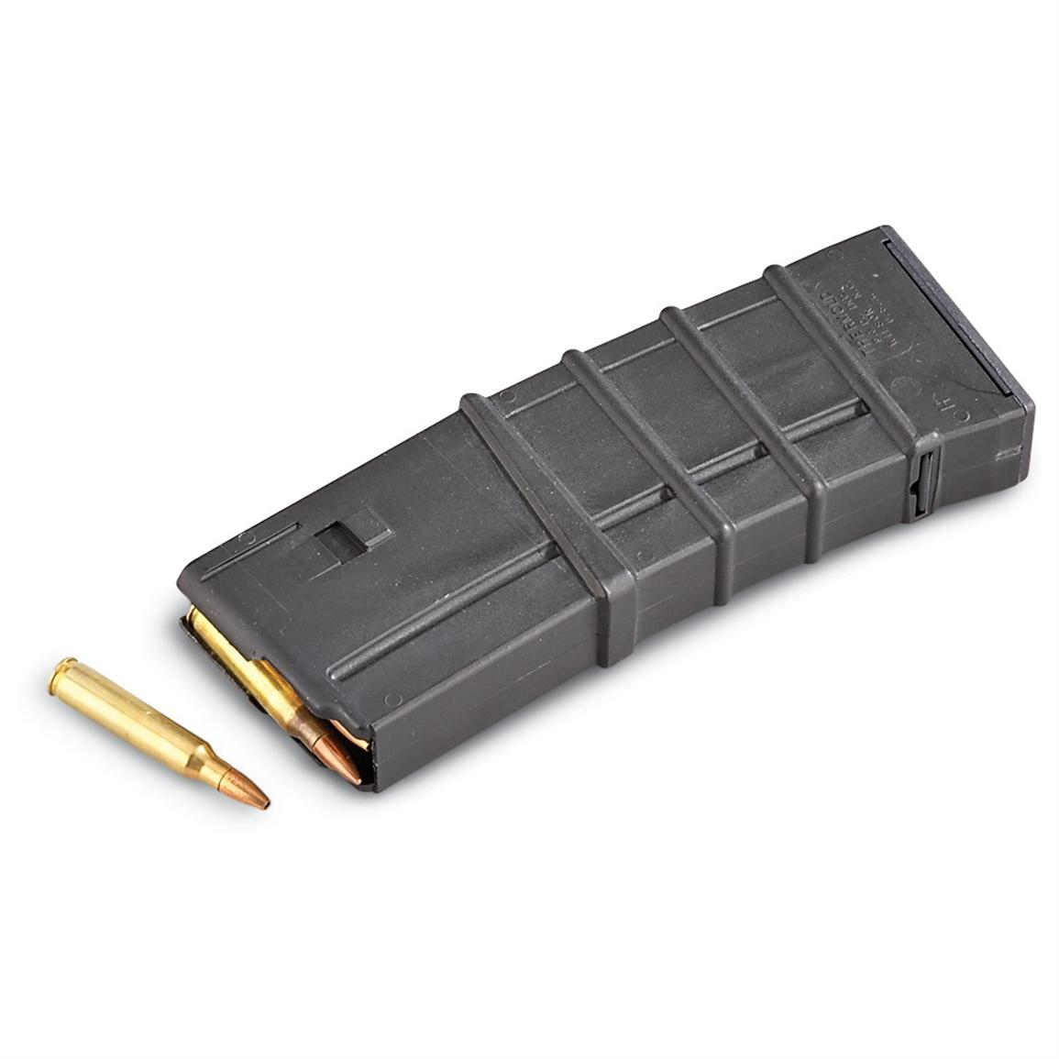
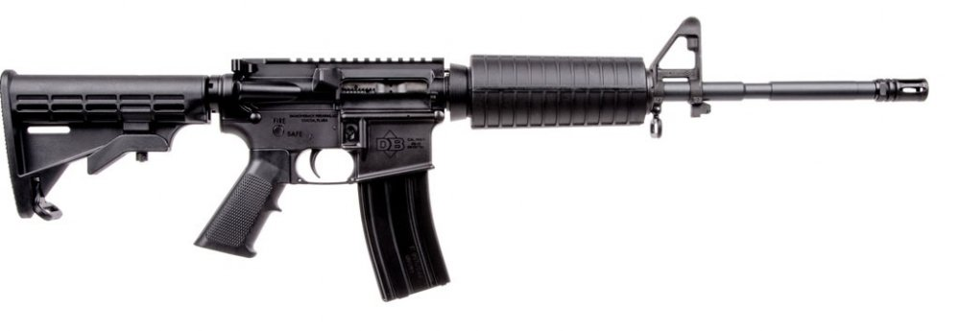

An AR-15 semi-automatic rifle. Semi-automatic magazine

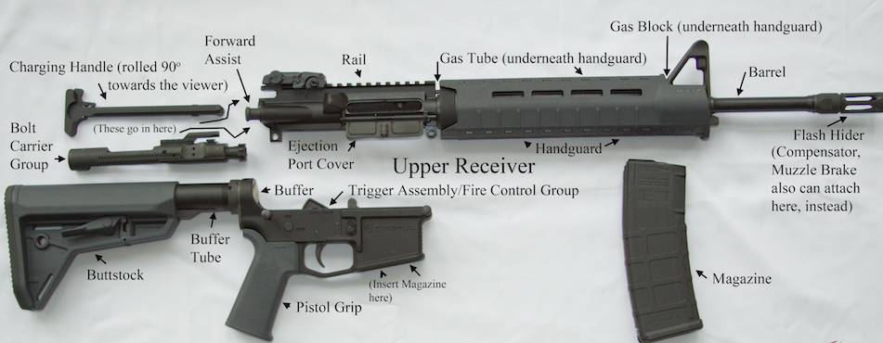

Breakdown of semi-auto rifle components

The semi-automatic rifle is one of the most infamous types of firearms. These guns are characterized by their loading mechanism, which uses gas, blowforward, blowback, or recoil energy to eject the spent cartridge after the round has traveled down the barrel and chamber a new cartridge from the magazine, while resetting the action. This means essentially that as soon as you pull the trigger, the gun is ready to shoot again. While these guns were originally developed in the late 19th century for consumer use, they quickly gained popularity with military factions due to the tactical advantage the loading mechanism gives soldiers. Unfortunately, the widespread availability of semi-automatic weapons today, such as the AR-15, as well as the ease of modifying the weapons to be fully automatic (gun keeps shooting as long as the trigger is depressed) and buy larger magazines, have made these powerful weapons a favorite of individuals committing mass shootings. The modified AR-15’s used by the Vegas shooter, for instance, is estimated to have been able to fire 540 rounds per minute. While a standard magazine holds about 20-30 bullets, magazines can be purchased that hold up to or even over 100 bullets.

Shotguns
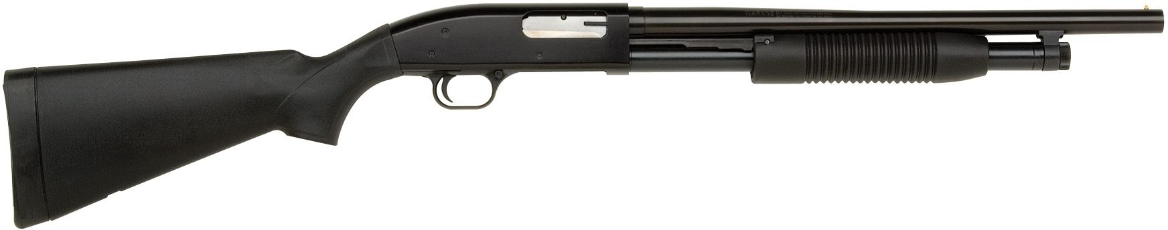
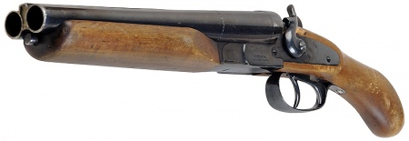

A pump-action shotgun. A sawed-off shotgun.

Early shotguns included weapons such as a musket, basically any firearm with a large diameter, smoothbore (no threading) barrel that could fire shot. Shot differs from bullets in that each shell contains a number of small metal balls that fire in a spray pattern. These guns were originally developed for bird hunting, as the large spray pattern allows the user to hit small, moving targets more easily. Most types of shotguns are available on the market in America. A shotgun usually holds about 4-5 shells.

Handguns

Semi-automatic Pistol Revolver
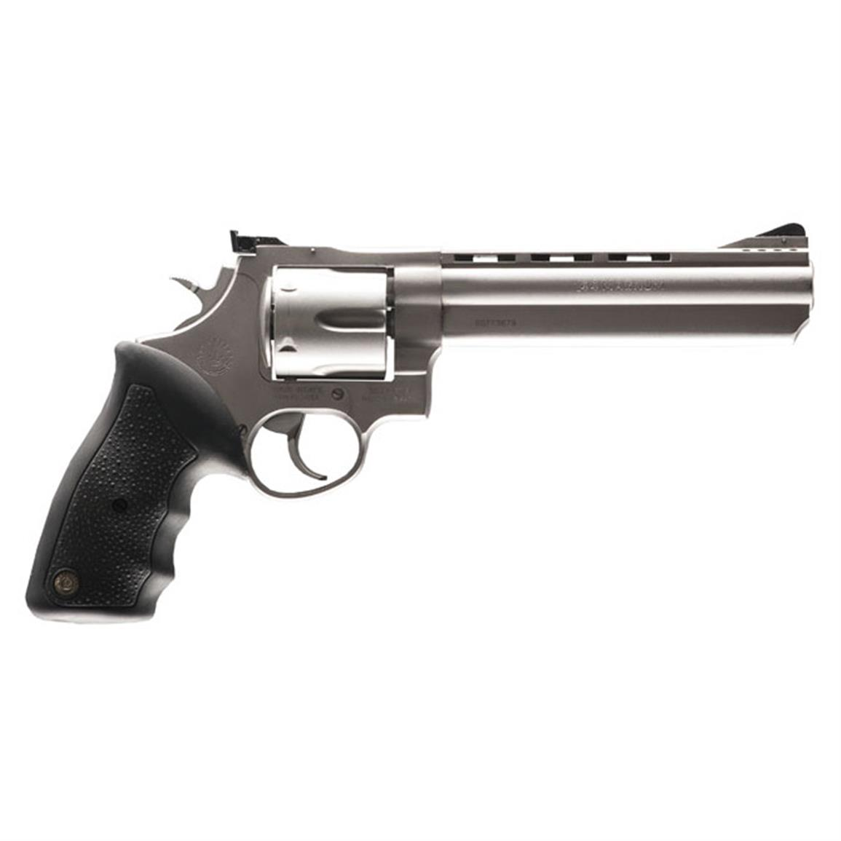
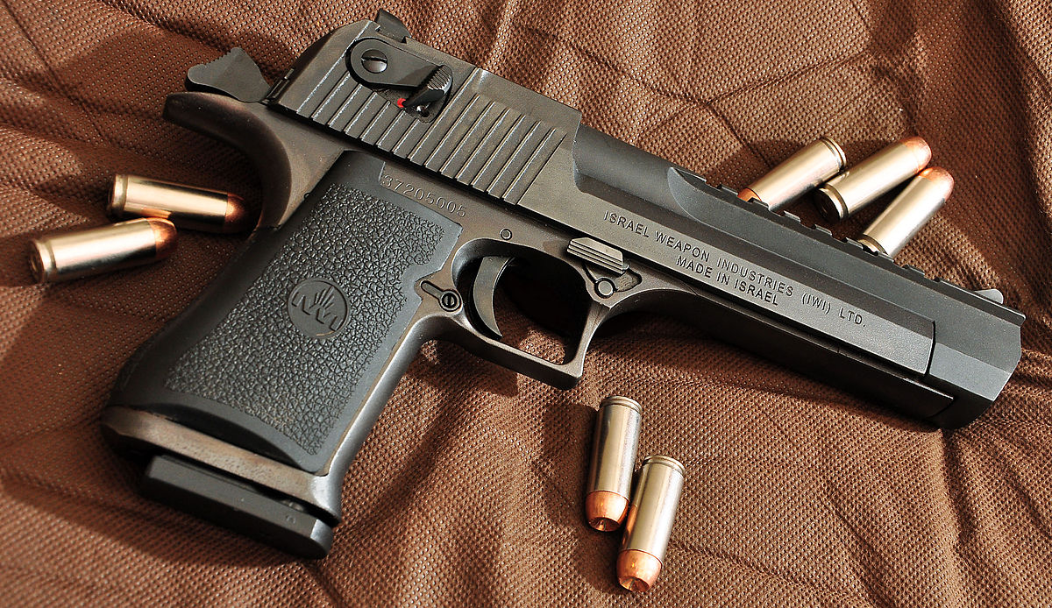

Handguns, or pistols, are another very famous type of firearm that has been around since the 16th century. Experts differ on what constitutes a “pistol”, but essentially the term refers to a small firearm to be used in one hand. The two most common types of handguns on the market today are semi-automatic and revolver style.

A revolver is the archetypal style handgun. The bullets are loaded into the cylindrical chambers, and each time the gun is fired, the chamber rotates, allowing a new bullet to be fired through the barrel. Revolvers are popular as backup/off-duty handguns among law enforcement officers, as well as being popular with consumers for defensive and sporting/hunting purposes. Revolvers usually have a capacity of 5-8 bullets depending on the size of the chamber.

A semi-automatic pistol functions similarly to a semi-automatic rifle. The magazine is housed in the grip of the pistol, and each time it is fired, a new round is chambered and live. A magazine for a semi-automatic pistol usually houses about 8-12 magazines, though it is easy to find aftermarket magazines housing up to 20 rounds. These firearms are very easy to reload, just press the magazine release (usually on the side of the weapon), and load a new magazine. The weapon is then ready to shoot.

Submachine Guns
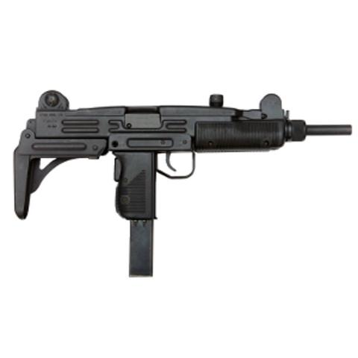
A submachine gun is similar to a fully automatic rifle, but is generally much smaller and designed to be used with pistol cartridges rather than full size rifle cartridges. They have very high fire rates, and today are used mostly by military special forces and SWAT teams due to the ease of control in close quarter combat.

