CLP CURRENT EVENT TUESDAY November 14, 2017

TOPIC: CATALONIA – Independence?

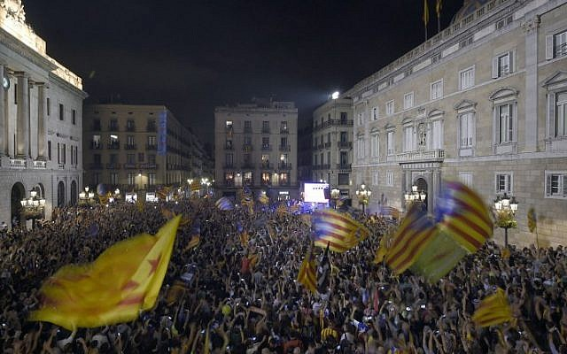
https://www.timesofisrael.com/breaking-neutrality-spanish-jews-come-out-against-catalan-independence/?
The Catalan region of Spain is in the northeastern corner of the country and is known for both beach resorts and snow-capped mountains. Barcelona, the capital, has an historic Gothic Quarter, La Rambla pedestrian mall, museums and beaches. It is over 12,000 square miles in size and a population of 7.5 million.
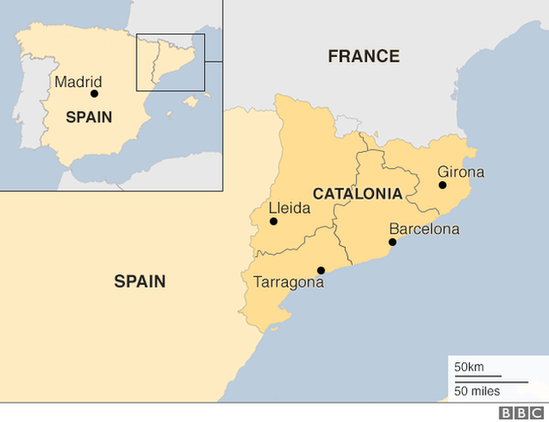http://www.bbc.com/news/world-europe-20345071

se·ces·sion səˈseSHən/noun
the action of withdrawing formally from membership of a federation or body, especially a political state. "the republics want secession from the union"
History: mid-16th century (denoting the withdrawal of plebeians from ancient Rome in order to compel the patricians to redress their grievances)

NEWS SOURCES (10 total)

Catalonia Crisis in 300 Words, from BBC News, Oct. 30, 2017
“Catalonia's drive for independence has plunged Spain into its biggest political crisis for 40 years. It's a complicated dispute, so let's break it down…”
http://www.bbc.com/news/world-europe-41584864
CLP: start here for an excellent, short explanation.

Factbox: Catalonia Crisis - What's Next?, by Reuters Staff, Reuters, Oct. 27
“Spain on Friday sacked Catalonia’s regional government, dissolved the Catalan Parliament and called a snap election in the region for Dec. 21, in a bid to draw a line under the country’s worst political crisis in 40 years. Below are several scenarios of what could happen in the next few days….”
http://www.reuters.com/article/us-spain-politics-catalonia-scenarios/facrbox-catalonia-crisis-whats-next-idUSKBN1CW2R0?il=0
CLP: helpful explanation of the meaning of a possible secession.

Catalonia’s Ousted Leader Calls for Peaceful Defiance, by Raphael Minder, Patrick Kingsley and Kimiko de Freytas-Tamura, New York Times, Oct. 28, 2017
“In a defiant message, Catalonia’s ousted leader, Carles Puigdemont, called on Saturday for Catalans to unite in peaceful ‘democratic opposition’ after the Spanish central government took control of the restive region …”
https://www.nytimes.com/2017/10/28/world/europe/spain-catalonia-independence.html?
CLP: call for peaceable protest.

300,000 Rally Against Catalan Independence as Autonomy Stripped, by Tim Lister, Vasco Cotovio and Angela Dewan, CNN, Oct. 29, 2107
“Hundreds of thousands of anti-independence protesters rallied in the Catalan capital of Barcelona on Sunday after Madrid took unprecedented measures to quash the region's bid to split from Spain…”
http://www.cnn.com/2017/10/29/europe/catalonia-independence-spain/index.html
CLP: citizens against independence.

Calling an Election Will By No Means Resolve the Catalan Conundrum, by Giles Tremlett, The Guardian (UK), Oct. 30, 2017
“When Catalans vote for a new regional government on 21 December, truncheon-wielding riot police should be absent and the results will clearly be valid, but the Spanish prime minister’s decision to call a snap election, combined with the imposition of direct rule, does not magically resolve the problem …”
https://www.theguardian.com/world/2017/oct/30/calling-an-election-will-by-no-means-resolve-the-catalan-conundrum
CLP: the secession/independence business is complicated!

Catalonia Ex-Officials Surrender to Belgian Police, BBC News, Nov. 5, 2017
“Catalonia's deposed leader Carles Puigdemont and four former advisers have turned themselves in to Belgian police, says a prosecutors' spokesman…”
http://www.bbc.com/news/world-europe-41877858

Catalonia’s Independence Bid Shows Signs of Strain as Coalition Splits, by Raphael Minder, New York Times, Nov. 8, 2017

https://www.nytimes.com/2017/11/08/world/europe/spain-catalonia-independence.html

CLP: a helpful look at the latest in what’s happening in Spain and Catalonia.

Spanish court annuls Catalonia's declaration of independence by Staff and agencies, Independent (UK), Nov. 8, 2017
“Spain's Constitutional Court has officially annulled the Catalan parliament's unilateral declaration of independence… New elections will be held on 21 December…”
http://www.independent.co.uk/news/world/europe/catalonia-independence-declaration-spanish-constitutional-court-catalan-spain-madrid-a8043851.html

Catalonia: Spanish Judge Jails Top Catalan Official Over Rebellion Charges, by Jesus Aguado and Agnus Berwick, Independent (UK), Nov. 10, 2017
“Spanish Supreme Court judge has ordered the Catalan parliament speaker to be jailed … The Catalan independence push has deeply divided Spain, dragging it into its worst political crisis since the return of democracy four decades ago…”
http://www.independent.co.uk/news/world/europe/catalonia-latest-spain-leaders-jailed-rebellion-sedition-over-independence-a8046961.html

Spain Catalonia: Barcelona Rally Urges Prisoners’ Release, from BBC News, Nov. 11, 2017
“Three-quarters of a million people have rallied in Barcelona to protest against Spain’s detention of Catalan independence leaders…”
http://www.bbc.com/news/world-europe-41956909

QUESTIONS TO CONSIDER (16 total)

- Where is Catalonia?
- What is the history of the Catalonian independence movement?
- What is the history of the Spanish Civil War and how might it affect events in 2017? How do countries deal with anti-democratic pasts? How do countries define patriotism and nationalism?
- What are the economic indicators that make independence an option for Catalonia?
- What is the Catalan language? Why is language a powerful cultural indicator?
- Why is the future of Catalonia significant for the future of Spain? The European Union? Other secessionist movements around the world?
- Why does Catalonia matter to the world?
- What other regions of Spain are also asking for more independence?
- Is secession legal? How are minority and majority rights protected in a secession movement?
- Is taking over the government and the police force of a region legal? Is it prudent?
- Is it possible to succeed in an independence movement using democratic means? What is “peaceful defiance”? https://www.nytimes.com/2017/10/28/world/europe/spain-catalonia-independence.html?
- What are the best arguments for Catalonian independence? What are the best arguments against independence for Catalonia? How many Catalonians favor independence? How many Catalonians fear independence?
- Are negotiations/conversations between Spain’s central government and the government of Catalonia a possibility?
- Is it possible to mend relations between Spain and Catalonia?
- What other secession and independence movements exist today?
- How did the American secession movement (The Civil War) change this country?

More questions from the BBC

http://www.bbc.com/news/world-europe-41551466

Catalonia crisis: What next for Spain?
- What powers does Catalonia have?

How did we arrive here?
- Reality Check: Would Catalonia be a viable country?

How did Madrid respond?

What do the Catalan separatists do now?

Do the secessionists face legal action?

Can Madrid really regain control?

Is there still room for compromise?

How great is the economic factor?

Will the outside world act over Catalonia?

BACKGROUND AND More (6 total)

Catalan Independence - What You Need to Know, from DW (Deutsche Welle, German)
http://www.dw.com/en/catalan-independence-what-you-need-to-know/a-40630039
CLP: excellent background for understanding what’s happening in the region; includes timeline.

Catalonia Crackdown Evokes Memories of the Dark Days of Spain’s Dictatorship, by Michael Birnbaum, The Washington Post, Nov. 9, 2017
“As Spanish leaders and Catalonia’s separatists battle over the fate of the would-be breakaway region, a shadow from the past is looming over the conflict: Francisco Franco, the dictator who held his nation in an iron grip from 1939 to well into the 1970s…They point to the no-negotiation stance by Prime Minister Mariano Rajoy…”
https://www.washingtonpost.com/world/europe/spanish-crackdown-on-catalonia-independence-effort-prompts-bitter-memories-of-franco-dictatorship/2017/11/08/b0ae6eac-bf14-11e7-9294-705f80164f6e_story.html?
CLP: “hangover” from the Franco days and a real threat to democratic institutions.

EU Cyber Team Raises Alarm Over Russian Role in Catalonia Independence Bid, by James Badcock, The Telegraph (UK), Nov. 9, 2017
http://www.telegraph.co.uk/news/2017/11/09/eu-cyber-team-raises-alarm-russian-role-catalonia-independence/
CLP: US is not alone in experiencing Russian interference

Rajoy vs Puigdemont: A Profile of Two Leaders, by Wil Longbottom, Sky News, Oct. 29, 2107
http://news.sky.com/story/rajoy-vs-puigdemont-a-profile-of-two-leaders-11103935
CLP: learn more about the two men at the center of the battle and their rivalry.

Tired by Years of Separatist Strife, Many Basques Wary of New Independence Bid, by Patrick Kingsley, The New York Times, Oct. 28, 2017
https://www.nytimes.com/2017/10/28/world/europe/spain-catalonia-basque-independence.html?
CLP: another region in Spain and its independence bid

Spanish History: Spanish Civil War (1936–39), from Encycledia Britannica
https://www.britannica.com/event/Spanish-Civil-War
CLP: the undercurrents of history with its strife and tension are not new

Lesson Plans (3 total)

Breaking News English Lesson on Catalonia, from Breaking News English ESL
https://breakingnewsenglish.com/1710/171005-catalonia-4.html
CLP: ELL lesson for several levels; nice summary of the conflict

Spain - National Geographic Kids

https://kids.nationalgeographic.com/explore/countries/spain/#spain-madrid.jpg

https://www.natgeokids.com/uk/discover/geography/countries/spain-facts/

CLP: overviews of Spain for middle school and below levels

Teaching Democracy – How did the Patriots Justify Their Separation from Great Britain?, by Jasmin Brown, Cal Humanities & The California History-Social Science Project, June 20, 2012

http://calhum.org/files/uploads/program_related/TD-How-Patriots-Justify-Separation-Lesson.pdf

CLP: look and learn from our own separation story in this well-done lesson

Constitutional & Legal Connections (4 total)

Article 155: The ‘Nuclear Option’ That Could Let Spain Seize Catalonia, by Raphael Minder, The New York Times, Oct. 20, 2017
“Prime Minister Mariano Rajoy held an emergency cabinet meeting on Saturday to decide what measures to take under Article 155 of the Spanish Constitution — a broad, forceful tool that has never before been used — that could allow him to take full administrative control of independence-minded Catalonia…Article 155 allows the central government to suspend some of a region’s autonomy under specific conditions…”
https://www.nytimes.com/2017/10/20/world/europe/catalonia-article-155.html?
CLP: explanation of Spain’s rarely-used constitutional option

Spain Is a Collection of Glued Regions. Or Maybe Not So Glued, by Megan Specia, Rick Gladstone and Raphael Minder, The New York times, Oct. 29, 2017
“…Spain has 17 autonomous communities, making it a decentralized country, but not a federal state. Most of the regions have long had their own traditions and histories, but some have more recent and political roots…”
https://www.nytimes.com/2017/10/29/world/europe/spain-autonomy-catalonia.html
CLP: very helpful piece in figuring out what’s going on in Spain and why

Spain – Catalans, from Minority Rights Group International
“…In 2006, the Spanish government approved a new Statute of Autonomy for Catalonia, further expanding the region’s autonomous powers and strengthening the Catalan culture….
In Catalonia children are entitled to receive primary education in their language of habitual use, whether this is Catalan or Spanish. Both languages are compulsory …”
http://minorityrights.org/minorities/catalans/
CLP: the power of Catalan culture and language

Role of International Law, personal communication with Hon. Marin Mrčela, President of the GRECO and Vice President of the Supreme Court of the Republic of Croatia, Nov. 5, 2017
“Not only is international law important, but even more is a national Constitution. Spain’s Constitution, if I understood media coverage, recognizes regional autonomy but not the right to secession. Former Yugoslav Constitution divided federal Republic of Yugoslavia into six federal units with the right to go out of the federal state after referendum and some legal decisions. Slovenia and Croatia formally used constitutional possibility and declared independence. That is the difference between Spain (with regions) and former Yugoslavia (with federal Republics).”
CLP: A neighbor’s look at a national constitution and what it allows.

For Oregon SOCIAL SCIENCE Standards

8.8 Evaluate information from a variety of sources and perspectives.
8.14 Explain rights and responsibilities of citizens.
8.20 Analyze the changing definition of citizenship and the expansion or rights.
8.26 Examine a controversial event, issue, or problem from more than one perspective.
8.27 Examine the various characteristics, causes, and effects of an event, issue, or problem.
8. 28 Investigate a response or solution to an issue or problem and support or oppose, using research.
HS.2 Analyze the complexity and investigate causes and effects of significant events in world, U.S., and Oregon history.
HS.5 Examine and evaluate the origins of fundamental political debates and how conflict, compromise, and cooperation have shaped national unity and diversity in world, U.S., and Oregon history.
HS.9 Identify historical and current events, issues, and problems when national interests and global interest have been in conflict, an analyze the values and arguments on both sides of the conflict.
HS.11 Gather and analyze historical information, including contradictory data, from a variety of primary and secondary sources, including sources located on the Internet, to support or reject hypotheses.
HS.16 Analyze the interconnectedness of physical and human regional systems (e.g., a river valley and culture, water rights/use in regions, choice/impact of settlement locations) and their interconnectedness to global communities.
HS.19 Evaluate how different points of view, self-interest, and global distribution of natural resources play a role in conflict over a territory.
HS.28 Evaluate how governments interact at the local, state, tribal, national and global levels.
HS.33 Explain the role of government in various current events.
HS.34 Explain the responsibilities of citizens (e.g., vote, pay taxes).
HS.57 Define, research, and explain an event, issue, problem or phenomenon and its significance to society.
HS.58 Gather, analyze, use and document information from various sources, distinguishing facts, opinions, inferences, biases, stereotypes, and persuasive appeals.
HS.59 Demonstrate the skills and dispositions needed to be a critical consumer of information.
HS.60. Analyze an event, issue, problem, or phenomenon from varied or opposing perspectives or points of view.
HS.61 Analyze an event, issue, problem, or phenomenon, identifying characteristics, influences, causes, and both short- and long-term effects.
HS.63. Engage in informed and respectful deliberation and discussion of issues, events, and ideas.

For Connections to lessons in We the People: The Citizen & the Constitution texts

Middle School, Level 2
- Unit 6, Lesson 29: What are the rights and responsibilities of citizenship?
- Unit 6, Lesson 30: How might citizens participate in civic affairs?
High School, Level 3
- Unit 6, Lesson 34: What is the importance of civic engagement to American constitutional democracy?
- Unit 6, Lesson 37: What key challenges does the United States face in the future?

