CLP CURRENT EVENT Tuesday, October 31, 2017

TOPIC: FIRE – Eagle Creek & Beyond

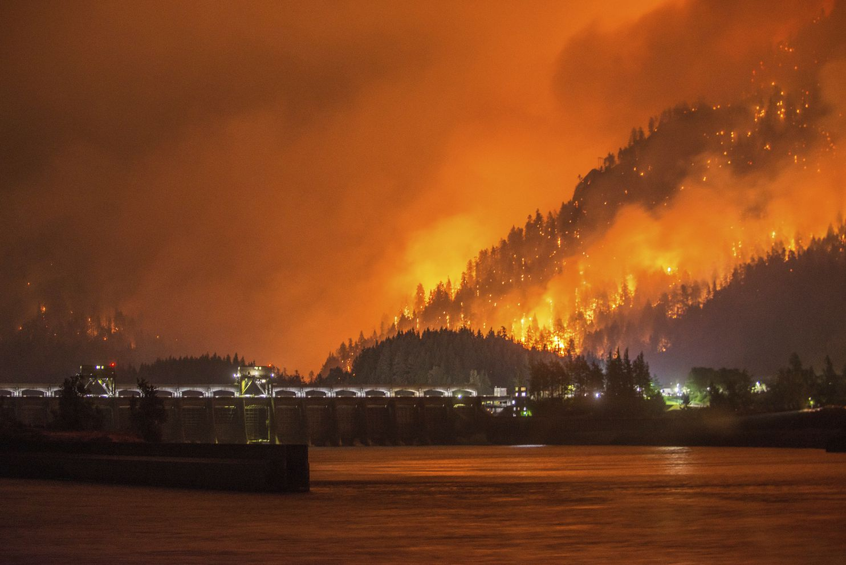
https://www.washingtonpost.com/news/post-nation/wp/2017/09/06/police-think-they-know-who-started-wildfire-that-made-it-rain-ash-in-oregon-giggling-teens/?

Eagle Creek Fire
The Eagle Creek Fire is an ongoing wildfire in the Columbia River Gorge in the U.S. states of Oregon and Washington. The fire was started on September 2, 2017, reportedly caused by teenagers igniting fireworks during a burn ban. Wikipedia
Cause: Illegal use of fireworks Location: Cascade Locks, Oregon, United States Date(s): September 2, 2017 –
Perpetrator: teenage minor(s) Burned area: 48,831 acres (198 km²)

Reckless Burning Law and Legal Definition.
A person is guilty of reckless burning if s/he: a. recklessly starts a fire or causes an explosion which endangers human life
b. having started a fire, whether recklessly or not, and knowing that it is spreading and will endanger the life or property of another, either fails to take reasonable measures to put out or control the fire or fails to give a prompt fire alarm; or
c. damages the property of another by reckless use of fire or causing an explosion
https://definitions.uslegal.com/r/reckless-burning/

NEWS SOURCES (12 total)
Oregon’s Eagle Creek Fire, Other fires, Climate Change

Oregon’s Eagle Creek Fire (7 total)

Heavy Rains Bring Landslides to Historic Columbia Gorge Highway, by Keely Chalmers, KGW, Oct. 24, 2017
“…Some residents who were forced to evacuate because of the Eagle Creek Fire last month were told they may have to get out again…”

http://www.kgw.com/news/local/heavy-rain-causes-several-landslides-in-columbia-gorge/485484049

Secrecy In Eagle Creek Fire Case Risks Burning Public Trust: Editorial, by The Oregonian Editorial Board, The Oregonian/OregonLive, updated October 21, 2017
"… when it's come to the 15-year-old charged with starting the massive blaze, law enforcement officials have aggressively worked to hide the process from public view…."
http://www.oregonlive.com/opinion/index.ssf/2017/10/secrecy_in_eagle_creek_fire_ca.html

CLP: interesting legal questions about the secrecy of proceedings surrounding the boy charged with igniting the fire.

Charges Filed Against 15-year-old Boy in Eagle Creek Fire, by Allan Brettman, The Oregonian/Oregon Live, Oct. 20, 2017

“A 15-year-old Vancouver boy faces reckless burning and other charges in the Eagle Creek fire that torched major swaths of the Columbia River Gorge, but …”
http://www.oregonlive.com/wildfires/index.ssf/2017/10/charges_filed_against_15-year-.html
CLP: if you read just one, this is it

How Much Has The Eagle Creek Fire Cost And Who’s Paying?, by Ericka Cruz Guevara, OPB, Oct. 20, 2017

“…As of Oct. 12, the Eagle Creek Fire had cost the U.S. Forest Service and the Oregon Department of Forestry more than $19 million. The fire, meanwhile, is still burning…”

http://www.opb.org/news/series/wildfires/oregon-eagle-creek-fire-price-tag-payment/

Criminal Investigation Into Eagle Creek Fire Focuses on Teen Suspect, by Noelle Crombie, The Oregonian/OregonLive, updated Sept. 6, 2017
http://www.oregonlive.com/wildfires/index.ssf/2017/09/criminal_investigation_into_ea.html
CLP: interesting questions about responsibility

Police Believe They Know Who Started Wildfire That Made It Rain Ash in Oregon: Giggling Teens, by Cleve R. Wootson Jr., Washington Post, Sept. 6, 2017
“…The chief suspects: a group of teenagers who giggled and recorded video Saturday afternoon while lobbing fireworks into a parched canyon…”
https://www.washingtonpost.com/news/post-nation/wp/2017/09/06/police-think-they-know-who-started-wildfire-that-made-it-rain-ash-in-oregon-giggling-teens/?

Public Demands Consequences for 15-Year-Old Eagle Creek Fire Suspect, by Aimee Green, The Oregonian/OregonLive, Sept. 7, 2107
“…He could be ordered to pay for the costs of fighting the Eagle Creek fire, to the tune of millions. His parents might have to foot some of the bill for the damage done. He also could face prison…”
www.oregonlive.com/wildfires/index.ssf/.../public_demands_consequences_fo.html
CLP: what price should be paid?
Other fires, Climate Change (5 total)

GAO: Climate Change Already Costing US Billions in Losses, by Michael Biesecker, Associated Press, Oct. 24, 2017
https://apnews.com/a40f2858a11b4cd5b2fac9f2556bd1f1/GAO:-Climate-change-already-costing-US-billions-in-losses
CLP: non-partisan federal watchdog agency report points finger at climate change

California’s Wildfires: Why Have They Been So Destructive? By Julie Turkewitz, The New York Times, Oct. 11, 2017
“… Wildfires often break out in California in October after the state’s dry, sunny summers. The fires are worse this year because…”
https://www.nytimes.com/2017/10/11/us/california-fires-questions.html
CLP: good, current overview; multiple causes of fires, including climate change, with people most responsible
Insured Losses Top $1 Billion in Northern California Fires, by Joseph Serna, Sonali Kohli and Makeda Easter, Los Angeles Times, Oct. 19, 2017
“…at least 5,700 structures destroyed, more than 2,800 homes gone, in the city of Santa Rosa alone. Officials called it the deadliest week in California fire history, with at least 42 confirmed fatalities.”
http://www.latimes.com/local/lanow/la-me-ln-fires-20171019-story.html
CLP: deadliest fire in CA history; financial and other costs

Portugal and Spain Wildfires Kill at Least 39 People, by Judith Vonberg and Vasco Cotovio, CNN, Oct. 17, 2017
http://www.cnn.com/2017/10/16/europe/portugal-spain-wildfires/index.html

A Raging Wildfire in Western Australia Has Destroyed an Entire Town, by Nash Jenkins, Time, Jan. 8, 2016
http://time.com/4172484/yarloop-western-australia-wildfire-bushfire/

QUESTIONS TO CONSIDER (17 total)

- Why is fire considered a threat?
- How does the poor air quality from large fires affect health? (see lesson http://eschooltoday.com/natural-disasters/wildfires/wildfire-facts.html)
- What are the long-term results of a forest fire? Why is the area of the burn subject to floods and landslides? What is the effect of fire on endangered animals? How does fire pose a serious threat to undocumented residents of a burn area?
- What are the causes of recent large fires? What could be done to prevent future fires? What resources are needed? What is “urban sprawl”?
- Is there a connection between climate change and fires? Is there a connection between overdevelopment and fires?
- Do wildfires pose a problem in other places in the United States? Elsewhere in the world?
- Is blame a constructive way to move forward after a disastrous fire? How is fire the result of multiple factors? What changes do we need to make to avoid fires in the future? Are methods of firefighting changing?
- What charges could be made in the Eagle Creek Fire?
http://www.oregonlive.com/wildfires/index.ssf/2017/09/public_demands_consequences_fo.html
- What law enforcement authority has jurisdiction over the person charged in the Eagle Creek fire: federal or state, adult or juvenile?
- Was this a negligent act? Was it a reckless act? Was it an intentional arson to start a forest fire? What is the meaning of “intent”?
- How are juveniles treated in our court system? How should juveniles be punished for actions that cause harm to others? Why are the names of juveniles kept out of the news? What is a “deadly prank”? Why do juveniles do “stupid” things? Why are juveniles attracted to fires? Is unwise behavior more likely in teenage groups?
- What responsibility do we have to discourage others from dangerous behavior? Do we have a responsibility to dissuade our friends from reckless acts?
- What is arson? What is reckless burning?
- What are the long-term effects of large fires? What about general dislocation, floods, landslides, loss of income, housing shortages, tourist decline, business losses, government costs to restore civic life, etc.?
- What is our policy on wildfire and forest fire management? Should it be changed? What are current best practices in wildfire management?
- What educational tools might be used to promote fire safety?
- How might the threat of fire bring people together? Countries together? What are examples of public outpouring to help fire victims?

BACKGROUND AND More (6 total, choose a focus)

FOCUS on FIGHTING FIRES - 7 Burning Questions: Wildfires & Public Lands, Blog, U.S. Department of the Interior
https://www.doi.gov/blog/7-burning-questions-wildfires-public-lands
CLP: learn how wildfires start, how big a threat they are and more.

FOCUS on FIGHTING FIRES - Smokey Bear’s Wildfire Prevention How-To, from U.S. Forest Service
https://smokeybear.com/en/prevention-how-tos
CLP: Smokey’s website

FOCUS on FIGHTING FIRES - We've Been Fighting Forest Fires Wrong For 100 Years, by Becky Oskin, OurAmazingPlanet – Business Insider, Jan. 15, 2013

http://www.businessinsider.com/weve-been-fighting-forest-fires-wrong-for-100-years-2013-1
CLP: evaluation of prescribed burns for fire suppression

FOCUS on FIGHTING FIRES/MAKING FRIENDS - Israelis, Jordanians, Palestinians Find a Common Enemy: Natural Disasters, by Judah Ari Gross, The times of Israel, Oct. 25, 2017

“Emergency response teams from around the world work together in EU-sponsored exercise on fighting forest fires, earthquakes…”
https://www.timesofisrael.com/israelis-jordanians-palestinians-find-a-common-enemy-natural-disasters/?
CLP: fire and other disasters can bring enemies together!

FOCUS on LAW - EDITORIAL (News Source repeat): Secrecy In Eagle Creek Fire Case Risks Burning Public Trust, by The Oregonian Editorial Board, The Oregonian/OregonLive, updated October 21, 2017
"… when it's come to the 15-year-old charged with starting the massive blaze, law enforcement officials have aggressively worked to hide the process from public view…."
http://www.oregonlive.com/opinion/index.ssf/2017/10/secrecy_in_eagle_creek_fire_ca.html

CLP: interesting legal questions about the secrecy of proceedings surrounding the boy charged with igniting the fire.

FOCUS on JUVENILE LAW - Playing With Fire: Juveniles and Their Fascination, by Pamela Kulbarsh, Officer.com, Feb. 19, 2015
“Fire-setting is the largest cause of home deaths among children. It is the 2nd leading cause of all fatal home accidents…”
https://www.officer.com/tactical/ems-hazmat/article/12043526/playing-with-fire-juveniles-and-their-fascination
CLP: Children’s fascination with fire is definitely part of this issue

Lesson Plans (4 total, choose a focus)

FOCUS on FIGHTING FIRES - Forest Fires by Joyce Bailey, Discovery Education
http://www.discoveryeducation.com/teachers/free-lesson-plans/forest-fires.cfm
CLP: an exceptional lesson; thoughtful; environmental issues and fire as a tool

FOCUS on FIGHTING FIRES - Your Cool Facts and Tips on Wildfires, from eSchoolToday
http://eschooltoday.com/natural-disasters/wildfires/how-to-fight-wildfires.html
CLP: not really a lesson but great info

FOCUS on FIGHTING FIRES - Fire Safety: Activities to Spark Learning! by Gary Hopkins, Education World, updated 2013
http://www.educationworld.com/a_lesson/lesson/lesson026.shtml

CLP: for younger students, includes important considerations, advice, fire safety tips from the U.S. Fire Service

FOCUS on JUVENILE LAW - Juvenile Justice Introduction, by Rebecca Swinney, Teaching Civics
https://teachingcivics.org/lesson/juvenile-justice-introduction/
CLP: includes history, comparison to criminal law (adult), and delinquency

Constitutional & Legal Connections (3 total)

Oregon Law: ORS 164.335 – Reckless Burning
https://www.oregonlaws.org/ors/164.335
CLP: actual text of the Reckless Burning statute

After More Than 45 Days, Teenage Suspect Charged As Juvenile In Eagle Creek Fire, by Amanda Preacher, OPB, updated Oct. 20, 2017
“…The teen was charged with misdemeanors instead of felonies likely because of the investigators’ findings that he did not intend to ignite the wildfire. In order to file felony arson charges, the investigators would have needed to establish that the teen’s motive was to start a fire…”
http://www.opb.org/news/series/wildfires/oregon-eagle-creek-fire-teenage-suspect-charged/

See Also (in News Sources): Secrecy In Eagle Creek Fire Case Risks Burning Public Trust: Editorial, by The Oregonian Editorial Board, The Oregonian/OregonLive, updated October 21, 2017
http://www.oregonlive.com/opinion/index.ssf/2017/10/secrecy_in_eagle_creek_fire_ca.html

CLP: legal questions about the secrecy of proceedings surrounding the boy charged with igniting the fire.

OREGON (2 total)

Oregonians Are Unreasonably Furious at the Teen Who Started a Forest Fire, by Karina Brown, Slate, Sept. 12, 2107

“They have suggested he be sterilized, whipped, or even lynched. But if we’re looking to place blame, we all deserve some…”
http://www.slate.com/articles/health_and_science/science/2017/09/furious_oregonians_should_save_some_forest_fire_blame_for_themselves.html

Wyden renews call for Congress to fix wildfire funding, by Ted Sickinger, The Oregonian/OregonLive, Sept. 13, 2017
“Sen. Ron Wyden was back on the Senate floor Wednesday, renewing his plea to fix the nation's broken system of wildfire funding …”
www.oregonlive.com/wildfires/index.ssf/.../wyden_renews_call_for_congress.html
CLP: Congressional action to fight forest fires

For Oregon SOCIAL SCIENCE Standards

8.13 Explain how current and historical technological developments, societal decisions, and personal practices influence sustainability in the United States.
8.14 Explain rights and responsibilities of citizens.
8.26 Examine a controversial event, issue, or problem from more than one perspective.
8.27 Examine the various characteristics, causes, and effects of an event, issue, or problem.
8. 28 Investigate a response or solution to an issue or problem and support or oppose, using research.
HS.9 Identify historical and current events, issues, and problems when national interests and global interest have been in conflict, an analyze the values and arguments on both sides of the conflict.
HS.15 Analyze and illustrate geographic issues by synthesizing data derived from geographic representations.
HS.16 Analyze the interconnectedness of physical and human regional systems 9e.g., a river valley and culture, water rights/use in regions, choice/impact of settlement locations) and their interconnectedness to global communities.
HS.18 Analyze the impact of human migration on physical and human systems (e.g., urbanization, immigration, urban to rural).
HS.20 Analyze the impact on physical and human systems of resource development, use, and management and evaluate the issues of sustainability.
HS.27 Examine functions an process of United Sates government.
HS.28 Evaluate how governments interact at the local, state, tribal, national and global levels.
HS.29 Examine the structures and functions of Oregon’s state, county, local and regional governments.
HS.33 Explain the role of government in various current events.
HS.34 Explain the responsibilities of citizens (e.g., vote, pay taxes).
HS.57 Define, research, and explain an event, issue, problem or phenomenon and its significance to society.
HS.58 Gather, analyze, use and document information from various sources, distinguishing facts, opinions, inferences, biases, stereotypes, and persuasive appeals.
HS.59 Demonstrate the skills and dispositions needed to be a critical consumer of information.
HS.60. Analyze an event, issue, problem, or phenomenon from varied or opposing perspectives or points of view.
HS.61 Analyze an event, issue, problem, or phenomenon, identifying characteristics, influences, causes, and both short- and long-term effects.
HS.63. Engage in informed and respectful deliberation and discussion of issues, events, and ideas.

For Connections to lessons in We the People: The Citizen & the Constitution texts

Middle School, Level 2
- Unit 6, Lesson 29: What are the rights and responsibilities of citizenship?
- Unit 6, Lesson 30: How might citizens participate in civic affairs?
High School, Level 3
- Unit 6, Lesson 34: What is the importance of civic engagement to American constitutional democracy?
- Unit 6, Lesson 37: What key challenges does the United States face in the future?

